Internal Quality Assurance Report (January to March 2023)

Section A: Plan of action chalked out by the IQAC in the beginning of the quarter towards quality enhancement

(i) Fisheries College & Research Institute, Thoothukudi
Sl.No | Plan of Action
- Inclusion of globally recognized certifying authorities in the syllabus of a relevant BFSc course under the Dept. of Aquaculture
Action taken: The Head of the Department Aquaculture has been instructed to arrange for the inclusion of lectures on the globally recognized certifying authority such as British Retail Consortium (BRC), Aqua Culture Steward Council, Marine Steward Council and Social auditing authorities like Best Aqua Culture Practices Certification (BAP) under different aquaculture related courses such as FS 101 Principles of Aquaculture (1+1), FS 110 Freshwater Aquaculture (1+1) and FS 210 Coastal Aquaculture and Mariculture (2+1).

- Information on imitated products to be included in the syllabus of fish processing related UG course under the Dept. of Fish Processing Technology
Action taken: It was verified that the syllabus of the course 313 Fish Products and Value Addition (2+1) of the Dept. of Fish Processing Technology deals with the imitated products under the heading ‘Analog products’. Hence the suggestion proposed has been found already in practice.

(ii) Dr. M.G.R. Fisheries College & Research Institute, Ponneri
Sl. No. | Plan of Action
1 | Development and popularization of viable technologies:  - Standardization and demonstration of fish cube technology for TNFFWD officials will be completed within the quarter.  - According to sensory analysis, the thickening property of the soup cube property will be improved.  Action taken: 1. The binding ability of the soup cube was studied with the food binders.  2. The solubility of soup cubes was assessed with the gelling materials to improve the even solubility ratio.  (Person incharge: Dr.Masilan)
2 | Tailor made programmes to meet the need of the trainee sector which include fisher folk, women SHGs and the rural youth is undertaken to develop fisheries / aquaculture entrepreneurship:  1.“Pond – Operator” course will be developed as a course by DAQ and DAEM  2. Possibility of introducing a “Pre-processor” course exclusively for women will be  Explored.  Action taken: The course details and the fee structure for the one month skill course on “Pond – Operator” has been submitted for approval to the Registrar. The course will be offered in the next quarter (Farm Manager will serve as Course Coordinator) (HOD- DAQ).  A tentative course schedule for the pre-processor course was prepared. ( HOD- DFPT)
3. | Innovations in curricular design and transaction:  - Unit wise class quiz/test will be introduced  - Design and Curriculum for three month certificate “Pond – Operator” course will be developed.  Action taken: Discussions on the implementation of the unit-wise class quiz test was made with the coordinators and the course teachers.  The course details and the fee structure for the one month skill course on “Pond – Operator” has been submitted for approval to the Registrar.
4. | Inter-disciplinary programmes to be started:  - Online Skill development course on Culture of Pearl Spot Etroplus suratensis (bilingual) and video lesson preparation will be progress. Power points for 11 lessons with six resource persons in complete (DAQ, DFRM, DAAH, DFPT)  - “Pond – Operator” course will be developed as a interdisciplinary course (DAQ and DAEM)  Action taken: Video recording of the proposed skill course on culture of Etroplus sp. Is in progress
5. | Examination reforms implemented:  - Purchase of tabs through CSR funding is in progress. Corporates involved in aquaculture / public sectors will be approached  Action taken: Mobile-based examination is planned to be replaced with laptops in the final examinations.  High speed internet connection (BSNL leased line) has been provided in exam hall.
6. | Patents generated, if any (Patents filed, published and awarded):  - Awareness programme on “How to draft a patent” will be organized on 24.03.2023  Action taken: A talk on “How to draft a patent” was given by the Dr. S.P . Subramaniyan, Deputy controller of patents and Designs on 23.3.2023.
7. | Faculty development:  - It is planned to send five faculties to various faculty development programmes  - Training on office procedures has already been conducted on 02.02.23  Action taken: wo faculties, Mrs. Aruna and Mr. Karuppasamy, Assistant Professors attended five days training on PRIMER- V and PERMANOVA organized by the PRIMER- e and Cochin University of Science and Technology, Kochi, Kerala.  Two faculties, Dr. Uma, Professor & Head and Mrs. Angela, Assistant Professor attended the training on “Capacity Building Programme for Geo-tagging of Assets created under NADP/RKVP” conducted by the Scientist of National Remote Sensing Center (NRSC) at Tamil Nadu Watershed Development Agency, Ekattutangal, Chennai.
8. | Strengthening of the library:  - Books worth of Rs. 1 lakh will be purchased (Faculty are requested to provide list of foreign author books (Rs.10000/book) is planned to be purchased  - Five new journals will be subscribed in this quarter  Action taken: Books worth of Rs. 50, 000/- have been purchased and Three new journals have been subscribed
9. | New collaboration research programmes:  A new collaborative project will be proposed ( Action: Mrs.Nimish) In progress.

(iii) College of Fisheries Engineering, Nagapattinam
- Acquiring AICTE Accreditation and improve the infrastructure and other facilities as per AICTE norms
Action taken: Application for AICTE accreditation was submitted and ‘Extension of Approval’ for B.Tech.(Fisheries Engineering) is obtained for the year 2023-24.
- Acquiring ICAR Accreditation and improve the infrastructure and other facilities as per ICAR norms
Action taken: The status is in progress and Laboratories were provided budget for purchasing equipment to strengthen the practical sessions as per ICAR norms.
- Improve the quality of Teaching, Research and Extension activities on mandates of CoFE
Action taken: Four faculty members are assigned for each batch of UG students as Students Counsellors to enhance interaction and counsel the students. Class committees are formed to improve the quality of learning and teaching.

(iv) Dr. M. G. R. Fisheries College & Research Institute, Thalainayeru
Sl.No | Plan of Action
- Education Quality Assurance Committee (EQAC): Guidance and Counseling to the students
Action taken: During this quarter, the mentor-mentee meetings were conducted by all the staff in march 2023 and the documents maintained by the staff for this activity was verified by the dean.

- Teaching Evaluation Committee (TEC): IQAC students feedback for the year 2020-21 and 2022-23 batch will be collected, analyzed and submit the report for further improvement
Action taken: Instructions were given to 2021-22 batch students to provide the teachers’ feedback in the TNJFU website in IQAC portal for III semester.
Totally 49 students provided their feedback and it was analysed (copy enclosed). The consolidated scores of individual staff were shared to the faculty on 31.03.2023 to understand and improve their teaching efficiency.
Feedback for the year 2020-21 and 2022-23 batch is In-progress

- Training Quality Assurance committee (TQAC): To conduct the 2 days hands on training for data analysis in Fisheries for faculty
Action taken: Hands-on faculty training programme on “Data Analysis using SPSS” was organised for the teaching staff (19 Nos.) of Dr.MGR Fisheries College and Research Institute, Thalainayeru for 2 days in two batches (04.05.2023-05.05.2023 and 10.05.2023-11.05.2023). Dr.R.Palani, Assistant Professor (C), served as resource person for the training.

- Project Quality Assurance Committee (PQAC): An online talk on research funding opportunities from nationalized banks on 07.03.2023, 3-4 pm.
Action taken: Organized an online talk on Research Funding opportunities from Nationalized Banks on 07.03.2023 (Tuesday) between 3.00-4.15 pm. Dr. P Selvaraj, Chief General Manager (Retd.), NABARD and alumnus of FC&RI, Thoothukudi served as the resource person.

(v) Institute of Fisheries Biotechnology, Vaniyanchavadi, Chennai
Sl.No | Place of Action
- Obtaining feedback from the faculty & Students
Action taken: Feedback from students have been obtained. The following are the summary of overall rating for the various courses and teachers of B.Tech. (Biotechnology) degree program
Excellent : 7393
Very good : 1624
Good : 1776
Average : 400
Poor : 164
- Encouraging exchange programmes between institution and industry
Action taken: Exchange programs have been initiated with institutes like, ICAR- Sugarcane Breeding Institute, Coimbatore and ICMR-National Institute for Research on Tuberculosis, Chennai. B.Tech. (Biotechnology) students are already undergoing internship/project work programs in the above institutes
- Appreciation of the students by rewarding for their academic performance other than the routines
Action taken: For appreciating the undergraduate students, “Academic Proficiency Prize” has been instituted at Institute level. The following two students were given the above prize on 31st March, 2023
- N.Rohith Reddy 2019-2020 batch – Topper in III year
- Jason Prasangi Paul 2020-2021 batch – Topper in I year

- Strengthening of placement cell
Action taken: As suggested, Placement cell has been strengthened by the addition of one ‘Student Representative’
- Encouraging the participation of students in personality development programmes
Action taken: ‘Prospicience Groups’ has been initiated for encouraging group discussions among students

- Starting new academic programmes
Action taken: Approval has been obtained from the University for starting M.Tech. (Biotechnology) degree program.
- Refinement of existing curriculum
Action taken: A new 2+0 course titled ‘Bioprocess technology-Principles and Applications’ has been introduced in B.Tech. (Biotechnology) degree program.

(vi) Institute of Fisheries Postgraduate Studies, Vaniyanchavadi, Chennai
Sl.No | Plan of Action
- Obtaining feedback from the faculty & Students
Action taken: Feedback from students have been obtained from M.F.Sc and Ph.D students
- Encouraging exchange programmes between institution and industry
Action taken: Exchange programs have been initiated with institutes like, ICAR institutes like TRPVB -TANUVAS, Madras Veterinary College, CIBA, MSSRF to facilitate the students to carry out their research.
- To update the knowledge a journal club has been initiated - staff members and PG and doctoral students actively participate which helps the research scholars.
- Agro-industrial wastes and their utilization using solid state fermentation presented by -Dr. Amit Ranjan, Assistant Professor (FNT), IFPGS
- The art of writing a winning research proposal presented by - Dr. K. Kumanan, IFBT i/c
- Subject matter specialist meeting - Staff members / students who have participated in a workshop or undergone training present their experience and skills learnt during that period which helps in motivation of the PG and doctoral students and try to adopt few techniques in their research work
- “Omics Data Analysis and Its Applications” – presented by- Dr. A. Rathi Priya, SRF
2. “Stem cell therapeutics in livestock and pets” – presented by - Dr.Deepak
Agarwal,Assistant Professor, (FBT),IFPGS
- Refinement of existing curriculum - New PG and Ph.D syllabus approved by BSMA-ICAR has been introduced from this academic year onwards.

(vii) TNJFU, Fisheries Business School, Vaniyanchavadi, Chennai
Sl.No | Plan of action
- Obtaining feedback from the faculty & Students
Action taken: Feedback for all the courses were collected from the faculties
- Obtaining feedback from the students
Action taken: Feedback for all the courses were collected from all the students by concerned course teachers. The following are the summary of overall rating for the courses and teachers of BBA (FEM) degree programme:
Excellent : 3261
Very Good : 2619
Good : 2217
Average : 687
Poor : 134
- Encouraging exchange programmes between institution and industry
Action taken: Final year BBA students completed their internship at the following companies:
- JMJ exports, Kanyakumari
- IAS Group of Hatcheries, Kakinada
- Sun Aqua Marine, Nellore
- Philip Foods India Pvt. Ltd., Tuticorin
- Sun Shine Marine, Chengalpattu
Marine Technologies, Chennai
- Appreciation of the students by rewarding for their academic performance other than the routines
Action taken: Two students of BBA (FEM) Ms. Hepci Jefrina T (201-20 batch) and Ms. Heymalakshmi RB (2020-21 batch) were awarded with Academic Proficiency Prize based on their OGPA.
- Encouraging the UG and PG students to conceive the theme and prepare the Fisheries Enterprises Management programme for their research
Action taken: Students of MBA (FEM) 2020-21 batch completed their research work and submitted their thesis. Students of BBA (FEM) 2019-20 batch prepared an Outline of Research Work
- Creation and strengthening of placement cell
Action taken: Placement cell was established and MBA (FEM) students of 2020-21 Batch were placed in the following companies:
- Teachnook, Bangalore
- Grobest Feed Corporation India Pvt. Ltd., Chennai
- P&P Fish Factory Co. Ltd., Thailand
- Growel Feeds Pvt. Ltd., Krishna District
v. SK Marine Technologies Pvt. Ltd., Chennai

(viii) College of Fish Nutrition and Food Technology, Madhavaram
Sl.No | Plan of Action
- Dean informed the faculty to prepare proposal for Online Courses.
Action taken: Course details are completed. The video recording of the Lessons is to be done at Digital Blue at FC & RI Ponneri. The schedule for the same will be sent by 7 June 2023. Dr. S. Vishnupriya Faculty-in charge will follow up.

- EMS portal for students attendance and marks should be maintained regularly.
Action taken: Problems faced in marking attendance in EMS portal
- If theory and lab class for a subject is on the same day, faculty are not able to post attendance twice for the same subject
- B. Tech. (FT) 2020-2021 batch attendance is showing in reverse order (last roll number to first roll number)
- At the time portal is not opening to mark attendance
- Not able to upload Marksheet

Er. V. Velukumar, Faculty in Charge for EMS Portal is to inform the concerned staff at TNJFU HQ.

- Take action for getting FSSAI license for CFNFT Incubation Facility and Hostel Mess.
Action taken: FSSAI license can be applied only after Faculty attend FoSTaC training and receiving the certificate Dr. R.Brimapureeswaran, Faculty in charge of Food Safety Club will follow up on this matter.

(ix) Directorate of Incubation and Vocational Training in Aquaculture, Muttukadu, Chennai
Sl.No | Plan of Action
- Regular class committee meeting should be conducted and file to be maintained.
Action taken: Two regular class committee meetings were conducted with B.Voc (IA) students.
- Frequent field visits for the students to Farms, hatcheries, industries and TNJFU centres should be arranged.
Action taken: The B.Voc. Students visited to ICAR-CIBA, Muttukadu, Shrimp hatchery kalpakkam and Ornamental fish market, Kollathur.
- Innovation and entrepreneurship club to be formed for DIVA campus.
Action taken: Innovation and entrepreneurship club has been formed at DIVA, Muttukadu.
- Feedback from the students must be collected periodically. All coordinators should ensure the submission of feedback from the respective batch students.
Action taken: The feedback from all the three batches of B.Voc.(IA) has been received for the respective semesters during the first quarter.
- File with lecture schedule to be maintained for each course.
Action taken: The course files with lecture schedules were maintained for all the courses.

Section B: Details in respect of the following

- Activities reflecting the goals and objectives of the institute

(i) Fisheries College & Research Institute, Thoothukudi

Sl.No | Name of the Activities
1 | Onboard Training to the cadets of CFNT on MFV Kayal
2 | Two B.F.Sc, six M.F.Sc courses were offered. Research guidance was extended to one Ph.D (FQM) and one MFSc student in fish quality assurance. The department is serving as TNJFU Referral Laboratory for Fish Quality Monitoring and Certification for testing the quality of fish and fish products and issuing certificates to the fish entrepreneurs. Two Training Programme conducted by the Department. One On-Going Scheme Self financing scheme on “Quality analysis of fish samples” from 2012

TNJFU Referral Laboratory for Fish Quality Monitoring and Certification
The TNJFU Referral Laboratory for Fish Quality Monitoring and Certification has been accredited (TC-8265) in accordance with the ISO/IEC17025:2017, General requirement for the competence for testing and calibration testing. Now the laboratory is in the process of renewal of accreditation with 14 scopes.

Photos on Functioning of Equipments at NABL Accredited University Referral Laboratory for Fish Quality Monitoring and Certification
 | 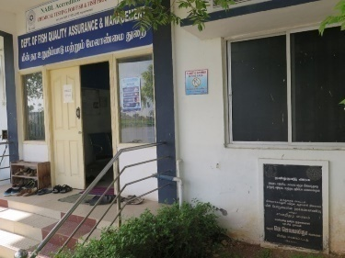 | 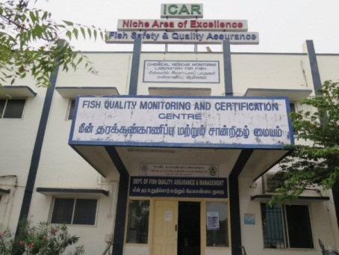 |  | 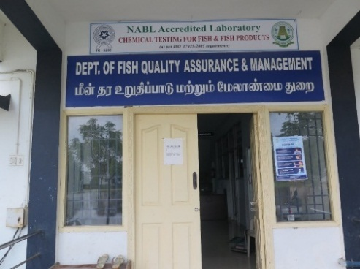
LC-MS/MS system in operation |  |  | GC-MS system in operation

(ii) Dr. M. G. R. Fisheries College & Research Institute, Ponneri
Sl.No | Name of the Activities
1 | B.F.Sc, M.F.Sc. and Ph.D. programmes are offered with an objective to produce professionally skilled manpower to cater to the needs of the Fisheries sector of the state
2 | Development and popularization of viable and appropriate fisheries / aquaculture technologies for the production and utilization of the fishery resources are undertaken through research, teaching and extension programmes
3 | Tailor made programmes to meet the need of the trainee sector which include fisher folk, women SHGs and the rural youth is undertaken to develop fisheries / aquaculture entrepreneurship

(iii) College of Fisheries Engineering, Nagapattinam
Sl.No | Name of the Activities
1. | Submitted letter to AICTE for inclusion of B.Tech.(Energy and Environmental Engineering) under UG Approved Nomenclature
2. | Efforts are under progress to include B.Tech.(Fisheries Engineering) as ICAR declined to approve the course since its not in BSMA.

(iv) Dr. M. G. R. Fisheries College & Research Institute, Thalainayeru

Sl.No | Name of the Activities
1
  Training Programme
  1 | Concepts on marketing of fish and fishery products | 01.03.2023
  2 | Feed and feeding management in murrel culture | 08.03.2023
  3 | Biofloc based Aquafarming | 20.03.2023
  4 | Disease management in seabass farming | 27.03.2023
  5 | Marine Cage culture | 31.03.2023
  Awareness Programme
  1 | Ten easy steps to start Aquaponics | 13.01.2023
  2 | Feed and feeding management in seabass culture | 30.01.2023
  3 | Seaweed farming & diversified products | 08.02.2023
  4 | Sustainable fishing practices | 08.02.2023
  5 | Ghost Fishing- - A threat to fishery resources | 24.03.2023

(v) College of Fish Nutrition and Food Technology, Madhavaram
Sl.No | Name of the Activities
1. | The template has been prepared to use and monitor progress of individual students for counseling class
2. | Prepare subject course file and upload course plan in university website
3. | Capture G-map photos in the forthcoming activities

(vi) Directorate of Incubation and Vocational Training in Aquaculture, Muttukadu, Chennai
Sl.No | Name of the Activities
1. | B.Voc. IA is being offered to produce manpower for aquaculture and allied industries.
2. | Aquafeed is produced for research, incubatees and farming communities.
3. | Wet Labs/ RAS / Biofloc facilities for research and industry projects.

(xi) DIVF, Mandapam
Sl.No | Name of the Activities
1. | B.Voc. IFT and B.Voc. IFPT have been offered to produce manpower for the marine fishing and fishing processing industries.
2. | Conducted six days of Training imparted to the fishermen

- New academic programmes initiated (UG, PG& Ph.D)

(i) Institute of Fisheries Biotechnology, Vaniyanchavadi, Chennai
Name of the Course | Initiated during the year
M.Tech. (Biotechnology) | Approval has been obtained from the University to start the program from the academic year 2022-2023

- Innovations in curricular design and transaction

(i) Fisheries College & Research Institute, Thoothukudi
Sl.No | Innovations made
 | Progress of curriculum activities is being reviewed by the Dean with all the course teachers. All course teachers were instructed to maintain a “Course File” containing course allotment letter, time table, lecture schedule, midterm and practical exam time table, question paper, mark sheets; and the student feedback forms.

(ii) Dr. M. G. R. Fisheries College & Research Institute, Ponneri
Sl.No | Innovations made
1 | Progress of curriculum activities is being reviewed by the Dean with all the course teachers. All course teachers were instructed to maintain a “Course File” containing course allotment letter, time table, lecture schedule, midterm and practical exam time table, question paper, mark sheets; and the student feedback forms.

(iii) Institute of Fisheries Postgraduate Studies, Vaniyanchavadi, Chennai
Sl.No | Innovations made
1 | New revised syllabus of M.F.Sc and Ph.D approved by BSMA-ICAR is being adopted.

(iv) TNJFU, Fisheries Business School, Vaniyanchavadi, Chennai
Sl.No | Innovations made
1 | Internship program organized for BBA and MBA students in Fisheries Industries

- Examination reforms implemented

(i) Fisheries College & Research Institute, Thoothukudi
Name of the reforms | Implemented during
Implementation of online examination instead of normal examination pattern | For the year 2020-21

(ii) Dr. M. G. R. Fisheries College & Research Institute, Ponneri
Name of the reforms | Implemented during
Examination pads for easing online examination through CSR funds | 2022-23

(iii) Institute of Fisheries Biotechnology, Vaniyanchavadi, Chennai
Name of the reforms | Implemented during
Online exams implemented | 2022-23

(iv) Institute of Fisheries Postgraduate Studies, Vaniyanchavadi, Chennai
Name of the reforms | Implemented during
Online exams implemented | 2022-23

(v) TNJFU, Fisheries Business School, Vaniyanchavadi, Chennai
Name of the reforms | Implemented during
Online exams implemented | 2022-23

- Candidates qualified: JRF/AIEEA-PG/NET/ARS

(i) Dr. M. G. R. Fisheries College & Research Institute, Ponneri
The following students qualified in AIEEA-PG examination and got admission for doing M.F.Sc in various institutions
Name of the Candidate | Qualified in
Avanthika, G. | Fish Nutrition,CIFE, Mumbai
Bharath Kumar, K. | Fish Genetics and Breeding,CIFE, Mumbai
Chandru, G. | AAHM,CIFE, Mumbai
Divya, K. | Fisheries Extension, CIFE, Mumbai
Jenisha Mol, J.G. | Fish Nutrition, CIFE, Mumbai
Sajan, D. | Biotechnology, CIFE, Mumbai
Subashini, M. | Fish Physiology, CIFE, Mumbai
Suryaprabha, V. | FRM, CIFE, Mumbai
Veera Maruthu, B. | Fish Nutrition, College of Fisheries (SKUAST), Kashmir
Rajkumar, J. | DFPT, CoF, Mangaluru
Likitha, K. | AQC,KUFOS, Kochi
Monika, R. | Fish Nutrition, KUFOS, Kochi

(ii) Institute of Fisheries Biotechnology, Vaniyanchavadi, Chennai
Name of the Candidate | Qualified in
V. Jothiswaran  N. Rohith Reddy  S. Tamil Mani | GATE  GATE  GATE

- Initiative towards faculty development programme

(i) Fisheries College & Research Institute, Thoothukudi
Sl.No | Initiative taken towards faculty development programme
 | Department of Fisheries Extension, Economics and Statistics organized a collaborative online training program with MANAGE, Hyderabad & TNJFU – FC & RI, Thoothukudi on “Fish Entrepreneurship development” from 03.01.2023 to 05.01.2023.
 | 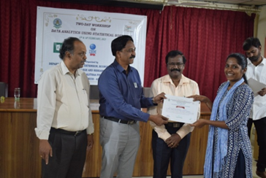
 | One day training programme on “Sulphite Residue Testing in Shrimp by Monier - Williams Method” was conducted at the Department of Fish Quality Assurance and Management, Fisheries College and Research Institute, Tamil Nadu Dr. J. Jayalalithaa Fisheries University, Thoothukudi on 05.01.2023 and 22.02.2023 based on the request from Seafood industries. Nineteen Quality Control Technologists representing various seafood industries.
 | 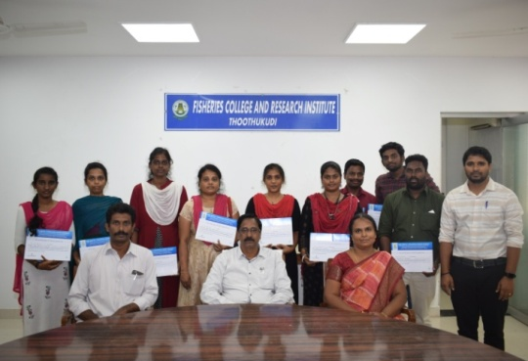 | 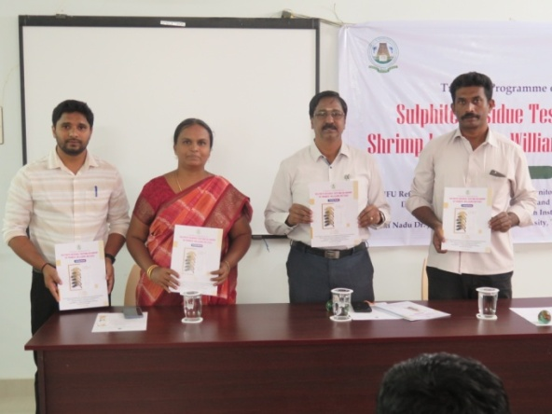
 | Department Fishing Technology and Fisheries Engineering, FC&RI, TNJFU, Thoothukudi and District Skill Development Office, Kanyakumari Jointly organized a one-week awareness programme on “Care and maintenance of fishing boat engine and safety of fishermen at sea to the fishermen of mechanized fishing vessels” of Kanyakumari district from 04.01.2023 to 11.01.2023, and 14.03.2023 to 21.03.2023, at CIVF, Thoothukudi

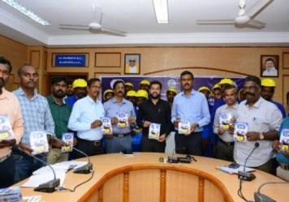 | 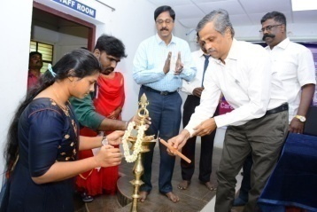
Department of Aquaculture offered one day training programme on “Integrated Fish Culture” funded by NADP on 19.01.2023 for Virudhunagar District fish farmers, on 23.01.2023 for Madurai District fish farmers, on 25.01.2023 for Tirunelveli and Tenkasi Districts fish farmers.
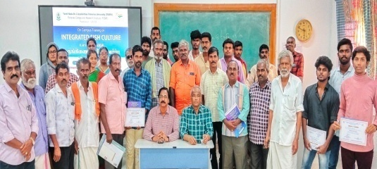

Department of Aquatic Environment Management organized one-day training programme entitled “Compost preparation using fish solid wastes" on 15.02.2023.
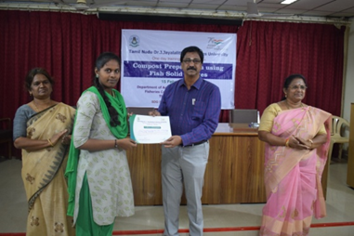

Department of Aquaculture offered one day training programme on “Breeding and seed production technology of Murrel” on 17.02.2023.
Department of Aquatic Environment Management organized one-day awareness programme entitled “Impact of plastics and microplastics on environment” on 21.03.2023 at Kulayankarisal village, Thoothukudi district
Department of Fish Processing Technology organized two days Skill Development Training Programme on “Sprouting Entrepreneurship in Marine Products” at FC&RI, Thoothukudi on 08.03.2023 and 09.03.2023. Under the funding support of Entrepreneurs Development Innovation Institute (EDII), Chennai.
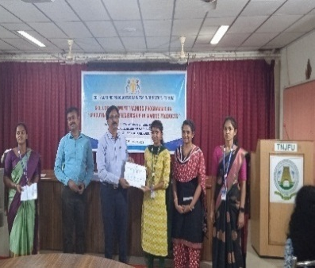

Department of Fish Processing Technology organized under the funding support of Entrepreneurs Development Innovation Institute (EDII), Chennai, the Innovation and Entrepreneurship Development Program (IEDP) – Fisheries Hub, which is being operated at Fisheries College and Research Institute, TNJFU, Thoothukudi, organized a two-day workshop on “Design Thinking” on 28.03.2023-29.03.2023.Workshop.
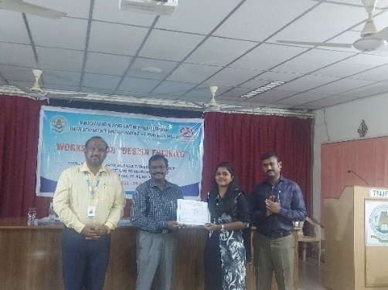
Department of Fish Processing Technology organized under the funding support of Entrepreneurs Development Innovation Institute (EDII), Chennai, the Innovation and Entrepreneurship Development Program (IEDP) – Fisheries Hub, which is being operated at Fisheries College and Research Institute, TNJFU, Thoothukudi, organized a two-day workshop on “E-leadership” on 23.03.2023-24.03.2023.
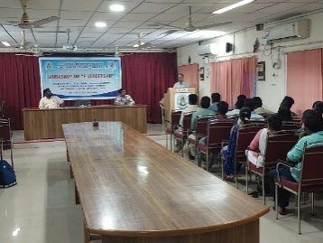
Department of Fish Processing Technology organized under the funding support of Entrepreneurs Development Innovation Institute (EDII), Chennai, the Innovation and Entrepreneurship Development Program (IEDP) – Fisheries Hub, which is being operated at Fisheries College and Research Institute, TNJFU, Thoothukudi, organized a three-day faculty development program on “Nurturing Entrepreneurship” from 15.03.2023 to 17.03.2023.
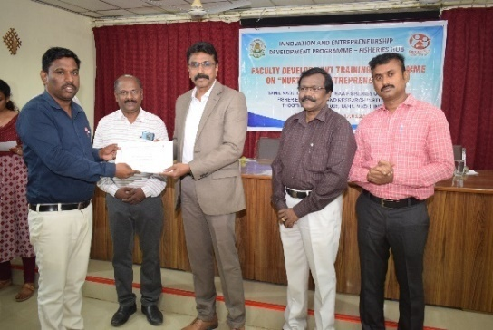 | 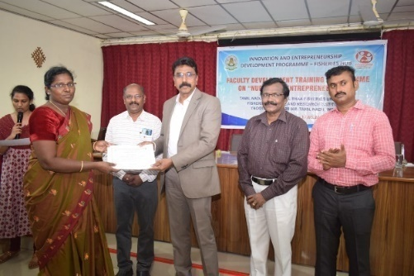
The event of launching seaweed based cosmetics products produced at EDII-MPBIF, DFPT, FCRI, Thoothukudi under the title of "Grand Launch of Seaweed Based Cosmetics" by M/s. Herblis Health Care, Madurai who is an incubatee of EDII-MPBIF, DFPT, FCRI, Thoothukudi was organized at Hotel Rathna Residency, Madurai on 10.03.2023.
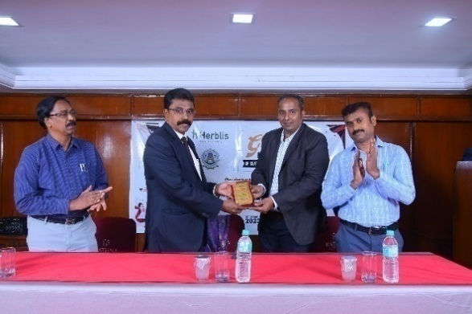 | 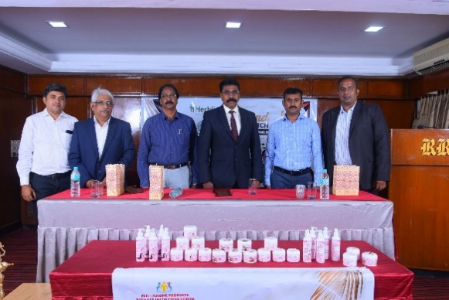

(ii) Dr. M.G.R. Fisheries College & Research Institute, Ponneri
Sl.No | Initiative taken towards faculty development programme
1 | Dr.A.Uma, Professor and Head DAAHM, and Mrs. S. Agnes Daney Angela Assistant Professor DFEES attended one day training on Geo-tagging of assets created under NADP schemes at TAWDEVA, Chennai on 09.03.2023
2 | Mrs.S.Aruna, Assistant Professor and Head in charge DAEM and Mr.K.Karuppasamy, Assistant Professor, DFRM participated a five day of training on PRIMER V7 and PERMANOVA organized by the PRIMER-e & Cochin University of Science and Technology,Kochi, Kerala from 20.03.23 to 24-03-2023.
3 | Dr. S. Selvaraj, Assistant Professor of DAQ participated in a five-day workshop on “FDA Good Aquaculture Practices” (GAP) from 09.01.2023 to 13.01.2023
4 | Dr. N. Muralidharan Assistant Professor, DFPT participated in 21 days Winter school on “Antimicrobial Resistance in Food Fish: challenges and Mitigation” from 09.01.2023 to 29.01.2023

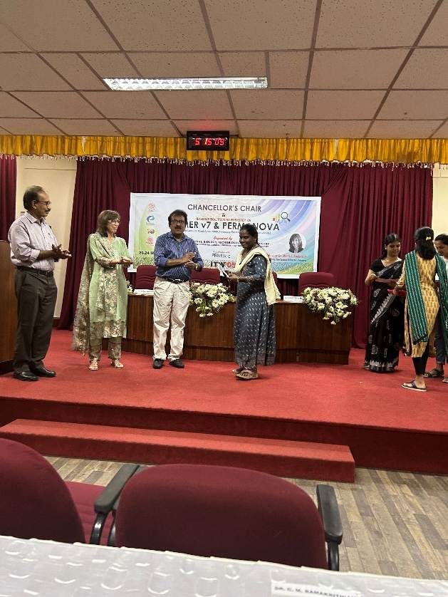  PRIMER V7 and PERMANOVA | 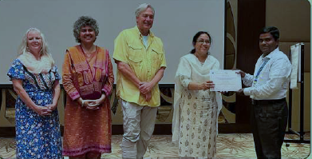  “FDA Good Aquaculture Practices”
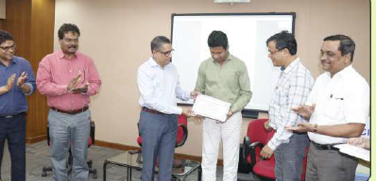

Antimicrobial Resistance in Food Fish: Challenges & Mitigation

(iii) Dr. M.G.R. Fisheries College & Research Institute, Thalainayeru
Sl.No | Initiative taken towards faculty development programme
1. | The Project Quality Assurance Cell of the IQAC of the institute organized an online talk on “Research Funding opportunities from Nationalized Banks” on 07.03.2023 between 3.00-4.15 pm. Dr. P Selvaraj, Chief General Manager (Retd.), NABARD and alumnus of FC&RI, Thoothukudi served as the resource person and detailed on the research funding opportunities from the NABARD. A total of 15 teaching staff and 42 students participated in the programme.

(iv) TNJFU, Fisheries Business School, Vaniyanchavadi, Chennai
Sl.No | Initiative taken towards faculty development programme
1. | Dr.S.Karunakaran ., Assistant Professor (C) Attended  EDII faculty Development Program conducted by FC &RI, Thoothukudi  From 15th to 17th march 23
2. | Dr.M.Ganeshkumar., Assistant Professor (C) Attended  EDII faculty Development Program conducted by FC &RI, Thoothukudi  From 15th to 17th march 23 .

(v) Directorate of Incubation and Vocational Training in Aquaculture, Muttukadu, Chennai
Sl.No | Initiative taken towards faculty development programme
1. | The faculty development through sending the faculty for attending CAFT programs will be encouraged.
2. | Faculty will be sent to CAFT programs after March 2023.

- Total number of seminars/workshops/conferences conducted

(i) Fisheries College & Research Institute, Thoothukudi
Sl. No. | Name of the Seminars/Workshops/conference | Date
 | National webinar on Taxonomy: An approach for exploring aquatic biodiversity (in commemoration of the World Taxonomist Appreciation Day) | 20.03.2023
 | Faculty development program on “Nurturing Entrepreneurship” – Dept. of Fish Processing and Technology | 15.03.23 to 17.03.23
 | Workshop on “E – Leadership – Dept. of Fish Processing and Technology | 23.03.23 and 24.03.23
 | Workshop on “Design Thinking – Dept. of Fish Processing and Technology | 28.03.23 and 29.03.23
 | Collaborative Training on “Fish entrepreneurship development” with MANAGE, Hyderabad | 03.01.2023 to 05.01.2023.
 | Workshop on “Development of Soft Skills for Entrepreneurship among Agri Graduates” | 05.02.2023
 | Workshop on “Data Analytics using Statistical Software | 15.02.23 and 16.02.23
 | Awareness programme on “Nurturing Entrepreneurship” | 15.03.23 and 16.03.23

(ii) Dr. M. G. R. Fisheries College & Research Institute, Ponneri
Name of the Seminars/Workshops/conference | Date
One day workshop on “Patenting system in India” was organized by IQAC for all staff members | 24.03.2023

(iii) College of Fisheries Engineering, Nagapattinam
Name of the Seminars/Workshops/conference | Date
Training on Fresh Water Fish Culture, Vadagudi village, Nagapattinam | 02.01.2023
Brainstorming on improvement of pass percentage and facilitation to arrear students in CoFE | 14.02.2023
Training on Fresh Water Fish Culture, Panangudi village, Nagapattinam | 10.02.2023
One-day technical training programme on Seabass culture and disease management | 27.03.2023
One day awareness training on “Use of fish processing equipment for fresh water fish processing | 29.03.2023
One day skill development training program entitled Seafood's value addition and its marketing strategies on 30.03.2023 | 30.03.2023
NSS Special Camp was conducted for 2019-20 batch B.Tech.(Energy and Environmental Engineering) students | 27.03.2023 to 02.04.2023

(iv) Institute of Fisheries Postgraduate Studies, Vaniyanchavadi, Chennai
Name of the Seminars/Workshops/conference | Date
Workshop on “Sustainable Seaweed Farming in Tamil Nadu – Way Forward” | 20.01.2023

(v) TNJFU, Fisheries Business School, Vaniyanchavadi, Chennai
Name of the Seminars/Workshops/conference | Date
Webinar on customer journey mapping and Business model | 07.03.2023
A workshop on gender in aquaculture | 09.03.2023
Students development webinar on Digital Marketing and How to ace Interview | 14.03.2023
Webinar on emerging management quality for 3D leadership and an Investor Awareness program | 18.03.2023
Prospects And Challenges Of Union Budget-2023 | 10.02.2023
Role Of Digital Technology And E-Marketing And Business Development And Its Sustainability | 22.02.2023
Students Networking | 06.03.2023
Investor Awarness Programme | 18.03.2023

(vi) College of Fish Nutrition and Food Technology, Madhavaram
Name of the Seminars/Workshops/conference | Date
Organised a program on the topic “Road Safety Awareness and Traffic Rules”. The Chief Guest of this event was Mr. N.M. Mayilvahanan, IPS, Joint Commissioner of Traffic Police, Greater Chennai. | 28.01.2023
Organised a seminar on the topic “Role of Food Science and Technology in Humanitarian Response”. The speaker of the session was Dr. Jayashree Arcot, Associate Professor (Food and Health),Food Science and Nutrition, School of Chemical Engineering,University of New South Wales Sydney, Australia. | 31.01.2023
Organised a program on FOSTAC Training (Food Safety Supervisor Training in Advance Manufacturing-General & COVID) for final year students (2019-2020 Batch). The training was conducted by Mrs. Shyla Ravi | 28.02.2023
Financial Awareness And Consumer Training (FACT)program organized by National Center for Financial Education (NCFE) with 69 students from 1st (2022-23 batch) and 2nd (2021-22 batch) year of B. Tech. Food Technology. | 02.03.2023
Training Program – I  NADP Skill training was conducted as a part of NADP scheme on Value Addition of Seafood Products. Women members from Ennore Fishermen community (24)participated in the skill training. | 08.03.2023
Training Program – II  NADP Skill training was organized training on Entrepreneurship Development of Seafood Products. Women candidates from the Ennore Fisherman Community (24) participated in the skill training. | 29.03.2023

(vii) Directorate of Incubation and Vocational Training in Aquaculture, Muttukadu, Chennai
Name of the Seminars/Workshops/conference | Date
Awareness of cost-efficient feed development and farming practices of Asian Seabass | 31.01.2023
On field demonstration of developed feed for Asian Seabass farming in Brackishwaters of Kundrukadu, Chengalpattu | 08.03.2023
On field demonstration of developed feed for Asian Seabass farming in Freshwater ponds | 17.03.2023
Awareness program on seabass farming in different cultural systems. | 30.03.2023

- Research projects a) Ongoing b) completed

(i) Fisheries College & Research Institute, Thoothukudi
a) Ongoing Research projects
Sl. No. | Name of the faculty | Title of the project |  |  | Funding Agency |  |  |  | Budget of the project |  | Salient Research findings
1 | Dr. R. Shalini | Self financing scheme on “Quality analysis of fish samples” |  |  | Revolving fund |  |  |  | Self - Financing |  | No. of samples analyzed: 53  Income 64,015/-
2 | Mr.Manickavasagam | Assessing seasonal variations of plankton biomass and diversity in Thoothukudi coastal waters |  |  | DAEM –  FC & RI,  Thoothukudi |  |  |  | Rs.20,000/- (University Research Project |  | - Noctilucascintillans bloom was observed  - Presented Oral Presentation on 01.02.2023 at ICRAAS’23 conference
3 | Dr. N. Jayakumar, Associate Professor & Head | Assessment of spawning seasonality of Major marine fishery groups along the coast of Tamil Nadu for sustainable fishery management |  |  | Tamil Nadu Innovation initiatives (TANII) |  |  |  | 146.80 |  | - Detailed below
- Specimens of major marine fish groups and catch data were collected from the major fishing harbours situated along the coast of Tamil Nadu periodically.
- Morphometric measurements like total length / fork length and total weight were taken for all the specimens collected.
- Fish specimens collected were dissected and number of males and females were recorded for each species based on the presence of testis and ovary for the determination of sex ratio,
- Reproductive biological characteristics like gonad length, gonad weight, maturity stages, feeding intensity, gut weight, weight of the gut contents and liver weight were recorded for each species. The female gonads (ovaries) were preserved in Gilson’s fluid and number of eggs was counted to estimate the fecundity.
- Ova diameter were measured using ocular micrometer for ascertaining intra-ovarian periodicity
- Plankton sampling was done for the collection of eggs and larvae of fishes.
- All the field data and data collected in the laboratory were entered in the data register and excel database.
- Purchased two units of trinocular microscope at a cost of Rs. 7,31,600/- through GeM portal.
- Placed supply order through GeM for two units of Automatic Tissue Processor at a cost of Rs. 5,40,000/- and two units of Tissue Embedder at a cost of Rs. 7,89,000/-These equipment are expected to be delivered shortly.
- Entered in to bidding for the purchase of three units of PCR through GeM
4 | Mr. C. Sudhan  Principal Investigator | Digital solutions for sea turtle conservation in south Tamil Nadu |  |  | TNJFU-JTRF Scheme (2021-22) |  |  |  | 1.70 |  | - Detailed below
- Developed one blog for the turtle species identification, conservation and management along Gulf of Mannar coast
- Launched test drive for the developed blog in open-source cloud for copyrights, similarity and plagiarism updates
5 | Dr.B.Chrisolite - PI  Dr.P.Sivasankar – Co-PI |  | National Surveillance programme for Aquatic Animal Diseases –Phase II |  |  | PMMSY through ICAR-NBFGR |  |  | 52.20 |  | - Detailed below
- Shrimp samples were collected from Thoothukudi, Ramanathapuram, Pudukkottai, Thanjavur and Nagapattinam, district shrimp farms. During this period, 94 samples were collected from 51 farms. DOC of the samples ranged between Pl 08 to DOC 120.
- WSSV Analysis: Ninety four shrimp samples (P. vannamei) were analyzed for the presence of WSSV by PCR. Four samples were positive for WSSV.
- EHP Analysis: The shrimp samples (94 samples) were tested for the presence of EHP by PCR. Forty two samples were positive.
- All the samples were analyzed for the presence IHHNV, MBV and BP. The analysis gave negative result.
- All the samples were analyzed for Decapod iridescent virus (DIV1) by PCR. The analysis gave negative result for DIV1.
- All the samples were analyzed for the presence of IMNV, TSV, and YHV. The analysis gave negative result.
- AHPND Analysis: One hundred and sixty four bacterial isolates isolated from TCBS plates were analysed for the presence of AHPND by PCR. The isolates gave negative result for AHPND.
- Fish Analysis: Sea bass fish samples collected from Ramanathapuram district were analysed for Iridovirus and Photo bacteriumdamselae by PCR technique. The analysis gave negative result.
- Tilapia, Catla, Rohu, Bahu, and Garrafish samples were collected from Madurai, Tirunelveli, Thoothukudi, Thiruvarur, Tenkasi and Thanjavur district were analyzed for the presence of Tilapia lake virus. The analysis gave negative result.
- Snake head fish samples collected from Thanjavur district were analyzed for the presence of Rhabdovirus. The analysis gave positive result for Rhabdo virus.
- Tilapia, Catla, Bahu, Snake head fish samples collected from Thanjavur, Madurai and Thiruvarur districts were analyzed for the presence of Rhabdo virus. The analysis gave negative result.
- Tilapia and Snake head fish samples collected from Madurai and Erode district were analysed for the presence of viral pathogen. The analysis gave negative result.
- Inter laboratory comparison analysis: Three samples were received from NBFGR, Lucknow for inter laboratory comparison analysis. WSSV, Aphanomycesinvadans and Enterocytozoonhepatopenaei were analysed by PCR technique and the result were submitted to NBFGR.
- Principal Investigator and Co-investigator attended the Launch Workshop and Review Meeting of NSPAAD-Phase II in Chennai.
- QUAAD and Quarterly report was regularly sent to ICAR –NBFGR
6 | Dr. P. Ganesan  (as PI) | Establishment of Marine Products business incubation forum |  |  | EDII, Chennai |  |  |  | 250 lakhs |  | Detailed below
EDII-MPBIF related activities
- 2 Incubatees enrolled under EDII-MPBIF, DFPT, FCRI, Thoothukudi
- One no. of IVP submitted on topic, Seaweed cosmetic products
- Renewed FSSAI licensing
- Visited Britto Exports, Thoothukudi, and introduced seaweed-incorporated fish sausage to them prepared at EDII-MPBIF, DFPT, FCRI, Thoothukudi
- A grant of Rs. 10000 was arranged (08.02.2023) through the M/s. FLTF Food Products, an incubatee of EDII-MPBIF, DFPT, FCRI and given to Ms. Priya, B.F.Sc. final year student to support her curriculum activities.
- Govt. Hr.Sec. school students and staff from Sorispuram, Thoothukudi has visited EDII-MPBIF, DFPT, FCRI on 28.02.2023
- Submitted details on activities undertaken through MoU signed under the project of EDII - MPBIF, DFPT, FCRI, Thoothukudi.
7 | Dr. P. Ganesan  Hub Co-ordinator | Innovation and Entrepreneurship Development Programme (IEDP) |  |  | EDII, Chennai |  |  | Till now received  Rs.2,00,500  and spent Rs. 1,97,822 for the conduct of various programs under the project. Further, the upcoming fund will be received then and there during the conduct of the programs. |  |  |  | Detailed below
IEDP – Hub related activities
- Interview called for the post of field coordinator under the project of IEDP- Fisheries Hub.
- Attended online IEDP hub meeting on 13th & 17th February 2023 as the Hub coordinator.
- Submitted TNSI award intimation details for students under the IEDP hub project to the Dean, FCRI, Thoothukudi
- Inauguration of IEDP – Fisheries Hub cum Top Management Meet and Awareness on Innovation Voucher Programme conducted on 09.11.2022 are benefited 150 persons.
- Faculty development program conducted from 15.03.2023 to 17.03.2023 are benefited 40 persons.
- E- Leadership program conducted on 23.03.2023 and 24.03.2023 are benefited 48 persons.
- Design thinking workshop programme conducted on 28.03.2023 and 29.03.2023 are benefited 50 persons.
8 | Mr.S.Mariappan |  |  | Improvement of catch efficiency of wire mesh fish traps for reef fishery of Thereshpuram fishing village of Thoothukudi District |  |  | DFT&FE  FC & RI,  Thoothukudi |  |  | Rs.1.10 lakhs /- (TNJFU-JTRF) |  |  | Detailed below
- Information on the catch including the type of fish caught, the length and weight of the fish captured in the trap, and the prices of the fish caught from existing fish trap were collected fortnightly for the month of January, February and March 2023.
- Two experimental fishing trail per month was carried out in the selected fishing grounds of Therespuram fishing village
- Information on the catch including the type of fish caught, the length and weight of the fish captured in the trap, and the prices of the fish caught from experimental fish trap were collected.

- Completed Research projects
Sl. No | Name of the faculty | Title of the project | Funding Agency | Budget of the project | Salient Research findings
1 | Dr.V.Rani | Production of Eicosapentaenoic acid (EPA) from marine Diatom Phaeodactylumtricornutum isolated from coastal waters of Gulf of Mannar (S.C. No:EEQ/2019/000760) | DST – SERB, Govt. of India, New Delhi | 41.85 lakhs | - The marine diatom P. tricornutumisolated for the first time in Indian coastal waters  - The maximum EPA (20:5:ω3) of 32.68% was obtained and the level of fatty acid present is comparable with the reports from this diatom in other countries
2 | Mr. T. Ravikumar | Study on the effect of hook size and baits on the catching efficiency of longline operated along Thoothukudi coast | -- | -- | - Data compilation and final report preparation  - Final report submitted

(ii) Dr. M. G. R. Fisheries College & Research Institute, Ponneri
- Ongoing Research projects
Sl.No | Name of the faculty | Title of the project | Funding Agency | Budget of the project | Salient Research findings
1. | Dr. R. Jeya Shakila | “Climate changes and their role emergence of antibiotic résistance Salmonella in Farmed shrimp and its environment” | NICRA | 34.75 lakh | The present project is aimed with a hypothesis that indiscriminate uses of antibiotics in shrimp farms develop multi drug resistance in bacterial pathogen, Salmonella due to climate stressers. The project focuses to study the influence of climate stressers on the distribution and incidence of antibiotic resistance, salmonella servers, to investigate the stress genes in isolated the serovars, to conduct denova evaluation of antibiotic resistance and to suggest mitigation measures to control evaluation of antibiotic resistance in salmonella spp of shrimp farms.
2. | A.Uma | Integrated disease surveillance monitoring system and Seed quality assessment to augment aquaculture production in Tamil Nadu at SRLAAH,TNJFU-Madhavaram campus | NADP- GOI | 101.8 lakhs | Atraining programme on “Methods for the selection for quality seeds of Fish and Shrimp Farming” was conducted for the staff of TN state fisheries department in the “Train the trainers” mode. A total of eight officials in the cadre ofSub Inspector and Inspector of Fisheries and Fishermen Welfare attended and got benefited
3. | Mrs. S.Aruna | Artificial Coral Reef / Live Rock (ACR / LR) and Fish Aggregating Artificial Reef (FAAR) to Enhance Fish Diversity and Biomass in the Sea Near Pulicat Lake Towards Fishing Pressure Reduction and Livelihood Improvement of Fisherfolk in the Lake Region | TN state planning commission -TANII | 430.66 Lakhs | Phytoplankton and zooplankton diversity were assessed. Scuba diving investigations have also been conducted alongside to evaluate the benthos and fishery status. Monthly fish landing data are gathered to monitor the fish diversity in the local fishing village
4. | Mrs.S. Agnes Daney Angela | Establishment of Digital Blue- E-extension Hub in aquaculture and Fisheries sector | NADP- GOI | 106.00 Lakhs | Success stories of two ACADP trainees were video documented and published
5. | Dr.Manikandavelu | Study on the assessment of fishery resources and its productivity to assess the ecosystem services in the critical ecosystems along East coast of India | NCCR | 31.61 Lakhs | Sampling was conducted in Gulf of Mannar and Pulicat Lake
6. | Mrs.S. Agnes Daney Angela | Socio-economic and environmental Impact study of shrimp farms and hatcheries in selected districts of Tamil Nadu (PI - Mrs. Angela) | TNJFU Research Corpus Fund | 14.98 | Consolidation of Information given by the key informants on socio-economic impact.  Regular sampling in Chengalpattu and Villupuram. As stocking has not been started in Nagapattinam and Mayiladuthurai.
7. | Mr. K. Karuppasamy | A study of Ichthyofaunal diversity along the Chennai Coast of Bay of Bengal Region | University Research Project-TNFU | - | Totally 245 finfish species were reported including 45 elasmobranchs along Chennai coast of Bay of Bengal.
8. | Mrs. B.R. Sona | Seasonal variation and diversity assessment of macrobenthos in Pulicat lagoon | URP-TNJFU | - | Water, sediments and macrobenthos samples were collected from ten sample sites.  12 species of macrobenthos (10 gastropods and 2 bivalve species) have been identified.
9. | Dr. N. Mahadevi | Cost effective captive breeding technology for Channa striata (Striped Murrel) for field level adoption | Tamil Nadu State Land Use Research Board, SDPC | 15.18 | Created facility for brood stock rearing and breeding of striped murrel.  Brood stock rearing is in progress.  Collection of pituitary gland form Murrel and Tilapia for induced breeding trial is in progress.

- Completed Research projects

Sl.No | Name of the faculty | Title of the project | Funding Agency | Budget of the project | Salient Research findings
1. | Dr. Cheryl Antony | Evaluation of the effect of protein hydrolysates on the growth and immune response in Penaeus vannamei | Kemin, Chennai | Rs. 7.55 lakhs | The feeding trial has been completed and challenge study is completed. Data analysis and report prepared and report has been sent to the funding agency.

(iii) College of Fisheries Engineering, Nagapattinam
- Ongoing Research projects
Sl.No | Name of the faculty | Title of the project | Funding Agency | Budget of the project | Salient Research findings
1. | Dr.M.Ramar  Assistant Professor | Design and development of Nano generator from crustacean shell waste | TNJFU JTRF | 2.0 | - The output performance was checked for piezoelectrci tile  - Analysis of output performance of piezoelectrci tile
2. | Dr.M.Kamalakannan  Assistant Professor | Design and development of IOT based smart Fish grading system with a financial | TNJFU JTRF | 2.0 | - designed Grading mechanism in the coveryor system  - estimation received for upgrading

(iv) Dr. M. G. R. Fisheries College & Research Institute, Thalainayeru
- Ongoing Research projects
Sl.No | Name of the faculty | Title of the project | Funding Agency | Budget of the project | Salient Research findings
 | Mr. S. SanthoshKumar and Dr. A. Subburaj (Co-PI) | Assessment of spawning seasonality of major Marine Fishery groups along the coast of Tamil Nadu for sustainable Fishery Management | TANII | Rs. 146.80 lakh | - Conducted fish samplings from Nagapattinam and Cuddalore region  - Assessed the biological parameters such as total length, fork length, total weight, sex, maturity stages, gonad and gut weight, gut condition of collected fishes  - Steps taken to purchase the automated tissue processor, automated tissue embedder, microtome and deep freezers
University Funded Projects
 | Mrs. S.J. Abisha Juliet Mary  Assistant Professor | Spatial Distribution of β-Lactam Resistance genes among Vibrio spp. Isolated from Shrimp farms of Vedaranyam | TNJFU – JTRF | 2 lakhs | On Maternity leave. Submitted the request to the university for an extension of the project.  An interim report was submitted to the university
 | Mrs. M. Muthu Abishag  Assistant Professor | Studies on the low temperature preservation of microalgae (Navicula sp.) isolated from shrimp farms | TNJFU –URP | 0.45 lakhs | The pure culture of Navicula sp. can be obtained by serial dilution and incubation in f/2 Guillard media at 27-28℃ at 100 lux for about 15-20 days.  Among the different low temperatures preserved, Navicula sp. cryopreservedat -196 ℃ using 5% DMSO as cryoprotectant following 2 step freezing protocol exhibited good growth characteristics.  Final report was submitted on January, 2023
 | Dr. S. Deepika  Assistant Professor | Study on the impact of shrimp farms and anthropogenic activities on the water quality of the selected locations along Vedaranyam canal | TNJFU –URP | 0.5. Lakhs | On Maternity leave. Final report preparation is in progress
 | Mr. P. Yuvarajan  Assistant Professor | Water hyacinth leaf meal in the diet of genetically improved farmed tilapia | TNJFU –URP | 0.46 Lakhs | - A 60-day feeding trial was conducted for the replacement of deoiled rice bran bysolid state fermented water hyacinth leaf meal with the graded level of 0% (Control),33% (Treatment 1), 66%(Treatment 2) and 100% (Treatment 3).  - Better growth performance was observed in the treatment 3 compared to controland other treatments. Hence, SSF-WHLM can completely replace the DORB in thediet of genetically improved farmed tilapia.  - Final report was submitted on January, 2023
 | Mr. S. Kesavan | Assessment of molluscan diversity and debris abundance in Point Calimere wetland | TNJFU –URP | 0.10 Lakhs | Molluscan species collection & debris survey in Adirai beach, near mannaram islands and Muthupet mangrove region. Data entry and analysis
 | Dr.J.Jaculine Pereira | Effect mealworm for the replacement of fish meal on the growth of GIF Tilapia | Mini  research | - | Feeding trial completed

- Completed Research projects
Sl.No | Name of the faculty | Title of the project | Funding Agency | Budget of the project | Salient Research findings
 | Dr. V. Alamelu  Asst. Professor | Emergence of V.vulnificus risk in seafood safety in response to climatic changes (SC.NO.22 – 101– 01) | DST – SERB, New Delhi | 39.67 Lakhs | - Isolated and studied the important virulent biomarkers of V. vulnificus from the seawater and various seafood harvested during different seasons in Tamil Nadu coast  - Studied the effect of environmental parameters on the expression of virulence genes of V.vulnificus  - Studied the antibiotic susceptibility of the V. vulnificus isolates  - Antibiotic susceptibility of the 184 selected isolates was evaluated against the selected antibiotics using the disc diffusion method.  - Escherichia coli ATCC 25922 was employed as a bacterial strain for quality control. Antibiotic resistance profiles of V. vulnificus isolates were studied for antimicrobial susceptibility testing.  - Virulent gene expression studies were carried out.
University Funded Projects
 | Mrs.S.Vimaladevi,  Assistant Professor | Development and standardization of health drink from Bio-modulated chitosan | TNJFU – JTRF | 2 lakhs | - Water-soluble chitosan (WSC) based products were formulated and the products were found to decrease fat accumulation in adipocytes.  - WSC based products were found to be safe for consumption and the developed products can be used as anti-obesity food products.
 | Mr. V. Vijayarahavan, Assistant Professor | Formulation of Ulva based jam products | TNJFU -  URP | 0.30 lakhs | - Developed Ulva Jam and assessed its nutritional properties.  - The Shelf life of the seaweed Jam was found to be 6 months.
 | Mrs. S.J. Abisha Juliet Mary  Assistant Professor | Isolation and characterization of  antimicrobial resistant gut microflora associated with farmed shrimps in Nagapattinam region | TNJFU –URP | 0.6 lakhs | - Shrimp samples were collected from the selected 12 sites.  - A total of 92 bacterial isolates were isolated and characterised  - In the 92 G-ve isolates, 32(39.5%) were identified as Vibrio parahemolyticus, 31(20.8%) were identified as Aeromonas hydrophila and 29(18.2%) were identified as E. coli.  - AST was done for 13 Aeromonas hydrophila isolates and 15 E. coli isolates.  - Shrimp samples were collected from the selected 12 sites and isolation of bacteria was done.  - Biochemical characterization was done for each isolate.
 | Mr. V. Durai  Assistant Professor | Investigation on the catching efficiency of Monofilament And Multifilament Gillnets being operated selected fishing villages of Nagapattinam District | TNJFU –URP | 0.3 lakhs | - 12 months work has completed regarding data collection, CPUE  - Calculation estimation was done works is in progress for two-way ANOVA tool  - Catching efficiency of multifilament was better than monofilament.
Institutional development Project:
 | Mrs.S.Vimaladevi,  Assistant Professor  (Co-PI)  Mr. V. Vijayarahavan  Asst. Professor (Project in charge from May, 2022 onwards) | TNJFU’s Business Incubators in Aquaculture and Fish Processing to promote start-ups integrated Fisheries Entrepreneurship in Tamil Nadu State | NADP | 72 lakhs | - Conducted training programmes for fishing communities on value added fish products.  - Incubation center for fish products was established

(v) Directorate of Incubation and Vocational Training in Aquaculture, Muttukadu, Chennai
- Ongoing Research projects
Sl.No | Name of the faculty | Title of the project | Funding Agency | Budget of the project | Salient Research findings
1. | Dr. Mir Ishfaq Nazir | Development of cost-efficient feeds and farming practices of Asian Seabass for fish farmers of Tamil Nadu at Directorate of Incubation and Vocational Training in Aquaculture, TNJFU, Muttukadu | NADP-RKVY | 80.00 lakh | - Asian seabass feed was developed and was validated with trials in RAS, hapa cages and ponds.  - Analysis is going on.  - Equipments were purchased and installed.  - Four training programs and demonstrations were carried out.
2. | Dr. Mir Ishfaq Nazir | Nutrigenomic studies on feed development for larvae of striped Murrel (Channa striata) | DBT, India | 50.38 lakh | - Initiated recruitment of manpower.
 | Dr. Mir Ishfaq Nazir | TNJFU’s Business Incubators in Aquaculture and Fish processing Technology to promote Start – Ups Integrated Fisheries Entrepreneurship in Tamil Nadu State | NADP RKVY 2020-21 | 300 lakh | - Established 4 incubation centres in sub-centres of TNJFU.  - Purchased and installed RT-PCR.
 | Dr. Mir Ishfaq Nazir | Tamil Nadu Irrigated Agriculture Modernization Project (TN IAMP)” – Component III | World Bank | 9 lakh | - Feeding trial at Barur centre was completed.  - Sampling carried out for hemato-biochemical analysis.  - Analysis is going.  - All the STEP procurement packages were completed.

(vi) Institute of Fisheries Post Graduate Studies, Vaniyanchavadi, Chennai
- Ongoing Research projects
Sl.No | Name of the faculty |  | Title of the project |  | Funding Agency | Budget of the project |  |  | Salient Research findings
1 | Dr. Deepak Agarwal | Deciphering genomic insights associated with adaptation in Etroplussuratensis (Pearl spot) for climate resilient aquaculture |  | ICAR-NICRA |  |  | Rs. 33.5 Lakh | LC50 for salinity was determined (45.394 ppt).  LT50/CTmax value is standardized using Thermostat (34ºC ).
2. | Dr. V. Kaliyamurthi | Understanding the mechanism of resveratrol and IL-17 knockdown on macrophage via NFκB signaling pathway under  Metabolic stress conditions |  | DST SERB - CRG |  |  | Rs. 45 Lakhs | Newly Sanctioned Project
3. | Dr. Ambika Binesh | Investigation on molecular crosstalk of inflammatory hub NFκB and NICD using zebrafish model |  | DST SERB - SRG |  |  | Rs. 31.10 Lakhs | The inflammatory macrophage accumulation and differentiation in zebrafish larvae fed with a high cholesterol diet was studied.  * The expression of NFκB and Notch pathway proteins was elucidated.

- New collaboration research programmes

(i) Institute of Fisheries Post Graduate Studies, Vaniyanchavadi, Chennai
Sl.No. | Name of the programme | Collaborated with | Date
2. | Research Work collaboration for Zebra fish toxicology | Chettinad University | 03.03.2023
3. | Research work collaboration for nanoparticles characteization | SRM University | 03.01.2023

- Research grants received from various agencies

(i) Dr. M. G. R. Fisheries College & Research Institute, Ponneri
Sl.No. | Name of the Research Grant | Year | Agency Name | Amount (Rs.)
1. | ICAR- NICRA  (Transferred from FCRI Thoothukudi) | 2022-23 | CRIDA, Hyderabad | 7,89,963
2. | Student Project Proposal | 2022-23 | TN State Govt. | 7,500

(ii) College of Fisheries Engineering, Nagapattinam
Sl.No. | Name of the Research Grant | Year | Agency Name | Amount (Rs.)
1. | Development of edible package technology for fish soup for economic empowerment of Vadagudi and Manjakollai villagers | 2023 | UBA | 1.0 lakh
2. | Solar infrared hybrid dryer for hygienic production of dry fish | 2023 | UBA | 1.0 lakh
3. | Design and fabrication of fish vending trolley for empowerment fish peripatetic vendor women in Akkaraipettai village | 2023 | UBA | 1.0 lakh

(iii) Institute of Fisheries Post Graduate Studies, Vaniyanchavadi, Chennai
Sl.No. | Name of the Research Grant | Year | Agency Name | Amount (Rs.)
1. | NICRA | 2020-21 | ICAR | Rs. 33.5 Lakh
2. | SERB - CRG | 2020-21 | DST | Rs. 45 Lakhs
3. | SERB - SRG | 2022-23 | DST | Rs. 31.10 Lakhs

- Details of research scholars
(i) Fisheries College & Research Institute, Thoothukudi
Sl. No. | Name of the Research Scholar and ID.No. of the scholar | Batch |  | Degree | Title of Research |  | Research findings and status
1 | Chavadi Harini, U-17-TN-03-002-D-F-002 | 2015-16 |  | Ph.D | Studies on the maturation and spermatology of Penaeussemisulcatus brooders developed in captivity and cryopreservation of spermatophore |  | On-going
2 | Padala Dharmakar, U-18-TN-03-002-D-F-003 | 2018-19 |  | Ph.D | Assessment of solid-state fermented meals of cottonseed, sunflower seed and dried brewery waste on the growth and survival of Rohu(Labeorohita) in nursery phase. |  | On-going
3 | Pankaj Gargotra, I-18-TN-03-002-M-F-010 | 2018-19 |  | Ph.D | Role of selected vitamins and minerals on the maturation and induced spawning of Lepidocephalichthysthermalis (Valenciennes, 1846) |  | Completed
4 | Raswin Geoffery, U-20-TN-03-002-D-F-001 | 2020-21 |  | Ph.D | Nutritional evaluation of black soldier fly larvae (Hermetiaillucens) and water hyacinth (Eichhorniacrassipes) as a replacement of fish meal in the diets of GIFT Tilapia |  | On-going
5 | Ms.S.Subhashree Devasena  (U-18-TN-03-002-M-F-009) | 2018-19 |  | Ph.D | Efficiency assessment of bio-adsorbents prepared from fish scales in the treatment of municipal and seafood processing plant wastewater in Thoothukudi district |  | On-going
6 | P.Ramesh  U-21-TN-03-002-D-F-002 | 2021-22 | Ph.D |  | Assessment of mangrove species diversity, distribution and cover estimation in Thoothukudi district, Tamilnadu |  | On-going
7 | P. Subash  U-18-TN-03-003-M-F-005 | 2020-21 | Ph.D |  | Etiological analysis of white feces syndrome in Penaeusvannamei and its mitigation measures using phytogenic compounds |  | On-going
8 | D. Evangelin Paripoorana  U-18-TN-03-003-M-F-005 | 2021-22 | Ph.D |  | Immune responses of freshwater fishes immunized with inactivated viral vaccines against Tilapia lake virus (TiLV) |  | On-going
9 | Sumit Kumar Verma I-18-TN-03-002-D-F-012 | 2018-19 | Ph.D. |  | Microwave processing for drying, blanching and thawing of shrimp (Metapenaeusd obsonii): Evaluation and quality characterization |  |  | On-going
10 | Sravani, K  U-20-TN-03-002-D-F-006 | 2020-21 | Ph.D |  | Formulation of seaweed based edible table were and assessment of its physico-chemical, mechanical, bioactive properties and storage stability |  |  | On-going
11 | Deepika.B  U-19-AP-03-006-M-F-001 | 2021-22 | Ph.D |  | Extraction of bioactive compounds from seaweeds using green technologies and assessment of quality characteristics of seaweed fortified cosmeceutical and confectionery products |  |  | On-going
12 | Mr. R. Durairaja - Ph.D  (Part Time)  U-18-TN-03-D-F-006 (FRM) | (2018 - 19) | Ph.D. |  | Distribution, diversity and stock assessment of fishes in potamon zone of Thamirabarani River, Tamil Nadu, South India |  |  | Submitted
13 | Mr. Mahesh Chand Sonwal,  I-18-TN-03-002-D-F-011 (FRM) | (2018 - 19) | Ph.D. |  | Studies on molecular taxonomy, population dynamics, fishery and biology of selected species of Nemipteridae family along the Gulf of Mannar and Wedge Bank, Tamil Nadu coast |  |  | Submitted
14 | NanjalaVeerbhadraRao U -20 – TN – 03 – 002 – D – F – 007 | (2020 – 21) | Ph.D. |  | Diversity and stock assessment of fish species of Godavari River, Andhra Pradesh |  |  | Carried out research sampling and data analysis
15 | Tamil Selvan R  U -20 – TN – 03 – 002 – D – F - 009 | (2020 - 21) | Ph.D. |  | Fishery biology and stock status of File fishes (Family: Monocanthidae) along south Tamil Nadu |  |  | Carried out research sampling and data analysis
16 | Ms. Bavithra  DPF (T) 16030 (FRM)  (Part-Time), MRC of ICAR-CMFRI, Ramanathapuram | (2016 - 17) | Ph.D. |  | Integrative taxonomy of selected marine Ariid catfishes of south Tamil Nadu |  |  | Carried out research sampling and data analysis
17 | Mrs. NagothiJesintha  U-18-TN-03-003-D-F-007 (FRM) | 2020-21 | Ph.D. |  | Assessment of finfish and shellfish biodiversity and fishery and population characteristics of selected penaeid shrimp species of Pulicat Lake, South-east coast of India |  |  | Carried out research sampling and data analysis
18 | N. Moulitharan  U-20-TN-03-003-D-F-002 | 2020-21 | Ph.D. |  | Studies on ichthyofaunal diversity of rivers of Tiruvallur District, Tamil Nadu, South-east India |  |  | Carried out research sampling and data analysis
19 | Hari Prasad  U-17-GJ-04-004-M-F-005 | 2021-22 | Ph.D. |  | Diversity, Biology and Stock Assessment of Lesser studied Penaeid Genera of South-East Coast of Tamil Nadu |  |  | Carried out research sampling and data analysis
20 | Kishore Kumar M  U-18-TN-03-003-M-F-010 | 2021-22 | Ph.D. |  | Biodiversity, biology, stock assessment and fishery of elasmobranchs along the coast of south Tamil Nadu, India |  |  | Carried out research sampling and data analysis
21 | Sanjay  U-15-CG-02-004-B-F-020 | 2021-22 | Ph.D. |  | Integrative taxonomy, reproductive biology and stock assessment of Lethrinids of the Gulf of Mannar, Southeast coast of India |  |  | Carried out research sampling and data analysis
22 | Karthy A  U-20-TN-03-002-D-F-005 | 2020-21 | Ph.D. |  | Utilization of underutilized marine bivalve resources for the development of artificial fish bait suitable for longline fishing |  |  | On-going
23 | T. Ravikumar | 2018-19 | Ph.D. |  | Investigations on the effect of hook size, hook shape and baits on the catching efficiency and selectivity of long lines along Gulf of Mannar coast |  |  | On-going
24 | Amala shajeeva J  U-21-TN-03-002-D-F-003 | 2021-22 | Ph.D. |  | Design upgradation of serial collapsible carb trap for sustainable exploitation of crab resources along the coast of Ramanathapuram district |  | On-going
25 | Archana S  U-21-TN-03-002-D-F-003 | 2021-22 | Ph.D. |  | Investigation on deep sea fishing in selected fishing harbours |  | On-going
26 | Mrs. Triveni Kasukarthi  (U-18-TN-03-002-D-F-008) | 2018-19 | Ph.D. |  | An economic analysis of aquaculture production system in Nellore District, Andhra Pradesh |  |  | Completed
27 | Mrs. Deepthi Ande |  | Ph.D. |  | A critical analysis on the Attitude of shrimp farmers towards private extension services in Andhra Pradesh |  |  | Completed
28 | Mr. T. Iyyappan  (U-18-03-002-M-F-022) | 2020-21 | Ph.D. |  | Achievement motivation and attitude of ornamental fish entrepreneurs towards market-led extension in Tamil Nadu |  |  | - Instructed for data compilation  - Advised for data processing
29 | Ms. N. K. Sonanla  (U-18-TN-03-002-M-F-025) | 2020-21 | Ph.D. |  | Development of strategies towards consumer focused marketing of fish and fishery products in Manipur |  |  | Ongoing
30 | Talib Mohammad  (I-19-MH-01-001-M-F-007) | 2021-22 | Ph.D. |  | Developing Climate Resilient Adaptive Interventions across selected coastal districts in Tamil Nadu: A village level index-based approach |  |  | Discontinued
31 | Ms. Vishaka Gurung  (U-18-TN-03-002-M-F-024) | 2020-21 | Ph.D. |  | Impact of climate change on aquaculture and developing climate resilient strategies for improving livelihoods of fish farmers in the selected districts of West Bengal | Survey work is in progress

M.F.Sc
1 | Ms. Arni Sanchi G. Momin  (I-20-TN-03-002-M-F-012) |  | 2020-21 |  | M.F.Sc |  | Farmers’ perception of climate change on fish farming practices in West Garo Hills, Meghalaya. |  | Completed
2 | Ms. Koshalya Rohidas  (I-21-TN-03-002-M-F-006 |  | 2021-22 |  | M.F.Sc |  | Development of Extension strategies on Freshwater aquaculture technologies in  Khurdha district of Odisha |  | Discontinued
3 | C. Sowmiya |  | 2020-21 |  | M.F.Sc. |  | Evaluation of stocking parameters influencing the growth of Piractusbrachypomus (pacu) under the intensive cage farming |  | Completed
4 | Ms. Swati Kachhap  (U-18-TN-03-002-M-F-025) |  | 2021-22 |  | M.F.Sc |  | Impact of fisheries schemes on socio-economic status of fishers’ livelihood in selected districts of Jharkhand |  | On-going
5 | Ms. Jaya Prabha S |  | 2022-23 |  | M.F.Sc |  | Newly admitted |  | On-going
6 | Mr. Thayala Arjun G. |  | 2022-23 |  | M.F.Sc |  | Newly admitted |  | On-going
7 | Mr.Rishikesh Venkatrao Kadam  (I-21-TN-03-002-M-F-005) |  | 2021-22 |  | M.F.Sc |  | Optimisation of growth conditions for enhanced biomass and lipid accumulation in the marine diatom Thalassiosira sp isolated from Gulf of Mannar coastal waters” |  | On-going
8 | Narsale Swapnil Ananda  U-17-MH-03-002-B-F-023 |  | 2021-22 |  | M.F.Sc |  | Virulence and Antimicrobial Resistance genes in Vibrio parahaemolyticusfrom shrimp farms of selected districts of Tamil Nadu in relation to Acute hepatopancreatic necrosis disease (AHPND) |  | On-going
9 | P.Kaviyarasu  U-17-TN-03-003-B-F-024 |  | 2021-22 |  | M.F.Sc |  | Assessment of immunostimulatory potential of seaweed extract against Tilapia Lake virus |  | On-going
10 | M. M. Priyadharshini  U-17-TN-03-003-B-F-039 |  | 2021-22 |  | M.F.Sc |  | Assessment of infectivity and immunegene expression incultivable freshwater fishes challenged with Rhabdovirus |  | On-going
11 | S. GOWTHAM  U-16-TN-03-002-B-F-051 |  | 2020-21 |  | M.F.Sc |  | Isolation and Characterization of virulence genes and antimicrobial resistance genes in motile Aeromonassp from fresh water fishes of Tamil Nadu. |  | Final viva on 16.02.2023
12 | P. RAKESH  U-20-TN-03-002-M-F-004 |  | 2020-21 |  | M.F.Sc |  | Antiviral activity of natural compounds against Tilapia lake virus |  | Final viva on 16.02.2023
13 | MERIN TREESA VARGHESE  I-20-TN-03-002-M-F-011 |  | 2020-21 |  | M.F.Sc |  | Screening for virulence genes and antimicrobial resistance genes in Photobacteriumdamselaesubspdamselae from marine fishes of Tamil Nadu. |  | Final viva on 20.02.2023
14 | R.S Sri Balaje  U-16-TN-03-002-B-F-082 |  | 2020-21 |  | M.F.Sc |  | Etiological analysis of white feces syndrome in Penaeus vannamei and its mitigation measures using phytogenic compounds |  | Final viva on 15.02.2023
15 | Ms. C. Sindhu,  U-18-TN-03-002-M-F-007 |  | (2018 - 19) |  | M.F.Sc. |  | Study on fishery status and population biology of sting ray rays (Family: Dasyatidae) of Thoothukudi coast |  | Thesis submitted and conducted Final Viva Voce
16 | AdyashaSahu (2020 - 21)  U -16 – OD – 01 – 005 – B – F - 003 |  | (2020 - 21) |  | M.F.Sc. |  | Studies on biodiversity Portuniid crabs in Gulf of Mannar region |  | Thesis submitted and conducted Final Viva Voce
17 | Preetysh Nanda Patnaik (2020 - 21)  U -16 – OD – 01 – 005 – B – F - 010 |  | (2020 - 21) |  | M.F.Sc. |  | Studies on Molecular taxonomy and TRUSS morphometry of selected Portuniid crab species of Thoothukudi coast |  | Thesis submitted and conducted Final Viva Voce
18 | Ms. Arpita Patel  (2020 - 21)  U-16-UP-02-008-B.F-024 |  | (2020 - 21) |  | M.F.Sc. |  | A study on fish assemblage and fishery of Stanley Reservoir, Tamil Nadu, Southeast India |  | Thesis submitted and conducted Final Viva Voce
19 | Ms. Swati Priyadarsini  U-16-OD-01-005-B-F-045 |  | (2020 - 21) |  | M.F.Sc. |  | A study on fish assemblage and fishery of Bhavanisagar Reservoir, Tamil Nadu, Southeast India |  | Thesis submitted and conducted Final Viva Voce
20 | M.S. Shamini  U-17-TN-03-003-B-F-047 |  | 2021-22 |  | M.F.Sc. |  | Assessment of shellfish by catch of trawl net fishery of the coast of Kanyakumari, South India |  | Ongoing
21 | E. Dinesh Kumar  U-20-TN-03-002-MF-006 |  | (2020 - 21) |  | M.F.Sc. |  | Technical analysis on the Deep Sea Tuna Longline Fishing Gears of Kanyakumari District, South Coast Of India |  | Thesis submitted and conducted Final Viva Voce
22 | V. Naganandini |  | 2020-21 |  | M.F.Sc. |  | Investigation on catching efficiency of EZ baiter hook for the exploitation of marine predatory fishes of Gulf of Mannar coast of Ramanathapuram district through Long lines |  | Completed
23 | Sundareswari D  U-21-TN-03-002-M-F-007 |  | 2021-22 |  | M.F.Sc |  | Investigations on the small meshed gill net fishery and gill net selectivity of flying fishes caught along Nagapattinam coast |  | On-going
24 | Manjunathan. M  U-20-TN-03-002-M-F-007 |  | 2020-21 |  | M.F.Sc |  | Evolving of improved trolling line gear for Kombudurai fishing village Thoothukudi, Tamil Nadu |  | Completed
25 | V. Balamanikandan U-20-TN-03-002-M-F-008 |  | 2020-21 |  | M.F.Sc |  | Safety assessment of fresh water fishes caught from selected inland water bodies of Tamil Nadu for heavy metals and the impact of heat processing methods on the heavy metal concentration |  | Completed
26 | Hariharan.T  U-21-TN-03-002-M-F-004 |  | 2021-22 |  | M.F.Sc |  | Comparative evaluation of quality characteristics of  pond and biofloc with pond reared tilapia |  | Literature collection
27 | Arivukkarasi. G | 2022-23 |  | M.F.Sc |  | Newly admitted |  | - Advisory committee has been constituted  - Preparation of research proposal is in progress
28 | Rajakumari. R | 2022-23 |  | M.F.Sc |  | Newly admitted |  | - Advisory committee has been constituted  - Preparation of research proposal is in progress
29 | Krishnakumar. S | 2022-23 |  | M.F.Sc |  | Newly admitted |  | - Advisory committee has been constituted  - Preparation of research proposal is in progress
30 | S.V Rahul | 2022-23 |  | M.F.Sc |  | Newly admitted |  | - Advisory committee has been constituted  - Preparation of research proposal is in progress

UG
1 | UG students (2019-20 batch) for 15 days | 2019-20 | UG | Culture and growth assessment of microalgae in various conditions (Nannochloropsissp) | Mini research project for UG (other than PG research)
2 | UG students (2019-20 batch) for 15 days | 2019-20 | UG | Analysis of water quality parameter and plankton diversity along Thoothukudi coast | Mini research project for UG (other than PG research)

(ii) Dr. M. G. R. Fisheries College & Research Institute, Ponneri
Sl.No. | Name of the Research Scholar and ID.No. of the scholar | Batch | Degree | Title of Research | Research findings and status
1. | Mr. Sundhar  (ID NO U-20-TN-03-002-D-F-008 | 2020-2021 | P.hD. | Climate changes and their role in the emergence f antibiotic – resistant Salmonella in farmed shrimp and its environment | Progress during March – Two trials were conducted with ammonia stress at 1 to 4 ppm concentrations. The results showed that, salmonella was growing at all concentrations; further trials will be conducted to identify the ammonia stressor.
1. | M.Gururaj (ID NO U-20-TN-03-003-M-F-004 (DAAHM) Department of Aquatic Animal Health Management | 2020-2021 | M.F.Sc. | Prevalence of Antimicrobial resistance (AMR) in the shrimp culture systems in Tiruvallur district, Tamil Nadu | Prevalence of AMR in the bacterial isolates from the the shrimp culture systems in Tiruvallur district, Tamil Nadu was documented  Thesis submitted
2. | M.P. Sreelekha I.D.No.U-20-TN-03-003-MF-005(AAH) | 2020-2021 | M.F.Sc. | Evaluating the antimicrobial property  of selected herbs and assessing their effects on the disease resistance and immune response in asian sea bass,Lates calcarifer | The herbs with the antibacterial activity to be used for the control of fish disease treatment were identified  Thesis submitted
3. | T.Sanjay  U-20-TN-03-003-M-F-003 | 2020-2021 | M.F.Sc. | Studies on Captive Breeding and Rearing of Native Ornamental fish, Dawkinsia tambraparnie | Captive Breeding and Rearing of Native Ornamental fish, Dawkinsia tambraparnie standardised and larval rearing of D.tambraparanei Report received from the External Report and corrections made by the student. The final viva voce was conducted on 03.02.2023 and thesis submitted.
4. | Parthasarathy. P.K  U-20-TN-03-003-M-F-002 | 2020-2021 | M.F.Sc. | Development of captive breeding technology for Ompok bimaculatus | Captive breeding technology for Ompok bimaculatus was standardised.  The final viva voce was conducted on 22.02.2023 and thesis submitted
5. | Muthuvinayagam. P  U-20-TN-03-003-M-F-001 | 2020-2021 | M.F.Sc. | Enhancement of Growth and Survival rate of Catla catla fingerlings by adoption of biofloc technology using various dietary protein levels | Biofloc production standardised for rearing of Catla fingerlings.  Report received from the External Report and corrections made by the student. The final viva voce was conducted on 22.02.2023 and thesis submitted
6. | A.Kamalii  U-16-TN-03-002-B-F-055 | 2020-2021 | M.F.Sc. | Influence of dietary supplementation of black soldier fly larvae incorporated with moringa leaf powder on the growth performance and color enhancement of goldfish (Carassius auratus) juveniles | The final viva voce was carried out on 27.01.2023.Research Paper published inTurk. J. Fish. & Aquat. Sci. 23(2), TRJFAS21837https://doi.org/10.4194/TRJFAS21837
7. | Keerthivarman. G.S  U-20-TN-03-003-M-F-007 | 2020-2021 | M.F.Sc. | Isolation on Native algal strains from the fresh water fish culture tanks, temple tank, quarry water and evaluation of their biotic and carbon sequestration potential | The final viva voce was conducted.  Completed
8. | Dinesh kumar. R  U-20-TN-03-003-M-F-006 | 2020-2021 | M.F.Sc. | Comparative nutrient removal efficiency of biochar prepared from Eichhornia and sugarcane bagasse | The final viva voce was conducted
9. | Ashik ahamed | 2020-2021 | M.F.Sc. | Biomagnification of heavy metal lead, along the aquatic food chain | Fishes were collected and maintained in the laboratory.LC 50 trials for lead toxicity were initiated for moina, barb and murrels
10. | P. Gobi | 2020-2021 | M.F.Sc. | Study on effect of phytohormones and nitrogen limitation of growth and nutrients profile of Nannochloropsis | Pure culture was isolated and maintained. the experiment on effect of phytohormone on growth of Nannochloropsis was initiated
11. | Arpita Patel  U-20-TN-03-003-M-F-024 | 2020-2021 | M.F.Sc. | Fish Diversity and Assemblage of stanley Reservoir, TN south India | Research work completed and rough bound thesis submitted on 24.11.2022
12. | Swathi Priyadharsini  U-20-TN-03-003-M-F-045 | 2020-2021 | M.F.Sc. | Fish Diversity and Assemblage of Bhavanisagar Reservoir, TN south India | Research work completed and rough bound thesis submitted on 24.11.2022
13. | Lisha Krishnan  (I year / II Sem) | 2021-2022 | M.F.Sc. | Isolation, identification and characterisation of probiotic bacteria from biofloc fish culture system and their role in the disease resistance and immunity in Etroplus suratensis | Research work of thesis is being carried out
14. | Ms. Gayathridevi  U-20-TN-03-003-M-F-008 | 2020-2021 | M.F.Sc. | Studies on isolation and characterization of functional pigments from marine red algae | The final viva voce was conducted
15. | Mr. G.Elavarasan | 2021-2022 | M.F.Sc. | Development of bio-nanocomposite film from gelatin/cellulose blend reinforced with ZnO | The research trials are being carried out
16. | A.Jackqulin wino  I.D.No. U-20-TN-03-003-D-F-001 | 2020-2021 | Ph.D. | Evaluation of Relative Efficacy of insitu and exsitu jaggery based biofloc production in the culture of Etroplus suratensis (Bloch, 1790) | The in situ biofloc experiment trials (bio growth parameters and immune parameters) were completed. Ex situ biofloc experimental trials are being carried out.
17. | Priyatharshni.A  U-20-TN-03-003-D-F-003 | 2020-2021 | Ph.D. | Studies on seaweed supplemented diets on growth performance, digestibility, immune and stress responses in GIFT (Oreochromis niloticus) | Experimental trials has been carried out. Bio-growth parameters and immune parameters were increased in GIFT fed with seaweed supplemented diets.
18. | J. Praveen Raj | 2018-2019 | Ph.D. | Screening for bacterial and parasitic diseases in freshwater fishes of Andaman Islands and Thiruvallur district, Tamil Nadu and developing eco-friendly control measures. | Bacterial and viral disease prevalence and identification was carried out. Thesis has been submitted
19. | P. Philominal  U-20-TN-03-003-D-F-004 | 2019-2020 | Ph.D. | Influence of selected natural and synthetic immunomodulators on the growth, disease resistance and immune responses in Asian seabass, Lates calcarifer | Bio-growth parameters, immune gene expression and hematological parameters were found to be increased in Asian seabass with the supplementation of immunomodulators
20. | Manimozhi  (I Year/ II Sem) | 2021-2022 | Ph.D. | Metagenomic analysis of gut microbiome in pearlspot, Etroplus suratensis fed with probiotic and its dynamics during challenge with a bacterial pathogen | The research trials are being carried out
21. | Pon Srinivasan  (I Year/ II Sem) | 2021-2022 | Ph.D. | Development and standardization of rapid diagnostics kits for detection of Tilapia Lake Virus (TiLV) infecting Tilapia | The research trials are being carried out
22. | C. Rajeshwari  U-19-TN-03-003-D-F-001 | 2018-2019 | Ph.D. | An evaluation of fish waste and seaweed liquid as an Organic combo for micro algal cultivation and carbon sequestration | Correction done for Materials and methods and guided her in algal maintenance
23. | Ms. K. Sinduja | 2021-2022 | Ph.D. | Biosuccession of planktonic and benthic communities in Artificial reef structure at coastal region of Pulicat | Guided on Artificial Reef oriented plankton.
24. | Mrs. Sravani K | 2018-2019 | Ph.D. | Formulation of seaweed based edible tableware and assessment of its physico – chemical, mechanical, bioactive properties and storage stability
25. | Mrs. Nimish Mol Stephen | 2021-2022 | Ph.D | Exploring the nutritional and functional characterization of indian marine algae for food products preparation | Research work related to the work is in progress
26. | Mr. Gokulprasanth | 2020-2021 | M.F.Sc | Development of fish gelatin based green packaging material | PLA/Gelatin/PBAT-based three layer film was developed.The resulted films had improved elasticity. The incorporation Pysali leaf extract (PLE) to the PLA/Gelatin/PBAT three layer film extend showed improved water vapor permeability and extended the shelflife of fish meat powder throughout the storage period of 30 days
27. | Miss. M. Mangaiyarkarasi | 2021-2022 | M.F.Sc | Development of Seaweed Icecream | The research trials are being carried out

(iii) College of Fisheries Engineering, Nagapattinam
Sl.No | Name of the Research Scholar and ID.No. of the scholar | Batch | Degree | Title of Research | Research findings and status
1. | Kopperundevi S N, MTN 20009 | 2020-22 | M.Tech.(Aquacultural Engineering) | Identification of aquaculture sites in Karaikal-sirkazhi region through remote sensing and GIS | Thesis submitted to University for External examiner evalauation
2. | P B Skadlin Rose, MTN 20010 | 2020-22 | M.Tech.(Aquacultural Engineering) | Evaluation of Cage Aquaculture system using Life CycleAssessment (LCA) | Thesis submitted to University for External examiner evalauation
3. | R. Shawmiya  MTN 20011 | 2020-22 | M.Tech.(Fish Process Engineering) | Fabrication and performance evaluation of fish cube cutter for making freeze dried surimi cubes | Submitted the final thesis and waiting for final viva examination

(iv) Dr. M. G. R. Fisheries College & Research Institute, Thalainayeru
Sl.No. | Name of the Research Scholar and ID.No. of the scholar | Batch | Degree | Title of Research | Research findings and status
1 | Mr. V. Ranjith Kumar  U-21-TN-03-003-  M-F-010 (FRM) | 2021-22 | M.F.Sc. | Reproductive  biology and stock  assessment of  selected species of  lutjanids from  Nagapattinam  region | - Length weight data collected  - Fish samples collected and observed reproductive biology  - Collected catch and boat details  Corrected credit seminar slides
2 | S.Mithun Kumar (I.D.No.: U-16-TN-03-002-B-F-  064) | 2016-17 | M.F.Sc. | Effect of deoiled silkworm pupae meal (Bombyx mori) for the replacement of fish meal on the growth performance of Silver ompano, Trachinotus blochii | Submitted research article
3. | S.Kothandaperumal  U-18-TN-03-002-M-F-018 | 2018-19 | M.F.Sc | Defattening of Catfish (Pangasius sp.) fillets and their  utilization for development of pasta products | Final viva-voce was conducted on 02.02.2023 at FCRI, Thoothukudi

(v) Institute of Fisheries Post Graduate Studies, Vaniyanchavadi, Chennai
Sl.No. | Name of the Research Scholar and ID.No. of the scholar | Batch | Degree | Title of Research | Research findings and status
1. | Ms. I. Vidhya  MFV 17003 | 2017-18 | M.F.Sc (FGB) | Characterization of Mullet species using molecular markers | - Developed a RFLP marker to differentiate the genus of Mugil and Liza  Completed
2. | Mr. Rakesh Nirmalkar  U-18-TN-03-007-M-F-005 | 2018-19 | M.F.Sc. (FGB) | Evaluation of Nano Iron on the Growth Performance of Etroplussuratensis (Pearl Spot) | - Optimized nano iron level to incorporated in feed to enhance the pearl spot growth  Completed
3. | Ms. AnjushaMiriyala  U-19-OD-01-005-M-F-004 | 2019 -20 | M.F.Sc. (FGB) | Estimation of genetic parameter of reproductive traits in captive bred Zebrafish (Danio rerio) | - The repeatability of the zebra fish reproductive parameters was estimated.  - Amon the all the reproductive parameters, fecundity had the highest repeatability  - Completed
4. | Ms. MarbadePranali Prabhakar | 2020-21 | M.F.Sc. (FBT) | A study on Salinity Adaptability and its Effect on Growth through Gene Expression Profiling in Pearl Spot (Etroplussuratensis) | - LC50 for salinity was determined.  - IGF-1 responsible for growth and NaKATPase were highest at 15 ppt.  - Expression level of OSTF-1 and other stress marker genes such as SOD, Catalase and HSP70 were higher at high ppt.  Thesis submitted
5. | Mr. AbhishekSreechandan  U-20-TN-03-007-M-F-003 | 2020-21 | M.F.Sc (FPH) | Pharmacokinetics of enrofloxacin in Rohu (Labeorohita) fish | - Thesis submittedStandardized HPLC protocol for detection of enrofloxacin in fish plasma which is sensitive, accurate and more precise  - C_{max}, T_{max,} elimination half lifewas highest for intramuscular mode of administration.comparing to and oral gavage administration  - The Volume of distribution and bioavailability was higher in oral as compared to intramuscular and bath administration.  Enrofloxacin was found to have rapid absorption, higher volume of distribution.
6. | Ms. Rabika.R  I-21-TN-03-007-M-F-002  Chairman – Dr. Ambika Binesh | 2021- 22 | M.F.Sc | Cardio protective effect of the Seaweed Kappaphycusalvarezii: Attenuation of inflammatory mediators | Pursuing
7. | Ms. A. Jayasurya  U-21-TN-03-007-M-F-001 (FBT)  Chairman: Dr.S.Prakash | 2021-2022 | M.F.Sc | Biofabrication of Zinc (Zn), and Manganese (Mn) nanoparticles from seagrass species: Toxicity evaluation, growth enhancement and immune gene expression in Penaeus vannamei | Synthesis of NPs from seagrass samples.  Antimicrobial, antibiofilim inhibition with different test concentration of NPS
8. | Mrs.R.Ramya  U-20-TN-03-007-D-F-003  Chairman: Dr.S.A.Shanmugam | 2020-21 | Ph.d | Enhaancement of PUFA and identification of bioactive compounds in the selected marine microalgae | Pursuing
9. | Mr. Modi Kiran Piyshbhai  U-18-TN-03-007-M-F-001  Chairman – Dr. V. Kaliyamurthi | 21- 22 | Ph.d | Investigation of cardioprotective effects of multi-targeting compounds in lipopolysaccharide stimulated zebrafish model via Notch signalling pathway. | Pursuing
10. | Mrs. Sonalismita Mahapatra  U-18-TN-03-007-M-F-003 (FBT)  Chairman: Dr.S.Prakash | 2021-2022 | Ph.d | Effect of Ulvan mediated mono, and bimetallic Silver, Zinc and Selenium nanoparticles on growth and immune gene expression in Channa striata (Bloch, 1793) | Separation of Ulvan polysaccharides from green seaweeds.  Partial purification of Ulvan and their biosynthesis of Zinc nanoparticles
11. | Mr. Rahul Jaiswal Ramsree  U-18-TN-03-007-M-F-008  Chairwoman: Dr.A.Uma | 2021-22 | Ph.d | Assessing the toxic effects, haemato- biochemical, hisopathological responses and gene expressionin aquatic models exposed to microplastics | Pursuing

(vi) TNJFU – Fisheries Business School, Vaniyanchavadi, Chennai

Sl.No. | Name of the Research Scholar and ID.No. of the scholar | Batch | Degree | Title of Research | Research findings and status
1 | PG students research  Ms.Manoranjitham 20013 | 2020-21 | MBA | Impacts of COVID-19 on trawl fishery of Thoothukkudi, Tamil Nadu | Viva Voce Completed
2 | Mr. HarshaVardhan MBA 20012 | 20-21 | MBA | A study on Farmer’s perception on Avanti shrimp feed in Godavari district | Viva Voce Completed
3 | Ms.SwatishreeNayak MBA-20015 | 20-21 | MBA | Adaptation and acceptance of AI application technology in shrimp aquaculture with special reference to Xpertsea | Viva Voce Completed
4 | BandiIndrahas Reddy MBA – 20011 | 20-21 | MBA | Challenges faced by the shrimp farmers in Nellore district | Yet to be submitted
5 | Revanth Kumar. G MBA-20014 | 20-21 | MBA | Customers awareness on purchase of live ornamental fishes in India through social media | Viva Voce Completed
6 | Yuvanesavan MMBA-20016 | 20-21 | MBA | Constrains of wholesalers in tuna fish supply chain in Kasimedu fish landing centre | Viva Voce Completed

(vii) DIVF, Mandapam
Sl.No. | Name of the Research Scholar and ID.No. of the scholar | Batch | Degree | Title of Research | Research findings and status
1. | Ms.V.Naganandhini,  U-16-TN-03-002-B-F-065,  FC&RI, Thoothukudi | 2020-21 | M.F.Sc. | Investigations on the catching efficiency of EZ baiter hook for the exploitation of marine predatory fishes of the Gulf of Mannar coast of Ramanathapuram District through Longlines | 3 research abstracts were published in the International Council for the  Exploration of the Sea (ICES).
2. | Mr.K.Vasanth, KUFOS, Kochi | 2020-21 | M.F.Sc. | Investigation on the effect of ‘J’ hook shapes for the pelagic predatory fishes of coastal region of Ramanathapuram district through longlines | 2 research abstracts were published in the International Council for the Exploration of the Sea (ICES).

(viii) Directorate of Incubation and Vocational Training in Aquaculture, Muttukadu, Chennai
Sl.No. | Name of the Research Scholar and ID.No. of the scholar | Batch | Degree | Title of Research | Research findings and status
1. | K. Manikandan | 2020-21 | Ph.D. | Development of Recirculatory Aquaculture System (RAS) specific feed for Asian seabass,  Lates calcarifer (Bloch, 1790) | Conducted one feeding trial. Initiated second feeding trial.
2. | G. Satish Kumar | 2021-22 | Ph.D. | Optimizing formulated diet for striped murrelChanna striata through physiological and molecular approaches | Conducted one feeding trial. Initiated second feeding trial.
3. | K. Rajalashmi | 2021-22 | Ph.D. | Novel Aquafeed formulations using sustainable ingredients for pacific white shrimp P. vannamei | Procured feed ingredients.  Prepartion of protein isolates for experimental feed.
4. | C. Sathishkumar | 2021-22 | M.F.Sc. | Effect of dietary nano-conjugated fucoidan (NCF) based nutraceutical on growth and health performances of P. vannamei | Collected seaweeds.  Extracted fucoidan from seaweeds.  Prepared fucoidan based nano-particles.  Characterized fucoidan nano-particles.
5. | G. Sanjay | 2021-22 | M.F.Sc. | Evaluation of dietary Bile acid and Lysophospholipid for efficient lipid utilization of Lates calcarifer reared in Recirculating Aquaculture System (RAS) | Procured feed ingredients.  Procured seabass seeds.  Acclimatized seabass seeds.

- Citation index of faculty members and impact factor
(i) Fisheries College & Research Institute, Thoothukudi
Sl. No. | Name of the faculty | h-index | i10 - index | Citations  (Present) | Research Gate score
1 | Dr.S.Athithan | 5 | 2 | 53 | 72.60
2 | Dr. C. Judith Betsy | 6 | 1 | 85 | -
3 | Mr. A. AnixVivekSanthiya | 2 | 1 | 56 | -
4 | Dr.P.Padmavathy | 10 | 10 | 324 | 84.2
5 | Dr.V.Rani | 5 | 3 | 115 | 7.63
6 | Dr.D.Manimekalai | 3 | 0 | 19 | 42.2
7 | Mr.S.Manickavasagam | 4 | 2 | 54 | 2.98
8 | Dr.N.V.Sujathkumar | 2 | 0 | 16 | 15
9 | Dr.R.Santhakumar | 2 | 0 | 23 | 23
10 | Dr. T. Umamaheswari | 4 | 0 | 21 | 22
11 | Dr. B. Manikandan | 1 | - | 1 | 1
12 | Ms. V. Gomathy | - | - | - | 6.8
13 | Dr. N. Jayakumar | 7 | 5 | 167 | 344.9
14 | Mr. R. Durairaja | 3 | 0 | 17 | 33.2
15 | Mr. C. Sudhan | 5 | 3 | 70 | 279.5
16 | Dr. B. Chrisolite | 5 | 3 | 142
17 | Dr. P. Sivasankar | 4 | 3 | 84 | 37.6
18 | Dr. P. Ganesan | 4 | 2 | 63 | 39
19 | Mr. M.Muruganantham | 2 | - | 8 | 12.2
20 | Dr.B. Sivaraman | 9 | 9 | 238 | 22.86
21 | Dr. R. Shalini | 11 | 12 | 397 | 18.09
22 | Dr. F. Parthiban | 5 | 3 | 55 | 54
23 | Dr. U. Arisekar | 10 | 10 | 336 | 194.4
24 | Dr.N.Neethiselvan | 8 | 5 | 73.3 | 5.18
25 | Th. T. Ravikumar | 4 | 2 | 69 | 7.19
26 | Th. S. Mariappan | 3 | 0 | 15 | 1.70

(ii) Dr. M. G. R. Fisheries College & Research Institute, Ponneri
Sl.No. | Name of the faculty | h-index | i10 - index | Citations  (Present) | Research Gate Citation
 | Dr. R. Jeya Shakila | 29 | 76 | 3184 | 195
 | Dr. Cheryl Antony | 5 | 3 | 121 | 345.9
 | Dr. S. Selvaraj | 19 | 23 | 561 | 6.6
 | Dr. V. Ezhilarasi | 1 | 0 | 3 | 0.03
 | Dr. Mahadevi | 2 | 0 | 11 | 41.60
 | Mr. P. Pavinkumar | 4 | 2 | 38 | 105.3
 | Mr. K. Karuppasamy | 3 | - | 34 | 188.1
 | Dr.A.Uma | 12 | 15 | 613 | 392.0
 | Dr. S. Saravanan | 3 | 0 | 23 | 7.58
 | Dr. D. Kaviarasu | 2 | 1 | 13 | 3.51
 | Dr. D. Manikandavelu | 4 | - | 9 | -
 | Mrs.S. Aruna | 2 | - | 12 | 19.4
 | Mrs.B.R.Sona | 2 | - | 3 | 2.65
 | Mrs. Nimish Mol Stephen | 6 | 5 | 390 | 12.11
 | Dr. N. Muralidharan | 14 | 16 | 618 | 21.78
 | Dr. K. Masilan | 5 | 3 | 64 | 8.71
 | Mr.R.Velmurugan | 3 | - | 21 | 1.82
18. | Mr.D.Arun Jenish | 1 | - | 3 | 3.75
19. | Mrs.S.Agnes Daney Angela | 1 | - | 3 | 11.4
20. | Dr. L loyd Chrispin | 5 | 3 | 73 | 123.6
21. | Dr.L.Surulivel | - | - | 2 | -

(iii) College of Fisheries Engineering, Nagapattinam
S.  No. | Name of the Faculty | h-index | i10  index | Citations (past 5 years) | Citations (overall) | Research gate Score
1. | Dr. N. Manimehalai | 5 | 3 | 40 | 77 | 96
2. | Dr. Mohammad Tanveer | 5 | 2 | 45 | 48 | 156.9
3. | Dr.M.Kamalakannan | 2 | 0 | 13 | 14 | -
4. | T.L.S. Samuel Moses | 3 | 0 | 18 | 27 | 30.2
5. | Er.R.Rengarajan | 2 | 1 | 38 | 38 | 02
6. | Er.C.Mercy Amrita | 2 | 1 | 28 | 28 | 58.5
7. | Dr. P. Karthickumar | 7 | 5 | 83 | 93 | 199.6
8. | Dr.D.Kesavan | 21 | 38 | 1942 | 1267 | 984
9. | Dr. M.Ramar | 5 | 2 | 39 | 59 | 62.7
10. | Er.S.Monikandon | 2 | 0 | 18 | 18 | 44.4
11. | Er. D. Babiyola | 2 | 0 | 9 | 9 | 8.8

(iv) Dr. M. G. R. Fisheries College & Research Institute, Thalainayeru
Sl.No. | Name of the faculty | h-index | i10 – index | Citations  (Present) | Research Gate score
1. | Dr. S. Balasundari  Dean | 4 | 4 | 78 | NA
2. | Dr. J. Jaculine Pereira  Assistant Professor and Head | 3 | - | 25 | NA
3. | Dr.S. Santhoshkumar  Assistant Professor & Head | 4 | 3 | 48 | NA
4. | Dr. V. Alamelu  Assistant Professor & Head | 4 | 3 | 47 | NA
5. | Mrs. Vimaladevi  Assistant Professor | 1 | 1 | 16 | NA
6. | Mr. V. Vijayarahavan  Assistant Professor | 2 | 0 | 11 | NA
7. | Dr. A. Subburaj  Assistant Professor | 5 | 4 | 95 | NA
8. | Dr.P. Elakkanai  Assistant Professor | 2 | 1 | 31 | NA
9. | Dr. M. Menaga  Assistant Professor | 1 | 1 | 28 | NA
10. | Mrs. M. MuthuAbishag  Assistant Professor | 2 | 0 | 50 | NA
11. | Dr. S. Deepika  Assistant Professor | 2 | 0 | 6 | NA
12. | Mr.V.Durai  Assistant Professor | 2 | 1 | 33 | NA
13. | Mr. P. Yuvarajan  Assistant Professor | 2 | 0 | 18 | NA
14. | Mr. S. Kesavan  Assistant Professor | 2 | 2 | 36 | NA
15 | Mrs. S.J Abisha Juliet Mary  Assistant Professor | 1 |  | 3 | NA
16. | Mr. M. Mohammed Faizullah  Assistant Professor(C) | 4 | 1 | 49 | NA
17. | Dr. M. Petchimuthu  Assistant Professor (C) | 2 | 1 | 22 | NA
18. | Dr. R. Palani  Assistant Professor (C) | 2 | 1 | 18 | NA
19. | Mr. P. Praveenkumar  Assistant Professor (C) | 1 | 0 | 3 | NA
20. | Mr. S. Sudarshan  Assistant Professor (C) | 1 | 0 | 3 | NA
22. | Ms. G. Ferolin Jessina  Assistant Professor (C) | - | - | - | NA
23. | Ms. M. Keerthika  Assistant Professor (C) | 3 | 1 | 20 | NA
24. | Ms. Hermon Jisha R.H  Assistant Professor (C) | - | - | - | -

(v) Institute of Fisheries Postgraduate Studies, Vaniyanchavadi, Chennai
Sl.No. | Name of the faculty | h-index | i10 - index | Citations  (Present) | Research Gate score
1. | Dr. E. Suresh | 6 | 5 | 98 | -
2. | Dr. V. Kaliyamurthi | 9 | 9 | 1072 | -
3. | Tmt.A.Jemila Thangarani | 6 | 4 | 91 | 30.8
4. | Dr. Jemila Thangarani | - | - | - | -
5. | Dr. Ambika Binesh | 5 | 4 | 104 | -
6. | Dr. S. Prakash | 16 | 26 | 1106 | 752.8
7. | Dr. Amit Ranjan | 11 | 11 | 274 | -
8. | Dr. Deepak Agarwal | 6 | 5 | 108 | 232.6

(vi) TNJFU, Fisheries Business School, Vaniyanchavadi, Chennai
Sl.No. | Name of the faculty | h-index | i10 - index | Citations  (Present) | Research Gate score
 | Dr.S.Karunakaran | 2 | - | - | 6.3
 | Dr.Soumyabtata Sarkar | 4 | 1 | 37 | 71.9
 | Dr.Kavithambika | 1 | - | 1 | 25.3

(vii) College of Fish Nutrition and Food Technology, Madhavaram
Sl.No. | Name of the faculty | h-index | i10 - index | Citations  (Present) | Research Gate score
1. | Dr. Usha Antony | 26 | 36 | 2249 | -
2. | Dr. R. Brimapureeswaran | 2 | - | 11 | -
3. | Dr. K. Hema | 2 | - | 11 | -
4. | Mr. D. Lakshmikanth | - | - | - | -
5. | Dr. G. Rajalakshmi | - | - | - | 7.6
6. | Er. V. Velukumar | 4 | 1 | 36 | 26
7. | Dr. S. Vishnu Priya | - | - | - | -
8. | Er. M. Roshini Deepika | - | - | - | -

(viii) Directorate of Incubation and Vocational Training in Aquaculture, Muttukadu, Chennai
Sl.No. | Name of the faculty | h-index | i10 - index | Citations  (Present) | Research Gate score
1. | Dr. P. Chidambaram | 2 | 2 | 141 | 2
2. | Dr. Mir Ishfaq Nazir | 9 | 9 | 254 | 22
3. | Dr. E. Prabu | 8 | 6 | 325 | 8
4. | Dr. P. Nageswari | 4 | 3 | 52 | 3
5. | Ms. K. Krishnaveni | 1 | - | 12 | 0.8

(ix) DIVF, Mandapam
Sl.No. | Name of the faculty | h-index | i10 - index | Citations  (Present) | Research Gate score
1. | M.Kalaiarasan | 3 | - | 21 | 4.69
2. | Dr.L. Vinothkumar | 4 | 3 | 42 | 15
3. | Dr.D.Vignesh | 5 | 3 | 76 | 15
4. | Dr.A.Sarojini | - | - | - | -
5. | Mr.M.Manivannan | - | - | - | -

- Honors / Awards to the faculty: National and International
(i) Fisheries College & Research Institute, Thoothukudi
Sl. No. | Name of the faculty | Honors/Awards | National / International
 | Dr. C. Judith Betsy | Best Teacher Award, 2022 | National
 | Dr. C. Judith Betsy | Best Poster Award | National
 | Dr. D. Manimekalai | Best contribution award | National
 | Mr. C. Sudhan  Assistant Professor  Dept. of Fisheries Biology and Resource Management,  TNJFU-FCRI, Thoothukudi | Best Poster Presentation Award, ICAR-Central Inland Fisheries Research Institute, Baraackpore, Kolkata – 700 120, Poster presentation under the Theme Fisheries Extension | National
 | Dr.G.ArulOli, Dr. B. Chrisolite, Dr.R.Shalini, Dr. F. Parthiban and Dr. C. Judith Betsy, | Appreciation award, (ICAR accreditation  team) TNJFU | National
 | Dr. T. Uma Maheswari, Dr. F. Parthiban and Dr. D. Manimekalai | Best Paper award-(First place Best Paper presentation award) Agricultural Scientific Tamil Society, New Delhi | National

(ii) Dr. M. G. R. Fisheries College & Research Institute, Ponneri
Name of the faculty | Honors/Awards | National / International
Dr. R. Jeyashakila | NAAS fellow award | National
Dr. A. Uma | Best Scientist award in the Eighth Tamil Science Agricultural science conference | National
Ms. S. Aruna | Best paper Award in the Tamil Science Agricultural science conference | National

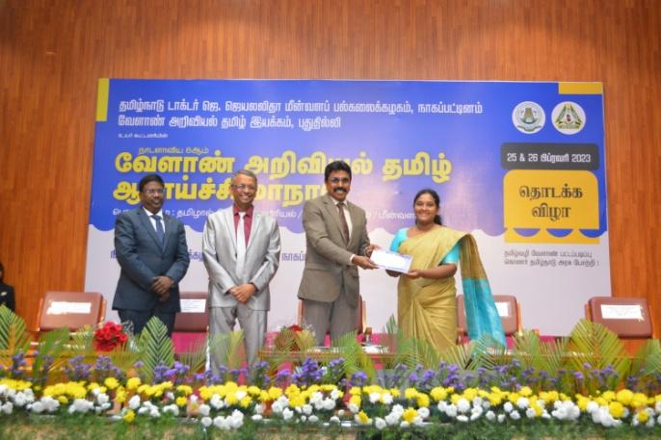 | 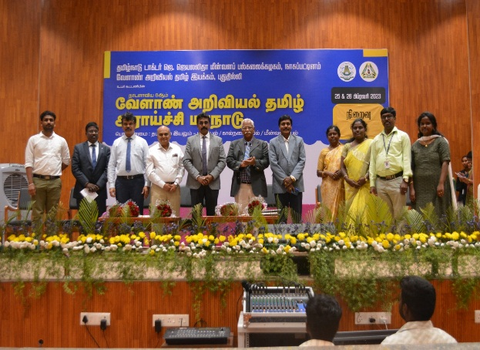

(iii) Dr. M. G. R. Fisheries College & Research Institute, Thalainayeru
Name of the faculty | Honors/Awards | National / International
Dr. S. Balasundari | Best University Officer Award 2022 | National
S. Kesavan, Assistant  Professor, DFBRM | DST- Augmenting Writing Skills for Articulating Research (AWSAR 2022) | National

(iv) Institute of Fisheries Postgraduate Studies, Vaniyanchavadi, Chennai
Name of the faculty | Honors/Awards | National / International
Dr. E. Suresh | Best Poster Presenter Award in 12th Indian Fisheries and Aquaculture Forum held at Chennai | National
Dr. Deepak Agarwal | Young Researcher Award | University level
Dr. Amit Ranjan | J. R. Agro Innovation Award | National (The Solvent Extractors Association of India)

(v) TNJFU, Fisheries Business School, Vaniyanchavadi, Chennai
Name of the faculty | Honors/Awards | National / International
Dr.S.Kavithambika | Young Researcher Award | “International conference on innovative approaches in drop improvement for sustainable Agriculture” organized by J.S.A.college of Agriculture and Techonology, Avatti, Tamil Nadu

(vi) College of Fish Nutrition and Food Technology, Madhavaram
Name of the faculty | Honors/Awards | National / International
Dr. K. Hema  Assistant Professor,  CFNFT, Chennai | BEST RESEARCH PAPER AWARD | 8th Tamil Agriculture Research Conference

(vii) Directorate of Incubation and Vocational Training in Aquaculture, Muttukadu, Chennai
Name of the faculty | Honors/Awards | National / International
Dr.E.Prabu | Best Paper Presentation | National - TNJFU &amp; Agricultural  Scientific Tamil Society  On 26.02.2023
Dr.E.Prabu | Best Paper Award

- Internal resources generated
(i) Fisheries College & Research Institute, Thoothukudi
Sl. No. | Internal resources generated | Amount (Rs.)
1 | Tuition Fees | --
2 | Exam Fees | --
3 | Sale of Inputs | --
4 | Samples Testing | 64,015/-
5 | Training | 30,000/-
6 | Building Rent | --
7 | Sale of Tender | --
8 | Library Outcomes | 3,045/-
9 | Other Fees | --
10 | Vehicle Hire Charges | 10,650/-
 | Total | 1,07,710/-

(ii) Dr. M. G. R. Fisheries College & Research Institute, Ponneri
Sl.No. | Internal resources generated | Amount (Rs.)
1. | Tuition Fees | 2,52,350
2. | Exam Fees | 2,99,550
3. | Sale of Inputs | 28,172
4. | Samples Testing | 1,75,300
5. | Training | --
6. | Building Rent | 1,15,970
7. | Sale of Tender | 50,400
8. | Library outcomes | 15,049
9. | Other Fees | 8,499
10. | Vehicle Hire charges | 7,000
11. | Training | –
 | Total | 9,52,290

(iii) Institute of Fisheries Postgraduate Studies, Vaniyanchavadi, Chennai
Sl.No. | Internal resources generated
1. | Rs. Rs.44,675 was revenue generated through analysis of sample from wetlab.

(iv) Directorate of Incubation and Vocational Training in Aquaculture, Muttukadu, Chennai
Sl.No. | Internal resources generated
1. | A revenue of Rs. 88590/- has been generated in this quarter.

- Details of departments getting assistance / recognition under SAP, COSIST (ASSIST)/DST, FIST, ICAR-NAE / CoE and other programmes

(i) Fisheries College & Research Institute, Thoothukudi
Name of the college | Assistance / recognition under SAP, COSIST (ASSIST)/DST, FIST, ICAR-NAE / CoE and other programmes | Amount  (Rs.) | Remarks
Fisheries College and Research Institute, Thoothukudi | ICAR DG 2022-23 | 12,00,000/- | --

(ii) Dr. M. G. R. Fisheries College & Research Institute, Ponneri
Name of the college | Assistance / recognition under SAP, COSIST (ASSIST)/DST, FIST, ICAR-NAE / CoE and other programmes | Amount  (Rs.) | Remarks
Dr.MGR Fisheries College and Research Institute, Ponneri | ICAR DG 2022-23 | 18,00,000 | -

(iii) Directorate of Incubation and Vocational Training in Aquaculture, Muttukadu, Chennai
Name of the college | Assistance / recognition under SAP, COSIST (ASSIST)/DST, FIST, ICAR-NAE / CoE and other programmes | Amount | Remarks
DIVA, Muttukadu | One research and development project from DBT has been sanctioned | 50 lakh | -

- Community services
(i) Fisheries College & Research Institute, Thoothukudi
Name & address of Community services | Contact No. | Details of Services | Remarks
M/s. Omni Product Pvt. Ltd | 9790002767 | Veterinary Health Certificate to export cuttle fish bone as per EC1069/2009 and EC142/2011 and 97/78/EC for purpose of pet food | To export Turkey
Mr. Pradeep kumar  Deputy Director  Fisheries Department Tamil Nadu | 8667487677 | Lecture notes given (PPT) | --
Dr. Joy Sinthiya A.S.I  Assist. Prof. Dept. of Physics |  | Lab Visit | Discuss regarding biofilm

(ii) Dr. M. G. R. Fisheries College & Research Institute, Ponneri
Name & address of Community services | Contact No. | Details of Services | Remarks
Awareness training program organized to Fisherfolks of Pazhaverkadu on Sea Grasses Day on March 1st 2023 | - | Awareness lectures were given on varieties, habitats, Importance and Conservation of Sea grass | -
The Student's Association and NSS unit of Dr.M.G.R Fisheries College and Research Institute, Ponneri organized the Traditional Day 2023 on 10.01.23 | - | As a part of celebrating Azazdi Ka Amir Mahotsav Programme to Commemorate the 75th year of progressive independent India | -
Seven-day special NSS camp conducted by Dr.MGR FCRI,Ponner from 01.02.23 to 07.02.23 | - | -As a part of the NSSS camp, veterinary camp, medical camp and special lectures were organized for the benefit of the villagers | -
International Day of Women and Girls in Science was celebrated in the Seminar Hall of Dr. M.G.R. Fisheries College and Research Institute on 11.02.2023 and the event was coordinated by the Science Club and NSS unit. | - | As a part of celebrating Azazdi Ka Amir Mahotsav Programme to Commemorate the 75th year of progressive independent India | -

(iii) Dr. M. G. R. Fisheries College & Research Institute, Thalainayeru
Name & address of Community services | Contact No. | Details of Services | Remarks
Th.Balasubramaniyam | 9843877533 | EHP & ways to prevent its route transfer in Shrimp Farms | -
Mr. Jayaraman | 9442222151 | Pond Preparation in Low Saline Waters for shrimp farming | -
Mr. Sundar | 9894520519 | Slurry Ice Preparation and benefits of PMMSY scheme for Start-up business related to fisheries | -
Dr. Govintharajan | 9789496939 | Regarding workshop on value added fish and fishery products to college students | -
Mr. Sagayarajan | 9600472244 | Canned fishery products | -

(iv) College of Fish Nutrition and Food Technology, Madhavaram
Name & address of Community services | Contact No. | Details of Services | Remarks
NSS Students, College of Fish Nutrition and Food Technology, Chennai – 51 | Incharge Faculty  Dr. K. Hema  8754297471 | Maintaining Kitchen Garden, everyday | -
Food Safety Club, College of Fish Nutrition and Food Technology, Chennai – 51 | Incharge Faculty  Dr. R. Brimapureeswaran  9790869252 | Distributing the poster to local shop nearby Madhavaraam Milk Colony to create awareness about food handling | -
Students Volunteers of Eco club  &  Nizhal Foundation Team, Madhavaram | Dr. K. Hema  8754297471 | Watering and maintaining of plants and trees at Madhavaram Urban Forest every week | -

(v) Directorate of Incubation and Vocational Training in Aquaculture, Muttukadu, Chennai
Name & address of Community services | Contact No. | Details of Services | Remarks
On-field demonstration of developed feed and seabass farming was done. | - | Farming practices. | -

- Teachers and officers newly recruited

(i) Institute of Fisheries Biotechnology, Vaniyanchavadi, Chennai
Sl.No. | College | Name of the Teachers | Name of the Officers | Recruited Date
1 | TNJFU-IFBT | Dr. V. Kalpana | - | 10.02.2023

(ii) Directorate of Incubation and Vocational Training in Aquaculture, Muttukadu, Chennai
Sl.No. | College | Name of the Teachers | Name of the Officers | Recruited Date
1. | DIVA, Muttukadu | K. Krishnaveni, AP (Contractual) | - | 20.01.2023

- Teaching – Non-teaching staff ratio
(i) Fisheries College & Research Institute, Thoothukudi
Sl.No. | College | Teaching – Non-teaching staff ratio  (E.g. 10:50)
1. | FC&RI, Thoothukudi | 34 : 97

(ii) Dr. M. G. R. Fisheries College & Research Institute, Ponneri
Sl.No. | College | Teaching – Non-teaching staff ratio  (E.g. 10:50)
1 | Dr. MGR FC&RI Ponneri | 25:24

(iii) College of Fisheries Engineering, Nagapattinam
Sl.No. | College | Teaching – Non-teaching staff ratio  (E.g. 10:50)
1. | College of Fisheries Engineering, Nagapattinam | 57:43

(iv) Dr. M. G. R. Fisheries College & Research Institute, Thalainayeru
Sl.No. | College | Teaching – Non-teaching staff ratio  (E.g. 10:50)
1 | Dr. MGR FCRI, Thalainayeru | 24 : 55

(v) Institute of Fisheries Biotechnology, Vaniyanchavadi, Chennai
Sl.No. | College | Teaching – Non-teaching staff ratio  (E.g. 10:50)
1 | TNJFU-IFBT | 3:10

(vi) Institute of Fisheries Postgraduate Studies, Vaniyanchavadi, Chennai
Sl.No. | College | Teaching – Non-teaching staff ratio  (E.g. 10:50)
1 | TNJFU-IFPGS | 16:30

(vii) TNJFU, Fisheries Business School, Vaniyanchavadi, Chennai
Sl.No. | College | Teaching – Non-teaching staff ratio  (E.g. 10:50)
1 | TNJFU-FBS | 9:3

(viii) College of Fish Nutrition and Food Technology, Madhavaram
Sl.No. | College | Teaching – Non-teaching staff ratio (E.g. 10:50)
1. | College of Fish Nutrition and Food Technology, MMC, Chennai | 8 : 14

(ix) Directorate of Incubation and Vocational Training in Aquaculture, Muttukadu, Chennai
Sl.No. | College | Teaching – Non-teaching staff ratio  (E.g. 10:50)
1. | DIVA, Muttukadu | 5:12

(x) DIVF, Mandapam
Sl.No. | College | Teaching – Non-teaching staff ratio  (Eg. 10:50)
1. | PPIFT, Ramanathapuram | 5:7
2. | PPIFT, Madhavaram | 6:5

- Improvements in the library services

(i) Fisheries College & Research Institute, Thoothukudi
Sl.No. | Improvements in the library services
1 | Library provides E-journals and E-books.  Students are using the E-books and E-journals (soft copy) in the library.
2 | Contributions from faculty on special days for sponsored books to the library  Nineteen books have been sponsored (motivational / inspiring books) in English and Tamil
3 | Additional Wi-Fi Device installed for 24/7 Wi-Fi connectivity to the students for accessing E Journals

(ii) Dr. M. G. R. Fisheries College & Research Institute, Ponneri
Sl.No. | Improvements in the library services
1. | Library provides E-journals and E-books.  Students are using the E-books and E-journals (soft copy) in the library.
2. | Contributions from faculty on special days for sponsored books to the library. Fifteen books have been sponsored (motivational / inspiring books) in English and Tamil

(iii) College of Fisheries Engineering, Nagapattinam
Sl.No. | Improvements in the library services
1. | Brainstorming on improvement of pass percentage and facilitation to arrear students in CoFE on 14.02.2023. Based on the feedback, the library in-charge was instructed to improvise the facilities and monitor the students attendance at library.

(iv) Dr. M. G. R. Fisheries College & Research Institute, Thalainayeru
Sl.No. | Improvements in the library services
1. | Purchased New Desktop (Hp Ryzen 5 5500U – Rs. 59,700/- ) in the library for students study purpose

(v) Institute of Fisheries Biotechnology, Vaniyanchavadi, Chennai
Sl.No. | Improvements in the library services
1. | 12 new books have been added to the library for the benefit of B.Tech. (Biotechnology) students

(vi) Institute of Fisheries Postgraduate Studies, Vaniyanchavadi, Chennai
Sl.No. | Improvements in the library services
1 | Index cards were made available for the students and make use of library facility in preparing their thesis topics and search articles for their research work.
(vii) TNJFU, Fisheries Business School, Vaniyanchavadi, Chennai
Sl.No. | Improvements in the library services
1 | Purchased furniture like book racks, reading tables and chairs for the library

(viii) College of Fish Nutrition and Food Technology, Madhavaram
Sl.No. | Improvements in the library services
1. | Purchase of Magazine rack
2. | Purchase of Newspaper English and Tamil to improve the general knowledge of students

(ix) Directorate of Incubation and Vocational Training in Aquaculture, Muttukadu, Chennai
Sl.No. | Improvements in the library services
1. | CeRA facility for accessing publications has been installed.
2. | Two desktops for software skill development have been arranged for students.

- New books/journals subscribed and their value

(i) Dr. M. G. R. Fisheries College & Research Institute, Ponneri
Sl.No. | Name of New books/journals subscribed | Quantity | Value (Rs.)
1. | Journals of Fisheries and Life Science ISSN -2456-6268 | 2 | ₹. 3,000/-
2. | Indian Journal of Microbiology Research  ISSN No:-2394-546X | 4 | ₹. 6,650/-

(iii) TNJFU, Fisheries Business School, Vaniyanchavadi, Chennai
Sl.No. | Name of New books/journals subscribed | Quantity | Value (Rs.)
1 | Fisheries related books (21) management (2) | 23 | Rs.49890/-

- Courses in which students assessment of teachers is introduced and the action taken on student feedback

(i) Dr. M. G. R. Fisheries College & Research Institute, Ponneri
Sl.No. | Name of the course | Action taken
1. | FS-217 Fish Canning Technology 2(1+1) | To increase the use of ICT tools, to (PPT, Video) to show concepts in a better way.
2. | Internal Communication No.338/TNJFU/IQAC/C2/2023 | - Internal Communication given to Campus Committee Coordinator  - Reply submitted on 31.03.2023

(iii) College of Fisheries Engineering, Nagapattinam
Sl.No. | Name of the course | Action taken
 | I semester courses of B.Tech.(FE) and B.Tech.(EEE) | The feedback by the students were discussed in detail in the Quarterly Meeting of IQAC On 07.02.2023. Further, brainstorming on improvement of pass percentage and facilitation to arrear students in CoFE was conducted on14.02.2023 along with students. Based on the assessment of teachers, students having arrears were given special attention to clear the exams.

(iv) Dr. M. G. R. Fisheries College & Research Institute, Thalainayeru
Sl. No. | Name of the course | Action taken
IV Semester (2020-21 Batch)
1 | FS-210 Coastal Aquaculture and Mariculture | Consolidated feedback were discussed in the staff meeting for understanding and improving their teaching efficiency on 21.02.2023
2 | FS-211 Genetics and Breeding
3 | FS-212 Fish Nutrition and Feed Technology
4 | FS-213 Fish and Shellfish Pathology
5 | FS-214 Physiology of Finfish and Shellfish
6 | FS-215 Fishery Oceanography
7 | FS-216 Aquatic Pollution and Coastal Zone Management
8 | FS-217 Fish Canning Technology
9 | FS-218 Fishing Gear Technology
II Semester (2021-22 Batch)
1 | FS-110 Freshwater Aquaculture | Consolidated feedback were discussed in the staff meeting for understanding and improving their teaching efficiency on 21.02.2023
2 | FS-111 Aquaculture in Reservoirs
3 | FS-112 Taxonomy of Shellfish
4 | FS-113 Anatomy and Biology of Shellfish
5 | FS-114 Inland Fisheries
6 | FS-115 Limnology
7 | FS-116 Marine Biology
8 | FS-117 Food Chemistry and Fish in Nutrition
9 | FS-118 Information and Communication Technology

(v) Institute of Fisheries Biotechnology, Vaniyanchavadi, Chennai
Sl.No. | Name of the course | Action taken
All the course teachers of B.Tech. (Biotechnology) degree program were evaluated through the online portal for feedback. Suitable instructions were given to those course teachers whom have been rated poor, to assess the reasons and correct them.

(vi) Institute of Fisheries Postgraduate Studies, Vaniyanchavadi, Chennai
Sl.No. | Name of the course | Action taken
All the course teachers handling PG degree program were evaluated through the online portal for feedback. So far M.F.Sc suitable evaluation has been completed. Ph.D students instructions to complete the process of evaluation once their courses have been uploaded.

(vii) TNJFU, Fisheries Business School, Vaniyanchavadi, Chennai
Sl.No. | Name of the course | Action taken
1 | BBA and MBA (FEM) | The following are the summary of overall rating for the various courses and teachers of B.B.A(FEM) degree program  Excellent : 3261  Very good : 2619  Good : 2217  Average : 687  Poor :134

(viii) College of Fish Nutrition and Food Technology, Madhavaram
Sl.No. | Name of the course | Action taken
1. | All Subject | - Dean discussed with the faculty to conduct class test/ quiz for students after the completion of each unit of the syllabus  - To arrange an internship for each course  - Faculty should make use of ICT tools during teaching  - Evaluation process by the faculty should be fair and unbiased

(ix) Directorate of Incubation and Vocational Training in Aquaculture, Muttukadu, Chennai
Sl.No. | Name of the course | Action taken
1. | All courses of I, III and V semester of B.Voc (IA) | Action was taken for use of ICT tools like modern teaching aids, smart boards, handouts, power point presentation, web-resources, etc. which was main thing quoted in the feedback assessment.

(x) DIVF, Mandapam
Sl.No. | Name of the course | Action taken
1. | VFT 111English Writing and Communication | Based on the student’s feedback, the entire syllabus was covered for all the courses under the I semester (2022-23)
2. | VFT 112Applied Mathematics
3. | VFT 113Swimming
4. | VFT 114Fishing Gear Materials, Design and Fabrication of Fishing Gears
5. | VFT 115Fishing Craft Construction and Maintenance
6. | VFT 116Fishing Biology and Fish Handling
7. | VFT 117 Basics of Navigation and Seamanship
8. | VFT 118Basics of Marine Engines
9. | VFT 119Marine Communication

Sl.No. | Name of the course | Action taken
1. | VFT 211Engineering Drawings | Based on the student’s feedback, the entire syllabus was covered for all the courses under the III semester (2021-22)
2. | VFT 212Marine Pollution
3. | VFT 213 Oceanography
4. | VFT 214Naval Architecture
5. | VFT 215Care and Maintenance of Marine Engines
6. | VFT 216Fish Processing Technology
7. | VFT 217Advanced Fishing Technology

- Feedback from stakeholders
(i) Institute of Fisheries Biotechnology, Vaniyanchavadi, Chennai
Sl.No. | Name of the stakeholders | Feedbacks
1 | B.Tech. (Biotechnology) students | The following are the rating  Excellent : 7393  Very good : 1624  Good : 1776  Average : 400  Poor : 164

(ii) TNJFU-Fisheries Business School, Vaniyanchavadi, Chennai
Sl.No. | Name of the stakeholders | Feedbacks
1. | Dr.Santhana Krishnan CEO S.K Marine Technology Pvt Ltd , Chennai | Highly appreciated
2. | Mr.Yuvaraj Founder of Sun shine hatcheries , Chennai | Highly appreciated
3. | Mr.Siva Ram managing Director of IAS Group of Hatcheries Nellore | Highly appreciated

- Unit cost of education – (January to March 2023)

(i) Fisheries College & Research Institute, Thoothukudi
Sl.No. | Unit cost of education | Amount in (Rs.)
1 | Cost of Personnel | 18134199
2 | Recurring | 8744155
 | Total | 26878354
3 | Total No. of students | 293
4 | Unit cost of education for three months (January to March 2023) per student | 91735

(ii) Dr. M. G. R. Fisheries College & Research Institute, Ponneri
Sl.No. | Unit cost of education | Amount in (Rs.)
1 | Cost of Personnel | 8740262
2 | Recurring | 2171336
 | Total | 10911598
3 | Total No. of students | 266
4 | Unit cost of education for three months (January to March 2023) per student | 41021

(iii) College of Fisheries Engineering, Nagapattinam
Sl.No. | Unit cost of education | Amount in (Rs.)
1 | Cost of Personnel | 6855042
2 | Recurring | 910606
 | Total | 7765648
3 | Total No. of students | 159
4 | Unit cost of education for three months (January to March 2023) per student | 48840

(iv) Dr. M. G. R. Fisheries College & Research Institute, Thalainayeru
Sl.No. | Unit cost of education | Amount in (Rs.)
1 | Cost of Personnel | 7522828
2 | Recurring | 778081
 | Total | 8300909
3 | Total No. of students | 190
4 | Unit cost of education for three months (January to March 2023) per student | 43689

(v) Institute of Fisheries Biotechnology, Vaniyanchavadi, Chennai
Sl.No. | Unit cost of education | Amount in (Rs.)
1 | Cost of Personnel | 766536
2 | Recurring | 543428
 | Total | 1309964
3 | Total No. of students | 90
4 | Unit cost of education for three months (January to March 2023) per student | 14555

(vi) Institute of Fisheries Post Graduate Studies, Vaniyanchavadi, Chennai
Sl.No. | Unit cost of education | Amount in (Rs.)
1 | Cost of Personnel | 3928092
2 | Recurring | 1028141
 | Total | 4956233
3 | Total No. of students | 33
4 | Unit cost of education for three months (January to March 2023) per student | 150188

(vii) TNJFU-Fisheries Business School, Vaniyanchavadi, Chennai
Sl.No. | Unit cost of education | Amount in (Rs.)
1 | Cost of Personnel | 512878
2 | Recurring | 613674
 | Total | 1126552
3 | Total No. of students | 70
4 | Unit cost of education for three months (January to March 2023) per student | 16094

(viii) College of Fish Nutrition and Food Technology, Madhavaram
Sl.No. | Unit cost of education | Amount in (Rs.)
1 | Cost of Personnel | 1399845
2 | Recurring | 649130
 | Total | 2048975
3 | Total No. of students | 118
4 | Unit cost of education for three months (January to March 2023) per student | 17364

(ix) College of Fisheries Nautical Technology, Madhavaram
Sl.No. | Unit cost of education | Amount in (Rs.)
1 | Cost of Personnel | 527671
2 | Recurring | 148575
 | Total | 676246
3 | Total No. of students | 17
4 | Unit cost of education for three months (January to March 2023) per student | 39779

(ix) Paraprofessional Institute of Aquaculture Technology, ECR, Muttukadu
Sl.No. | Unit cost of education | Amount in (Rs.)
1 | Cost of Personnel | 635268
2 | Recurring | 242985
 | Total | 878253
3 | Total No. of students | 65
4 | Unit cost of education for three months (January to March 2023) per student | 13512

(x) Paraprofessional Institute of Industrial Fishing Technology, Mandapam
Sl.No. | Unit cost of education | Amount in (Rs.)
1 | Cost of Personnel | 706764
2 | Recurring | 161096
 | Total | 867860
3 | Total No. of students | 28
4 | Unit cost of education for three months (January to March 2023) per student | 30995

- Computerization of administration and the process of admissions and examination results, issue of certificates

(i) College of Fisheries Engineering, Nagapattinam
Sl.No. | List of computerization of administrations and the process of admissions and examination results, issue of certificates made
1. | Pay roll, Bill system, library books monitoring system are done online. Further course registration for UG and PG, hall ticket, attendance and mark statements are being implemented

(ii) Dr. M. G. R. Fisheries College & Research Institute, Thalainayeru
Sl.No. | List of computerization of administrations and the process of admissions and examination results, issue of certificates made
1. | - Totally 53 students (2022-23 batch) were admitted in the Dr. MGR FCRI, Thalainayeru campus (Closure of admission : 31st January 2023)
2. | - Fifth (Arrear), sixth and seventh semester final theory exam results were declared for the batch 2019-20 on 20.01.2023, 25.02.2023 and 28.03.2023 respectively  - Third semester final theory exam result declared for the batch 2020-21 on 21.01.2023  - First semester final theory exam result declared for the batch 2021-22 on 21.01.2023

(iii) Institute of Fisheries Biotechnology, Vaniyanchavadi, Chennai
Sl.No. | List of computerization of administrations and the process of admissions and examination results, issue of certificates made
- Education management system is digitalized
- Office management is partially digitalized

(iv) Institute of Fisheries Postgraduate Studies, Vaniyanchavadi, Chennai
Sl.No. | List of computerizations of administrations and the process of admissions and examination results, issue of certificates made
- Education management system is digitalized
- Office management is partially digitalized

(v) TNJFU, Fisheries Business School, Vaniyanchavadi, Chennai
Sl.No. | List of computerization of administrations and the process of admissions and examination results, issue of certificates made
1 | - Education management system is digitalized  - Office management is partially digitalized

(vi) College of Fish Nutrition and Food Technology, Madhavaram
Sl.No. | List of computerization of administrations and the process of admissions and examination results, issue of certificates made
1. | EMS Portal – Attendance & Mark statement – Submitting through Online TNJFU portal
2. | Final Theory Semester Examinations are conducted online

(vii) Directorate of Incubation and Vocational Training in Aquaculture, Muttukadu, Chennai
Sl.No. | List of computerization of administrations and the process of admissions and examination results, issue of certificates made
1. | Internal mark statement uploaded in EMS portal.

- Increase in the infrastructural facilities
(i) Fisheries College & Research Institute, Thoothukudi
Sl. No. | Increase in the infrastructural facilities | Amount
1 | CIVIL WORKS UNDER FC&RI, Thoothukudi and NADP SCHEME | Rs. 1286.22 Lakh
2 | Established laboratory complex | Rs. 1286.22 Lakh
3 | Renovated the integrated farm | Rs. 1286.22 Lakh
4 | TNJFU - NABL Laboratory Microbiology Lab Partition made and Layout sent for NABL Accreditation. | Rs. 1286.22 Lakh

(ii) Dr. M. G. R. Fisheries College & Research Institute, Ponneri
Sl.No. | Increase in the infrastructural facilities | Amount (Rs.)
1. | Providing Artificial reef 1x1 RCC sample tiles with plastering | 42729
2. | NIOT artificial Reef Deployment | 3,85,400
3. | Digital Microscope | 4,97,960
4. | Ultra Low Deep freezer | 6,54,959
5. | Sports items for students | 21,020
6. | Aquatic Recording studio | 13,87,968
7. | Storage device | 19,500
8. | Providing ICT enable Skill lab and Digital media Lab with facilities | 24,89,162
9. | Software Installation charges | 1,68,644
10. | Backdrop | 49,749
11. | Electronic accessories | 38,090
12. | Content Developer | 4,96,370
13. | Computer accessories | 37,500
14. | Antivirus Software | 29,640
15. | Labwares | 40,703
16. | Real time PCR accessories | 65,150
17. | Improvisation of TNJFU E-Fish Health app | 40,250
18. | Real time PCR Sequencing | 1,00,300
19. | Wetlab accessories and Equipments | 57,643
20 | PCR Power Supply | 51,500
21. | Printer catridges | 12,400
22. | Deep freezer | 24,970
23. | Refrigerator | 84,920
24. | Glasswares | 57,289
25. | Real time PCR machine | 12,76,900
26. | Seed quality assessment lab | 33,47,865
27. | Automated DNA Extraction | 5,99,954
28. | Air-conditioner -3 Nos. | 1,70,033
29. | Furniture | 2,58,271
30. | Laying of tarpaulin for two ponds in PRFF | 1,50,000
31. | Incubator Heater & Controller Replacement | 9,995.00
32. | Fibre Analyzer Heater | 16992.00
33. | Imhoff Cone 1000ml Tarson | 4997.00
34. | Distillation Unit Heater | 4956.00
35. | Refrigerator Centrifuge 15ml rotor | 14927.00
36. | Weighing Balance Capacity (10kg) | 4991.00
37. | Hand Homogensier | 14986.00
38. | Feed Petellizer Die 60 | 4956.00
39. | Bucket Autoclave | 17995.00
40. | Micropipette 10-100µl / Micropipette 100-1000µl | 17997.00
41. | Asbestos laying for outdoor hatchery | 1,00,000
1.Created a small-scale seaweed tissue culture laboratory at Department of Aquatic Animal Health Management, Dr.M.G.R. Fisheries College and Research Institute, Ponneri (Staff in charge : Dr. Saravanan).
2. Seed quality assessment lab was established under NADP scheme (2021-2023) on Integrated disease surveillance monitoring system and Seed quality assessment to Augment Aquaculture Production in Tamil Nadu at TNJFU-Madhavaram campus (PI- Dr. A.Uma)
3. Digital media lab, acoustic recording studio, ICT labs with inherent facilities were developed under NADP scheme of “Establishment of Digital Blue - e-extension hub in aquaculture and fisheries sector” was established (PI: Mrs. S. Agnes Daney Angela)

(iii) Dr. M. G. R. Fisheries College & Research Institute, Thalainayeru
Sl.No. | Increase in the infrastructural facilities
1 | The Hon’ble Chief Minister of Tamil Nadu inaugurated the first floor of Boys and Girls hostel at Dr.M.G.R Fisheries College and Research Institute, Thalainayeru through video conferencing mode on 09.03.23. Number of rooms: 38 with 4 person capacity
2 | Basketball court, gymnasium in boys’ and girls’ hostel of Dr. MGR Fisheries College and Research Institute, Thalainayeru was inaugurated by Honourable Vice-Chancellor on 29.03.2023.
3. | The Recirculatory Aquaculture System (RAS) in the Freshwater instructional fish farm, Korukkai of Dr. MGR Fisheries College and Research Institute, Thalainayeru was inaugurated by the Hon’ble Vice Chancellor on 29.03.2023 (with 16 Nos. of one ton capacity FRP tank with treatment and storage facility for raw water).

(iv) TNJFU, Fisheries Business School, Vaniyanchavadi, Chennai
Sl.No. | Increase in the infrastructural facilities
1 | - Newly purchased LCD Projector  - Xerox Machine,  - Printer and  - Tele phone

(v) College of Fish Nutrition and Food Technology, Madhavaram
Sl.No. | Increase in the infrastructural facilities
1. | Biogas plant was installed and is being used in the CFNFT Girls Hostel Mess
2. | Purchase of Incinerator –CFNFT Girls Hostel for disposal of sanitary napkins
3. | Earth Filling for Pathway from Girls Hostel to CFNFT – Work completed
4. | The following Equipments were purchased  - Computers  - Colony Counter  - Incubator  - Electrical and Electronic Equipments  - Moisture analyzer  - Gerber Centrifuge  - Printer  - Wifi connection facilities – CFNFT campus, Girls Hostel, Boys Hostel and NADP Lab  - Gardening equipments and tools
5. | Purchase of furniture - CFNFT campus, Boys hostel and Girls hostel
6. | Greening Campus – Purchase of fruits plant saplings and coconut tree saplings

(vi) Directorate of Incubation and Vocational Training in Aquaculture, Muttukadu, Chennai
Sl.No. | Increase in the infrastructural facilities
1. | The Laboratory infrastructure in terms of RT-PCR, Hematology analyzer, Microplate reader have been strengthened.

(vii) DIVF, Mandapam
Sl.No. | Increase in the infrastructural facilities
1. | Established the Marine Engineering Workshop at TNJFU-DIVF, Ariyaman Beach, Ramanathapuram
2. | Academic building construction works are in progress at PPIFT, Madhavaram campus

- Technology up gradation

(i) Dr. M. G. R. Fisheries College & Research Institute, Ponneri
Sl.No. | Technology up gradation | Date
1. | Ornamental Fish farming training | 28.03.2023

- Computer and internet access and training to teachers, non-teaching staff and students

(i) Dr. M. G. R. Fisheries College & Research Institute, Ponneri
Sl.No. | Computer & Internet access | Training to Teachers | Training to Non-Teaching Staff | Training to Students
1 | Newly 15 No of system have been installed in the NADP – Digital Blue –Centralized equipment lab computer lab | - | - | -

(ii) College of Fisheries Engineering, Nagapattinam
Sl.No. | Computer & Internet access | Training to Teachers | Training to Non-Teaching Staff | Training to Students
1. | 40 Working Computers and 50Mbps Internet Bandwidth | Nil | Nil | Students are training for the subject COM 101.

(iii) Institute of Fisheries Biotechnology, Vaniyanchavadi, Chennai
Sl.No. | Computer & Internet access | Training to Teachers | Training to Non-Teaching Staff | Training to Students
Computer and internet facilities available. All staff and students have been trained

(iv) Institute of Fisheries Postgraduate Studies, Vaniyanchavadi, Chennai
Sl.No. | Computer & Internet access | Training to Teachers | Training to Non-Teaching Staff | Training to Students
Computer and internet facilities available. All staff and students have been trained

(v) College of Fish Nutrition and Food Technology, Madhavaram
Sl.No. | Computer & Internet access | Training to Teachers | Training to Non-Teaching Staff | Training to Students
1. | 37 Computers with Internet access | - | - | Searching for notes related to the subject

(vi) Directorate of Incubation and Vocational Training in Aquaculture, Muttukadu, Chennai
Sl.No. | Computer & Internet access | Training to Teachers | Training to Non-Teaching Staff | Training to Students
1. | Available | - | - | Yes

- Financial aid to students
(i) Fisheries College & Research Institute, Thoothukudi
Sl. No. | Name of the financial aid | Amount in (Rs.) | Year
 | Pudhumai Penn Scholarship (Rs.1000/- per month x 6 students x 2 months) | 12000/- | Jan’23 – Mar’23
 | TNJFU Merit Scholarship  M.F.Sc. students Rs.4000/- per month & Ph.D. Students Rs.5000/- per month) | 981233/- | Jan’23 – Mar’23
 | NTS (UG students Rs.300/- per month & PG students per month Rs. 5000/- | 264336/- | Jan’23 – Mar’23
 | Student Ready Programme (B.F.Sc. 2019-2020 batch) | 796250/- | Jan’23 – Mar’23
 | 7.5% TN Gov Quota | -- | Jan’23 – Mar’23
 | TN SC ST Scholarship for one full time Ph.D.Scholar  (4 students x Rs. 100000/- Per year) | 400000/- | Jan’23 – Mar’23

(ii) Dr. M. G. R. Fisheries College & Research Institute, Ponneri
Sl.No. | Name of the financial aid | Amount in (Rs.) | Year
 | Pudhumai penn Scholarship | 3000 | 2021-20 batch 1 student
 | TNJFU Merit Scholarship | 370973 | 2021-22 batch
 | NTS | 18,000 | 2021-22 batch
 | Student Ready Programme | 845250 | 2019-20 batch
 | 7.5% TN Gov Quota | 157450 | 2021-22 batch
 | TN SC ST scholarship for one full time Ph.D scholar | 1,00,000 | 2019-2020 batch

(iii) College of Fisheries Engineering, Nagapattinam
Sl.No. | Name of the financial aid | Amount in (Rs.) | Year
1. | Registration fee for two IV B.Tech.(EEE) students to attend 3rd International Workshop on Biodiversity and Climate Change at IIT Kharagpur on 16th to 19th February 2023. | 9000 | 2023
2. | Registration fee for three M.Tech. students to attend Workshop on Data Anlytics using Statistical Software at FCRI, Thoothukudi, on 15th and 16th February 2023. | 1500 | 2023

(iv) Dr. M. G. R. Fisheries College & Research Institute, Thalainayeru
Sl.No. | Name of the financial aid | Amount in (Rs.) | Year
1. | Fishermen ward scholarship | Rs. 52,000/- | 2022-23
2. | 7.5% Government school students | - | -
3. | Pudhumai pen scheme | - | -
4. | Scholarship to BC and MBC students | - | -
5. | Scholarship to SC and ST students | - | -
6. | Pattukottai Azhagiri Endowment | - | -

(v) Institute of Fisheries Biotechnology, Vaniyanchavadi, Chennai
Sl.No. | Name of the financial aid | Amount in (Rs.) | Year
1 | Pudhumai Pen Scheme of Government of Tamil Nadu (C.Maria Nilani  BTV 20100) | 1000/- per month | 2023
2 | 7.5% Govt. School Quota (S Sowmiya  BTV 21139; B Preethi  BTV 22169 and P Sathyaseelan  BTV 22172) | Semester Fees exempted upto Rs.50,000 per year | 2023

(vi) College of Fish Nutrition and Food Technology, Madhavaram
Sl.No. | Name of the financial aid | Amount in (Rs.) | Year
1. | SC / ST Scholarship | 28,000/- (Per student) | 2022 – 2023
2. | Minority Scholarship | 21,000/- (Per student) | 2022 – 2023

(vii) Directorate of Incubation and Vocational Training in Aquaculture, Muttukadu, Chennai
Sl.No. | Name of the financial aid | Amount in (Rs.) | Year
1. | Most of the students are getting state semester wise government fellowships | 3000-5000 per student | 2022

(viii) DIVF, Mandapam
Sl.No. | Name of the financial aid | Amount in (Rs.) | Year
1. | Renewed the TN BC/MBC scholarship for the year 2022-23 | 62,400 | 2022-23
2. | Apply for the TN BC/MBC scholarship for the year 2022-23 | 70,200 | 2021-22
3. | Apply for the TN SC/ST scholarship for the year 2022-23 | 81,000 | 2020-21

- Activities and support from the Alumni Association
(i) Fisheries College & Research Institute, Thoothukudi
College | Batch | Activities | Support from Alumni Association
FCRI, Thoothukudi | General secretary | - Conducted AGBM with the executive members  - Initial registration process of the registration of the Alumni association in the name – AFCA Thoothukudi under TN registration portal

(ii) Dr. M. G. R. Fisheries College & Research Institute, Ponneri

College | Batch | Activities | Support from Alumni Association
Dr.MGR Fisheries College and Research Institute, Ponneri |  | The Alumni association “Association of Fisheries College Alumni Ponneri” had been registered on 31 January 2023 under the registration number “SRG/Thiruvallur/19/2023”
Dr.MGR Fisheries College and Research Institute, Ponneri |  | Organized multiple Special lectures for the Alumni who were the aspirants of Fisheries Sub-ordinate service exams
Dr.MGR Fisheries College and Research Institute, Ponneri |  | Requests were made to the District Collectorate to provide funds for the establishing an aquarium in the college campus for the display and to creative awareness about the native fishes and local fish biodiversity

(iii) College of Fisheries Engineering, Nagapattinam
College | Batch | Activities | Support from Alumni Association
CoFE | 2015-16  2016-17  2017-18  2018-19 | A whatsapp group for the alumni was created on 6.11.2022. First online meeting with the alumni was conducted on 02.12.2022. In Second online meeting conducted on 21.04.2023. A meeting with alumni is tentatively planned during May 2023. | -
CoFE | 2015-16 | Higher studies opportunities after B.Tech (FE) by Er.R.Pradeep on 12.03.2022 | -
CoFE | 2015-16 | Job opportunities in public sector after B.Tech.(FE) by Er.R.Aravind, RBI Assistant on 30.04.2022 | -
CoFE | 2015-16 | Job opportunities in Fisheries sector for Fisheries Engineers by Er.B.Pandiyaraja and Er.A.Suriya, Quality Controller, Avanti Frozen Foods, Pvt. Ltd., AP. On 07.05.2022. | -

(iv) College of Fish Nutrition and Food Technology, Madhavaram
College | Batch | Activities | Support from Alumni Association
College of Fish Nutrition and Food Technology, Madhavaram Milk Colony, Chennai - 51 | 2019 – 2020 Batch Student | Organised a program on FOSTAC Training (Food Safety Supervisor Training in Advance Manufacturing-General & COVID) for final year students (2019-2020 Batch) on 28 February 2023, from 10:00 AM to 5:30 PM.

- Health services
(i) Fisheries College & Research Institute, Thoothukudi
Sl.No. | Name of the Health services
1 | - Dr. Banu Devanesam, MBBS, DGO, Tuticorin has been engaged as part time Medical Officer to look after the medical care of students and staffs.  - Doctor visits the college twice a week i.e. on Tuesday and Thursday

(ii) Dr. M. G. R. Fisheries College & Research Institute, Ponneri
Sl.No. | Name of the Health services
1. | Dr. M. Eveln , M.B.B.S of Ponneri has been engaged as part time Medical Officer to look after the medical care of students and staffs.  Doctor visits the college twice a week i.e. on Tuesday and Thursday between 4.00pm and 5.00pm.

(iii) Dr. M. G. R. Fisheries College & Research Institute, Thalainayeru
Sl.No. | Name of the Health services
1. | A blood donation camp was conducted at Vattakudi village, Thalainayeru with the support of the Government Medical College, Nagapattinam. Twenty-two students of Dr.M.G.R Fisheries College and Research Institute, Thalainayeru and three volunteers from the village have donated their blood on 04.03.2023

- Performance in the sports activities
(i) Fisheries College & Research Institute, Thoothukudi
Sl. No. | College | Performance in sports activities | Date
1 | FC&RI,  Thoothukudi | V.SUBHASH, II year, B.F.Sc won the gold medal in Silambam, Tamil Nadu Chief Minister’s Trophy at SDAT, Tharuvai Sports Complex, Thoothukudi | 10.02.2023

(ii) Dr. M. G. R. Fisheries College & Research Institute, Ponneri
Sl.No. | College | Performance in sports activities | Date
1 | Dr.MGR Fisheries College and Research Institute, Ponneri. | Mr.D.Navin Kumar of 2020-21 batch, participated in TANG SOO DO (Korean karate) held at Bawana, Delhi. participated in 5 events  1. Sparring -70kg  2. Individual POOMSEY  3. Group POOMSEY  4. Group weapon  5.Self defense | 04.01.2023 to 06.01.2023.
2 | Dr.MGR Fisheries College and Research Institute, Ponneri. | 15 numbers of students Participated in the university team selection held at FCRI, Thoothukudi to participate in the Inter-Agri university competition. | 24.01.2023 and 24.01.2023
3 | Dr.MGR Fisheries College and Research Institute, Ponneri. | Mr.Ashik Ahmed from 1st M.F.Sc (2022-23 batch), Participated in Body building competition under 70 kg category conducted by World fitness federation Tamil Nadu JAI classic held at Athipattu, Thiruvallur District. | 19.03.2023.

(iii) College of Fisheries Engineering, Nagapattinam
Sl.No. | College | Performance in sports activities | Date
1. | CoFE | Ms.Vanapriya, 2022-23 B.Tech(FE), Secured II and III prize in Double and Single Sticks of Silambam event at CM Trophy, Nagapattinam | 09.02.2023
2. | CoFE | Ms.SahayaRubhasha, 2021-22  B.Tech(EEE), Secured II prize in Shot put event at CM Trophy, Nagapattinam | 09.02.2023
3. | CoFE | Ms.Pravarthika, 2021-22 B.Tech(FE) secured III Prize in High jump event at CM Trophy, Nagapattinam | 09.02.2023
4. | CoFE | Mr.Nithish, 2019-20 B.Tech.(FE), Second Prize in High jump at CM Trophy, Nagapattinam | 09.02.2023

(iv) Dr. M. G. R. Fisheries College & Research Institute, Thalainayeru
Sl.No. | Name | Performance in sports activities | Date
1 | Mr. P. Ajith, (2020-21 Batch) | 1st place in High jump Men in Tamil Nadu Chief Minister Trophy  Games 2023 (District level) by SDAT, District Sports and Youth Welfare department, Nagapattinam | 07.02.2023 to 09.02.2023
2 | Ms. R.S Ambrisha (2020-21 Batch) | 3rd place in Shuttle cork singles women in Tamil Nadu Chief Minister Trophy Games 2023 (District level) by SDAT, District Sports and Youth Welfare department, Nagapattinam | 07.02.2023 to 09.02.2023
3 | Ms. S. Bhavatharani and  Ms. B. Indhumathi (2020-21 Batch) | 3rd place in Table tennis doubles women in Tamil Nadu Chief Minister Trophy Games 2023 (District level) by SDAT, District Sports and Youth Welfare department, Nagapattinam | 07.02.2023 to 09.02.2023

- Student achievements and awards
(i) Dr. M. G. R. Fisheries College & Research Institute, Ponneri
Sl.No. | Student Name | Batch | Achievements and Awards | Date
 | Mr.D.Navin Kumar | 2020-21 | Participated in 5 Korean karate events  1. Sparring -70kg (Bronze medal)  2. Individual POOMSEY (Silver )  3. Group POOMSEY (Silver medal)  4. Group weapon (Gold medal)  5.Self-defense (Gold medal)  And also got Champions of Champion trophy after winning the matches with the other champions.
 | Mr.Ashik Ahemed | 1st M.F.Sc (2022-23 batch) | 4th Place in Body building competition under 70 kg category conducted by World fitness federation Tamil Nadu JAI classic held at Athipattu, Thiruvallur District.
 | Mr. G Elavarsan | 1st M.F.Sc (2021-22 batch) | Student Research grant
 | Mr. M. Gokulprasanth | II M.F.Sc 2020-21 batch | Participated in the International Food and Beverage Technology Conference (IFBT’23) his article entitled “Tilapia skin gelatin – based multi – layered film incorporated with an ethanolic extract from Physalis leaf and its applications on shelf life extension of mackerel meat Powder” in ‘Packing Innovations in Food and Beverage’ session and secured 2nd Prize in Poster presentation

(ii) College of Fisheries Engineering, Nagapattinam
Sl.No. | Student Name | Batch | Achievements and Awards | Date
1. | M.Archana | 2019-20  B.Tech.(EEE) | Best Poster Presentation Award for presentation entitled “Design and Development of Atmospheric Water Generator” in the International Conference on Environmental Management and Sustainable Development” organized by Holy Cross College, Trichy. | 24.01.2023
2. | G.S. Dhiravian | 2019-20  B.Tech.(EEE) | First price, Oral Presentation, ECOFEST’23 International Conference on Advancement in Energy Transition and Climate Neutrality.TNAU | 27.02.2023

(iii) Dr. M. G. R. Fisheries College & Research Institute, Thalainayeru
Sl.No. | Student Name | Batch | Achievements and Awards | Date
1 | Ms. B. Indhumathi | 2020-21 | Won first prize in the poster making competition on the theme of “Ways to Improve Fish Consumption in India” in CIFEST 2023 – National level by ICAR-CIFE, Mumbai | 20.03.2023 to 22.03.2023
2 | Ms. V. Swetha  Ms. D. Thofeeya Roy  Ms. D. LaxmiPriya  Mr. B. Kavibharathi and Mr. P. Ajith | 2020-21 | Won second prize in the Skit and Dance programme ” in CIFEST 2023 – National level by ICAR-CIFE, Mumbai | 20.03.2023 to 22.03.2023

(iv) Institute of Fisheries Biotechnology, Vaniyanchavadi, Chennai
Sl.No. | Student Name | Batch | Achievements and Awards | Date
1 | Frank Christon BG, Jerina, J and Bhuvaneswari,K. | 2021-2022 | Winner. TATA Box competition (Biomeraki-23) held at Anand Institute of Higher Technology, Chennai | 18.03.2023
2 | Karthick, R., Sudharshan,T and Harsath, X. | 2021-2022 and 2022-2023 | Runner. TATA Box competition (Biomeraki-23) held at Anand Institute of Higher Technology, Chennai | 18.03.2023
3 | Dharsica, G.M., Dayana,P | 2021-2022 | Winner. Biopictionary competition (Biomeraki-23) held at Anand Institute of Higher Technology, Chennai | 18.03.2023
4 | Srisha, A. and Trisha, S. | 2021-2022 and 2022-2023 | Runner. Biopictionary competition (Biomeraki-23) held at Anand Institute of Higher Technology, Chennai | 18.03.2023
5 | Karthikeyan,S. and CalwinMerish, M.A | 2021-2022 | Winners in ‘Boot Camp’ organized by ‘Tamil Nadu Student Innovation Contest’held at V.V College of Engineering, Tisayanvilai | 4-6th March, 2023
6 | Janisha, A. | 2022-2023 | Second prize in poem writing-8th National Conference on Agricultural Scientific Tamil held at Nagapattinam | 25-26th February, 2023

(v) Institute of Fisheries Postgraduate Studies, Vaniyanchavadi, Chennai
Sl.No. | Student Name | Batch | Achievements and Awards | Date
1 | Kalaiselvan. P M.F.Sc student (FNT)  U-18-TN-03-005-B-F-013 | 2022-23 | Bayer award | February 2023

(vi) TNJFU, Fisheries Business School, Vaniyanchavadi, Chennai
Sl.No. | Student Name | Batch | Achievements and Awards | Date
1. | Shriyarajesh | 21-22 | Best Manager | 18/03/23
2. | Shriya Rajesh-II BBA | 21-22 | II Prize (Just a Mint) | 07.03.2023

(vii) College of Fish Nutrition and Food Technology, Madhavaram
Sl.No. | Student Name | Batch | Achievements and Awards | Date
1. | Monisha. M  (I year) | 2021-2022 | An International Conference on “Innovations in Food and Beverage Technology for Sustainable Future” was organised by CFDT, TANUVAS, Koduvalli at MVC, Vepery, Chennai won 2nd prize for Poster Presentation | 04.01.2023 to 06.01.2023
2. | H. Manasa Nivedha and  C. Subaneshwari  (I year) | 2021 -2022 | An International Conference on “Innovations in Food and Beverage Technology for Sustainable Future” was organised by CFDT, TANUVAS, Koduvalli at MVC, Vepery, Chennai won 3rd prize for Poster Presentation | 04.01.2023 to 06.01.2023
3. | S. Suryaprakash  R. Balachander  A. Priyanka  S. Karthika  K. Archana  V. K. Swetha  V. Gokularaman  M. Kanaga Sankari | 2019 -2020 | Students attended the 29th ICFoST National Conference was organised by AFSTI Kerala Chapter at Al Saj Convention Centre, Thiruvananthapuram, Kerala. | 05.01.2023 to 07.01.2023
4. | Students of CFNFT | 2019- 2020  2020-2021  2021-2022 | Attended the seminar on the topic “Role of Food Science and Technology in Humanitarian Response” | 31.01.2023
5. | Dhivakkar, A. Kishore and R. Balachander  (IV Year) | 2019 -2020 | National Symposium on “Current Trends in Food Safety & Quality Control” was conducted atSRM Institute of Science and Technology, Kattankulathur in association with AFSTI Chennai Chapter won the Second Prize in New Food Product Development | 10.02.2023
6. | V. Naren,  V. K. Swetha and  T. P. Tharshini Dev (IV Year) | 2019-2020 | National Symposium on “Current Trends in Food Safety & Quality Control” was conducted atSRM Institute of Science and Technology, Kattankulathur in association with AFSTI Chennai Chapter won the Second Prize in Poster Presentation. | 10.02.2023

- Activities of the Guidance and Counselling unit
(i) Dr. M. G. R. Fisheries College & Research Institute, Ponneri
Sl.No. | Activities of the Guidance and Counselling unit
January’23 | The Fellowship details such as ICAR-NS International Fellowship, Bayer Fellowship Programme - Medha and Khorana - Scholars have been circulated to the students. The information on FAO Internship Programme, TNJFU-PG admission, UGC Net exam, IFBT Conference, National Technology Awards Internship/Training programme (Food Textural Analysis, Food Extraction Processing, Vritika) has been communicated to the students.
February’23 | The Cell has shared the details regarding higher study opportunities of TNJFU, Nagapattinam and ICAR-NAARM, Hyderabad to the students. The cell also shared the details regarding different programmes (District Forest Office, Tanjore; ICAR-CIFT, Kochi; ICAR-CIFE, Mumbai)
March’23 | The Cell has shared the details regarding higher study opportunities of SKUAST, Kashmir; dual degree Master programme at SKUAST, Kashmir & WSU, Australia; Ph.D. and Post-Doc positions at Sweden Universities to the students.The cell also shared the details regarding different programmes such as CM-Research Grant; CM-Research Fellowship; National Overseas Scholarship 2023; Customer Journey Mapping and Business Models; UN Volunteer Opportunities; SC-SP programme at CIFT, Kochi; IIP, Perungudi.

(ii) Dr. M. G. R. Fisheries College & Research Institute, Thalainayeru
Sl.No. | Activities of the Guidance and Counselling unit
1. | Seven - Nine students are allotted to each faculty member for providing mentoring support in their curricular and co-curricular activities and so far one meeting was conducted by the mentors on 19.03.2023 for their mentees.

(iii) TNJFU-Fisheries Business School, Vaniyanchavadi, Chennai
Sl.No. | Activities of the Guidance and Counselling unit
 | All the UG and PG students are guided by the respective Batch Coordinators and counsellor

(iv) Directorate of Incubation and Vocational Training in Aquaculture, Muttukadu, Chennai
Sl.No. | Activities of the Guidance and Counselling unit
1. | Regular meetings with students are being conducted for guidance and counselling.
2. | Motivational and personality development lectures from guest lectures were organized.

- Placement services provided to students
(i) Dr. M. G. R. Fisheries College & Research Institute, Ponneri
Sl.No. | College | Placement Service provided | Year
1. | FC & RI, Ponneri | The CVs of PG (15) and UG (19) students have been collected and sent to M/s. CP Aquaculture, Chennai; M/s. Growel Feeds Private Limited, Andhra Pradesh and M/s. Sheng Long Bio-Tech India Pvt. Ltd, Gummidipoondi. | January’23
2. | FC & RI, Ponneri | The cell has also processed the formalities to conduct the interview from M/s. CP Aquaculture, Chennai; M/s. Shenglong, Gummidipoondi. | February’23
3. | FC & RI, Ponneri | The cell has also processed the formalities to conduct the interview from M/s. CP Aquaculture, Chennai; M/s. Shenglong, Gummidipoondi and M/s. Britto Seafood Exports, Thoothukudi. | March’23

(ii) College of Fisheries Engineering, Nagapattinam
Sl.No. | College | Placement Service provided | Year
1. | College of Fisheries Engineering, Nagapattinam | On Campus Interview was conducted for recruitment in Avanti frozen Foods Pvt.Ltd., Andhra Pradesh | 09.01.2023

(iii) Dr. M. G. R. Fisheries College & Research Institute, Thalainayeru
Sl.No. | College | Placement Service provided | Year
1 | Dr. M.G.R. FC&RI, Thalainayeru | Organized an online talk on “How to become a successful Entrepreneur” by Mr. I.M. Michael Christopher, Founder and Managing Director, Aquatic Remedies and Founder and an alumnus of FC&RI, Thoothukudi | 28.03.2023

(iv) TNJFU, Fisheries Business School, Vaniyanchavadi, Chennai
Sl.No. | College | Placement Service provided | Year
1. | TNJFU FBS | All the passed out MBA students are placed in well reputed MNCs and Indian companies | 21-22 batch of MBA

(v) College of Fish Nutrition and Food Technology, Madhavaram
Sl.No. | College | Placement Service provided | Year
1. | College of Fish Nutrition and Food Technology, Madhavaram Milk colony, Chennai - 51 | Letters have been sent to different companies for internship and placement | 2019 – 2020 Batch Student

(vi) Directorate of Incubation and Vocational Training in Aquaculture, Muttukadu, Chennai
Sl.No. | College | Placement Service provided | Year
1. | PPIAT (B.Voc IA)  Batch 2019-2020 | The interested students were placed in aqua hatcheries, shrimp farms and feed industries. Rest of the students have gone for higher studies. | 2022.

(vii) DIVF, Mandapam
Sl.No. | College | Placement Service provided | Year
1. | TNJFU-PPIFT, Ramanathapuram | - A student of Ms.Antony Jacqulin Agustella, Ms.Abarna and Ms.Uvancy (2019-20) got placed as Apprentice in the Kumaran Filaments Private Limited, Nagercoil.  - A student of Mr.Prasinth (2019-20) got placed as Deckhand (Contractual) in the Deep Sea scheme, CIVF, Thoothukudi.  - A student of Mr.Siva (2019-20) got placed as Technician in the Bharani Aqua Farms, Ramanathapuram  - A 2020-21 student got placed as Apprentice with a salary of Rs.8,000/- in the Kumaran Filaments Private Limited, Nagercoil.  - The proposal was prepared and the same was submitted to the Registrar, TNJFU on 19.11.2022 regarding the inclusion of the B.Voc. (IFT) program for the permanent post such as Fishery Assistant, Fishery Oversees (Grade II), and Field Assistant (Contractual) under Sagar Mitras (PMMSY Scheme) in the Department of Fisheries and Fishermen Welfare. Further, the University has submitted to the Principal Secretary to Government, DAHDF&FW on 21.01.2023.  - The proposal was prepared and the same was submitted to the Registrar, TNJFU on 28.02.2023 regarding the inclusion of the B.Voc. (IFT) program for the permanent post of Assistant Manager by direct recruitment in the Tamil Nadu Fisheries Development Corporation Limited, Department of Fisheries and Fishermen Welfare, Tamil Nadu. | 2019-20

- Development programmes for non-teaching staffs
(i) Dr. M. G. R. Fisheries College & Research Institute, Ponneri
Sl.No. | College | Name of the programme | Date
1 | Dr. MGR FC&RI Ponneri | Training on “Official Procedures” | 02.02.2023

(ii) College of Fisheries Engineering, Nagapattinam
Sl.No. | College | Name of the programme | Date
1. | CoFE | Brainstorming on purchase procedures with LF auditor | 15.02.2023

- Good practices of the institution
(i) Fisheries College & Research Institute, Thoothukudi
Sl. No. | Good practices of the institution
1 | First quarter e-Newsletter for the year 2023 of FC & RI, TNJFU, Thoothukudi was published. The participation in the Indo-German workshop organised by KUFOS, Kochi during the first week of March yielded fruitful discussion with German Scientists for collaboration. Under EDII-IEDP, we have organised two important programmes on entrepreneurship development and start-up.
2 | Maintaining greenery inside campus to protect the environment - CNFT
3 | Making compose fertilizer from the waste produced inside the campus- CNFT

(ii) Dr. M. G. R. Fisheries College & Research Institute, Ponneri
Sl.No. | Good practices of the institution
1 | National Science Day 2023 was celebrated in the Seminar Hall of Dr. M.G.R. FC&RI, Ponneri on 28.02.2023.  Special lecture was organized in collaboration with Tamil Nadu Science Forum, Thiruvallur District.
2 | Dr. Joe K. Kizhakudan, Principal Scientist, Central Marine Fisheries Research Institute, Chennai delivered a guest lecture on “Artificial reefs for habitat enhancement and sustainable marine fisheries in India – A highway to blue economy”. He highlighted the importance of different stages in artificial reef deployment and importance of artificial reef deployment in undertaking sea ranching programme for stock enhancement.
3 | A special lecture on Preparation of UPSC and TNPSC examination was arranged through Kingmakers IAS Academy, Chennai at Seminar Hall of Dr. M.G.R. FC&RI, Ponneri on 15.03.2023 between 4 and 6 pm.
4 | A special lecture under Entrepreneurship Inspirational Talk Series on “Break the Barrier Initiative” was organized at Seminar Hall on 17.03.23 through Startup TN – Tamil Startup & Innovation Mission (TANSIM), Government of Tamil Nadu.

(iii) College of Fisheries Engineering, Nagapattinam
Sl.No. | Good practices of the institution
- The B.Tech students both Fisheries Engineering and Energy and Environmental Engineering are performing projects in field oriented problems
- Feedback by the students and staff were attained.

(iv) Dr. M. G. R. Fisheries College & Research Institute, Thalainayeru
Sl.No. | Good practices of the institution
1. | A total of 30 trees (Pungai – 20 Nos. and Neem – 10 Nos.) are planted in the college premises on January, 2023.

(v) Institute of Fisheries Biotechnology, Vaniyanchavadi, Chennai
Sl.No. | Good practices of the institution
- ‘Prospicience Groups’ has been initiated for encouraging group discussions among students
- Brainstorming sessions on subject matters for through ‘Biotechcellence Club’
- Mandatory project work for the final year Undergraduate students
- Compulsory internships
- Encouraging undergraduate students to be associated with faculty for research and lab activities
- Introduction of dress code to undergraduate students on selected days
- Development and adoption of SOP for all laboratories
- Frequent anti-ragging awareness programmes for a ragging free campus
- MOOC courses for undergraduate students
- Conduct of Biotechnology subject matter group meeting to facilitate student and faculty research
- Parent-Teacher meetings

(vi) Institute of Fisheries Postgraduate Studies, Vaniyanchavadi, Chennai
Sl.No. | Good practices of the institution
- Mandatory project work for the postgraduate student’s
- Encouraging postgraduate students to be associated with faculty for research and lab activities
- Development and adoption of SOP for all laboratories
- Encouraged student’sto undergo MOOC courses
- Subject matter group meeting to facilitate student and faculty research
- Journal club meeting conducted once in a month
- Proposed to engage a psychologist and help the weaker students who needs assistance
- Preparation of academic calendar during every academic year
- Preservation of good and poor answer scripts of students for analysis
- Display of student’s achievements on the website

(vii) TNJFU, Fisheries Business School, Vaniyanchavadi, Chennai
Sl.No. | Good practices of the institution
- All UG and PG students are wearing uniform weekly twice
- MOOC course are advised to register compulsory
- Mandatory for all Final year BBA and MBA students Project work
- Compulsory internship BBA and MBA students
- Guest lecture arranging for soft skill development for All FBS students
- Conducting group discussion and mock interview for All Final year students
- Conducting parents and teacher meeting
- Weekly seminars given to students
- Special communication skill training given to I BBA students
- Frequent anti-ragging awareness programmes for a ragging free campus

(viii) College of Fish Nutrition and Food Technology, Madhavaram
Sl.No. | Good practices of the institution
1. | To give orientation to students about Competitive exams and to arrange skill training and placement training during counseling class
2. | The feedback given by the students should be shared with every faculty individually and must be kept confidential
3. | All Faculty are instructed to mark attendance in EMS portal
4. | To check for water quality testing at government centre
5. | To check for possible publications and patents from final year student projects
6. | Conducted class test for the students after the completion of every unit in the syllabus
7. | To prepare plan and schedule industry visit
8. | Preparing to arrange for the Entrepreneurship and Personality development training program for other students

(ix) Directorate of Incubation and Vocational Training in Aquaculture, Muttukadu, Chennai
Sl.No. | Good practices of the institution
1. | Maintenance of campus greening.

- Linkages developed with National/International, academic/research bodies
(i) Dr. M. G. R. Fisheries College & Research Institute, Ponneri
Sl.No. | College | Linkages developed | National/International | academic/research bodies | Date
1. | Dr. MGR FC&RI Ponneri | 1. MoU to take up societal work through students.  2. Draft MoU was submitted to University on 09.02.2023 | National | Shenlong | 04.02.23
2. | Dr. MGR FC&RI Ponneri | 1. MoU with TNJFU to undertake collaborative research and to provide skill training for our students on drone.  2. Draft MoU was submitted to University on 16.02.23 | National | Garuda | 16.02.23

(ii) Institute of Fisheries Biotechnology, Vaniyanchavadi, Chennai
Sl.No. | College/Institute | Linkages developed | National/International | academic/research bodies | Date
1 | ICAR-Sugarcane Breeding Research Institute, Coimbatore | B.Tech. (Biotechnology Students are undergoing internship program | National | Research | Since March2023

(iii) Institute of Fisheries Postgraduate Studies, Vaniyanchavadi, Chennai
Sl.No. | College | Linkages developed | National/  International | academic/  research bodies | Date
1 | MSSRF Chennai | Linkages were developed and visits, by the postgraduate and doctoral students pursuing their research project work were able to take needy help from the above institutes. | National | Research | Upto March 2023
2 | TRPVB, TANUVAS, Chennai,
3 | Sathyabama Institute
4 | CIBA, Chennai

(iv) TNJFU-Fisheries Business School, Vaniyanchavadi, Chennai
Sl.No. | College | Linkages developed | National/  International | academic/  research bodies | Date
1 | TNJFU-FBS | - Sunshine  - IAS Group of Hatcheries  - S.K marine Technology | National | - SAP(Society of Aquaculture Professional  - MMA(Madras Management Association ) | I MBA students become member  Yet to be register students members

- Action Taken Report on the Quality Assurance Report of the previous quarter
(i) Fisheries College & Research Institute, Thoothukudi
Sl. No. |  | Action Taken towards the previous quarter
The following actions were taken against the minutes of the first IQAC quarterly meeting held on 28.02.2023 at FC & RI, Thoothukudi
Providing sign boards in different areas including fish farms and office room:
Sign boards have been already provided in different areas including fish farms and office rooms
Writing the Common and botanical names of the each of the trees inside the college campus
The action is in progress in consultation with the Botany Department of the Kamaraj College, Thoothukudi
Inclusion of globally recognized certifying authorities in the syllabus of a relevant BFSc course under the Dept. of Aquaculture
Based on the suggestions of one of the members of IQAC to include globally recognized certifying authorities in the syllabus of the BFSc courses, it was verified that the globally recognized certifying authorities such as British Retail Consortium (BRC), Aqua Culture Steward Council, Marine Steward Council and Social auditing authorities like Best Aqua Culture Practices Certification (BAP) are not taught by any of the courses being offered by the Department of Aquaculture at present. It is decided to include these aspects in the proposal of Head of the Department of Aquaculture in the Board of Studies.

Information on imitated products to be included in the syllabus of fish processing related UG course under the Dept. of Fish Processing Technology
Based on the suggestions of one of the members of IQAC to include the topic on “Imitated products” in the syllabus of any one of the UG courses on Fish Processing Technology. It was verified that the syllabus of the courseFS 313 Fish Products and Value Addition (2+1) of the Dept. of Fish Processing Technology already deals with “Imitated Fish Products” under the heading “Analog Products.”

(ii) Dr. M. G. R. Fisheries College & Research Institute, Ponneri
Sl.No. | Action Taken towards the previous quarter
1 | Development and popularization of viable technologies  1. Standardization and demonstration of fish cube technology for TNFFWD officials will be completed within the quarter.
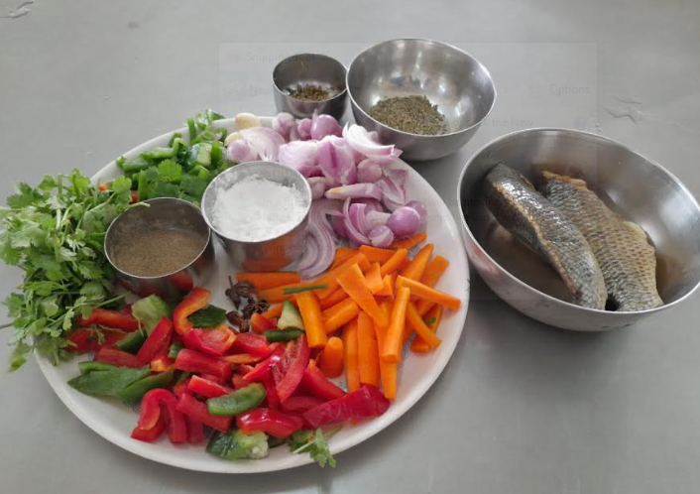 |  | 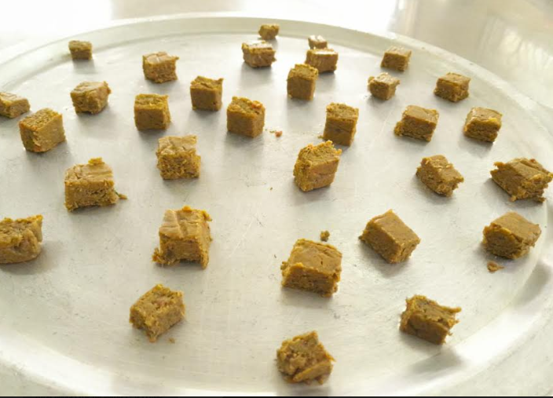
2. According to sensory analysis, the thickening property of the soup cube property will be improved.
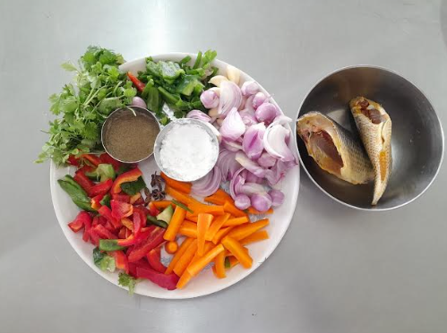 |  |  | 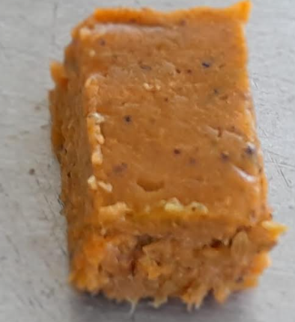
2 | Tailor made programmes to meet the need of the trainee sector which include fisher folk, women SHGs and the rural youth is undertaken to develop fisheries / aquaculture entrepreneurship  Possibility of introducing a “Pre-processor” course exclusively for women will be explored - A course schedule is being prepared by the DFPT  - Lesson Plan preparation was in progress
3. | Innovations in curricular design and transaction  - Progress of curriculum activities is being reviewed by the Dean with all course teachers. All course teachers were instructed to maintain a “Course File” containing course allotment letter, time table, lecture schedule, midterm and practical exam time table, question paper, mark sheets; and the student feedback forms.
4. | Inter-disciplinary programmes to be started  - Online Skill development course on Culture of Pearl Spot Etroplus suratensis (bilingual) and video lesson preparation is in progress. Powerpoints for 11 lessons with six resource persons has been completed (DAQ, DFRM,DAAH,DFPT)  - Design and Curriculum for three month interdisciplinary course (DAQ and DAEM) certificate course on “Pond – Operator” is in progress
5. | Examination reforms implemented  - Approached the Kamarajar Port Limited for an appointment to discuss getting CSR funds to purchase Examination tabs. Waiting for the appointment from the Chairman, KPL
6. | Patents generated, if any (Patents filed, published and awarded)  - A talk on “Patenting system in India” was organized on 24.03.2023
7. | Faculty development  - Training on office procedures was conducted on 02.02.2023
8.. | Strengthening of the library  - Two new journals were subscribed  - Indian Journal of Microbiology and Research  - Journal of Fisheries and Life Sciences
9. | New collaboration research programmes  A Collaboration Project submitted to CM Research Grant, Government of Tamil Nadu  - Entitled of “Development of a process for seaweed based functional food”  - TANUVAS - CFDT, Koduvalli & Dr. M.G.R FC&RI, Thalainayar.

(iii) College of Fisheries Engineering, Nagapattinam
Agenda No. | Minutes | Action Taken
1. | AICTE – Accreditation requirements committed and yet to be completed  -Update all the files pertaining to AICTE  Action: All the Teaching staff of CoFE  -DTCP Approval for CoFE buildings  Action: Er.R. Regupathi, Asst.Prof. CoFE  Vehicle parking shed needs to be constructed  Action: Dr.M. Kamalakannan, Asst. Prof. CoFE  -Motorized Road  Action: Request letter shall be sent to Estate Officer, by Er.R.Regupathi, Asst.Prof. & Campus Development Officer, CoFE, Nagapattinam  -Applying AICTE Approval for B. Tech (EEE) programme - Internal order is required with necessary staff arrangements for the purpose of AICTE, from the University  Action: Dr.M. Ramar, Asst. Prof., DBS, CoFE and Er.S. Monikandon, Asst. Prof. and Head shall initiate the steps for the same | Application for Extension of AICTE of Approval has been made. The files are periodically updated.  DTCP approval process is under progress.  Request for vehicle shed has been made to the University.  75% of laying of motorized road completed.  Necessary steps for inclusion of Energy and Environmental Engineering in AICTE approved nomenclature is under progress.
2. | ICAR Accreditation – Suggestions to improve  - The ICAR PRT team suggested to improve the Craft and Navigation, Aquaculture Engineering Departments since there is lot of scope in those lines and very limited faculty is working in the country as of now  Action: Head, Dept. of Aquaculture Engg. and Head i/c of Nautical Engg. | Field visits and internships are being planned to be conducted in the specified areas. Faculty requirement for the department is submitted to the University.
3. | Teaching  - Students feedback and suggestions to improve  Action: All the staff informed to adhere to the time table for taking theory and practical classes  - Staff feed back  All the teaching staff are informed to submit their feedback before 15th of Nov’ 2022 in the IQAC feedback format  - Improvement required in teaching learning process  Facilities in the classroom to be improved for effective teaching – Projector replacement in the correct position in B. Tech (FE) class rooms (Action: Dr.M. Kamalakannan before 15th Nov’2022)  I B. Tech (FE) class room – one portable device with pen drive mode will be installed with video and audio facilities on trial basis within end of Nov’2022 then it will be implemented in all the class rooms  Curtains for all classrooms and all rooms of CoFE buildings (Action: Mr.D. Muthukrishnan, Asst. Prof. (Contractual) Dept. of Nautical Engineering)  - Laboratory minimum requirements to run the lab for UG practical’s  A sum of Rs. 50,000 will be allotted to each faculty handling practical class for procuring recurring items (Action: All the teaching staff of CoFE to complete the purchase before Dec’2022)  Conduct of internal exams as per ASRR norms  The internal exams shall be conducted adhering by the ASSR norms (Action: All faculty) | Faculty are advised suitably to follow the time table for taking theory and practical classes.  Faculty members have submitted feedback.  These work were under progress and expected to be completed by the end of May 2023 by the respective in-charges.  Non-recurring budgets for laboratories are allotted for purchase of equipment and the purchase was done.  Internal examination was conducted as per the direction.
4. | Research  - Facilities required to undertake research in thrust areas (as per the minutes of RCM) of CoFE, immediate requirements for undertaking UG and PG project research – with fund requirement  All the teaching staff are informed to submit the facilities required to undertake the UG/PG research and funds will be allotted on need basis (Action: All the teaching Staff of CoFE)  - Propose research for UG and PG based on the thrust area given in the Minutes of Research Council Meeting (RCM)  The proposed B. Tech/ M.Tech. project works will be based on the thrust areas discussed in the 7th RCM meeting conducted in our University (Action: All the teaching staff of CoFE)  - Selection of Research coordinator  Dr.D.Kesavan, Assistant Professor and Head was nominated as Research Coordinator (Action: Dr.D.Kesavan, informed to coordinate the Research activities of CoFE) (Action: AO, Deans office: Prepare and issue orders for the same) | The student projects are being taken up according to the thrust areas. Further, the research proposals submitted by faculty follow the thrust areas as key point.  Non-recurring budgets for laboratories are allotted for purchase of equipment and the purchase was done.  Research data are being compiled as and when required by the College or University.
5. | Extension  - Trainings /seminar / symposia to be organised – list given to DEE and number of trainings to be conducted  (Action: All the teaching staff of CoFE)  Proposal for training based on Extension Education Council (EEC) suggestions  Training programmes needs to be planned based on the minutes of 7th EEC meeting (Action: All the teaching staff of CoFE)  Selection of Extension co-ordinator  Dr.M. Ramar, Asst.Prof., DBS, CoFE expressed his willingness to be the Extension Coordinator and accepted by all (Action: Dr.M.Ramar informed to coordinate the extension activities of CoFE)  (Action: AO, Deans office: Prepare and issue orders for the same) | The trainings planned during the start of the year and discussed as Action Plan during Respected Vice- Chancellor Annual review will be carried out as per the plan. Agenda was placed in the faculty meeting  3 trainings based on EEC minutes are conducted.  Extension activities are coordinated by the Extension Coordinator.
6. | Any other items – for improving the quality of teaching research and extension  - Student placement initiatives  Student placement cell focus on job opportunities and higher studies at various institutes for the completed graduates of CoFE (Action: Dr.Mohammed Tanveer, and Dr.P.Karthickkumar)  - Formation of CoFE Alumni Association and conducting Alumni Meet for getting feedback from the alumni before May’2023 (Er.R.Regupathi, Asst.Prof. CoFE)  - Revamping the syllabus of CoFE that suits the industrial needs (Action: All the staff of CoFE and Dean, CoFE for framing syllabus revamping committee and placing the same in BoS for approval)  - B. Tech (EEE) eligibility for PG courses in Anna University and Annamalai University (Request letter will be prepared by Er.S.Monikandon, Asst. Prof. & Head, and sent through Dean, CoFE, Registrar, TNJFU, Nagapattinam to the concerned institutes) | The placement cell is continuously working for possibilities of job opportunities for the graduates of CoFE. In this connection one student is doing Ph.D., (Aquacultural Engineering) at IIT Kharagpur, One is doing PhD (Food Process Engineering) at NIFTEM-Thanjavur, One is doing M.Tech at NIFTEM-Thanjavur, two students are doing M.Tech at Anna University.  Moreover in the context of job efforts for CoFE students, one of the M.Tech (Aquacultural Engineering) students is obtained Junior research Fellowship at IIT Kharagpur.  On Campus Recruitment drive was conducted on 09.01.2023. Avanti Frozen Foods Pvt Ltd, Andhra Pradesh visited CoFE conducted interview for IV B.Tech.(Fisheries Engineering) and selected 5 students.  A whatsapp group for the alumni was created on 6.11.2022. First online meeting with the alumni was conducted on 02.12.2022. In Second online meeting conducted on 21.04.2023. A meeting with alumni is tentatively planned during May 2023.  Committee has been constituted for revamping of the syllabus.  Letter for eligibility is drafted and submitted to Dean, CoFE through Students Coordinator.

(iv) Institute of Fisheries Biotechnology, Vaniyanchavadi, Chennai
Sl.No. | Action Taken towards the previous quarter
1 | - ‘Action Plan’ for the year 2023 has been drawn  - Feedback has been obtained from the students for the B.Tech. (Biotechnology) degree courses  - Five, final year BTech.(Biotechnology students)have enrolled for annual membership in ‘Society for Aquaculture Professionals (SAP)’ to get first-hand information about employment opportunities  - Modalities have been worked out for instituting ‘best Performer of the Year’ award for I, II, III and IV year BTech Biotechnology students. In this context, the following two students were awarded ‘Academic Proficiency Prize’.  - N.Rohith Reddy 2019-2020 batch – Topper in III year  - Jason Prasangi Paul 2020-2021 batch – Topper in I year

(v) Institute of Fisheries Postgraduate Studies, Vaniyanchavadi, Chennai
Sl.No. | Action Taken towards the previous quarter
1 | - ‘Action Plan’ for the year 2023 has been drawn  - Feedback has been obtained from the PG students  - Revised syllabus approved by BSMA-ICAR has been adapted  - Subject matter specialist group meeting initiated- Dr.A.Rathipriya and Dr. Deepak Agarwal shared their experience from the skill developed from the workshop they attended  - Journal club meeting initiated – Dr. Amit Ranjan presented an article in the meeting.  - An industrialist Mr.Manohar Pratap Singh , Managing Director, J.M. Bioscience, Chennai has been inducted in the IQAC  - One alumnus Dr.A. Rathi Priya has been inducted in the IQAC

(vi) TNJFU-Fisheries Business School, Vaniyanchavadi, Chennai
Sl.No. | Action Taken towards the previous quarter
1 | A strategy to be implemented for forthcoming academic year 23-24 Enroll BBA and MBA students

- Any other relevant information the institution wished to add.
(i) Fisheries College & Research Institute, Thoothukudi
Sl.No. | Any other relevant information
1 | The NSS unit of FC & RI, Thoothukudi organized the “Blood Donation Camp” on 02.02.2023.
2 | NSS unit of FC&RI, Thoothukudi organized “Leprosy Awareness Camp” on 09.02.2023.

(ii) College of Fisheries Engineering, Nagapattinam
Training on Fresh Water Fish Culture at Adopted Villages
On 02.01.2023, a “Training on Fish Culture in Freshwater Ponds” was organized by CoFE in Vadagudi village. Dr.N.Manimehalai, Dean, CoFE has presided over the training and emphasized on the importance of fisheries sector. Dr.D.Kesavan, Principal Investigator of UBA scheme and Dr.M.Ramar, Assistant Professor & UBA Co-ordinator, has delivered guest lecture cum training. Mrs. Semmalar Gunasekaran, Panchayat President delivered special address to the training. More than 60 villagers and youngsters including ward members participated in the training.
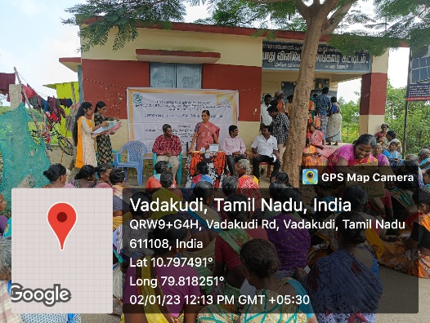 | 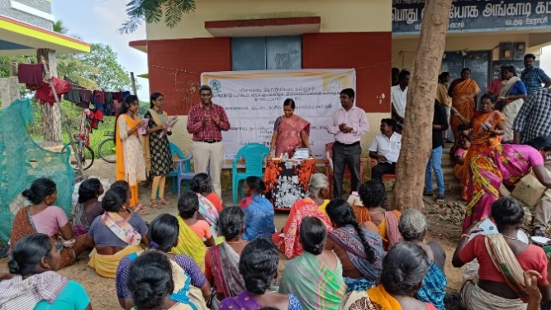
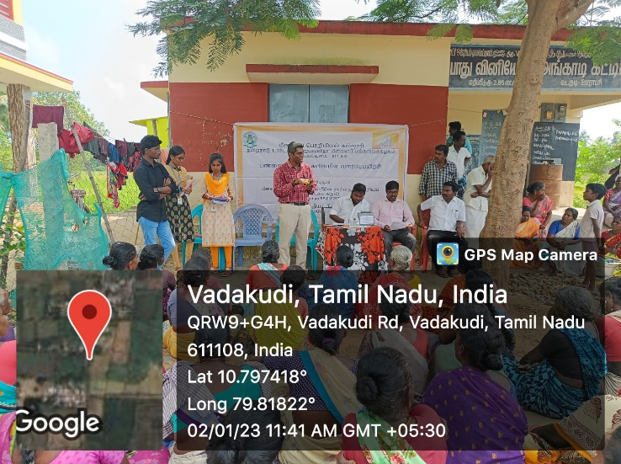

Training at Vadagudi village
Similarly, another training was organized at Panangudi on 10.01.2023. Mrs. Jamuna Senthilkumar, Panchayat President delivered special address to the training. More than 60 villagers and youngsters participated in the training.
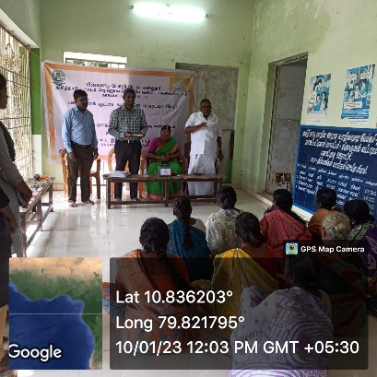 | 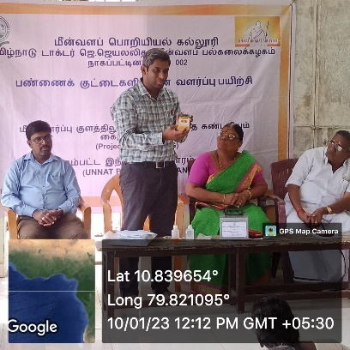
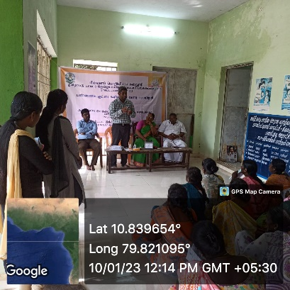 | 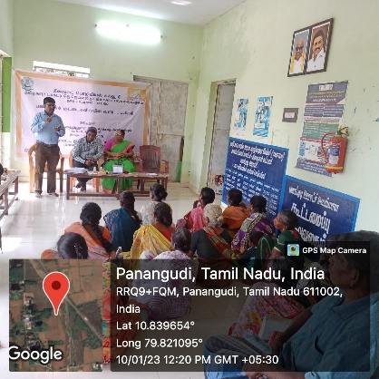

Training at Panangudi village

Guest lecture at CoFE
A Guest lecture on "Waves" and "Equipment used in fisheries" was organized on 20.01.2023. Captain Viswananthan explained about various electronic equipment used in marine field for navigation. Captain Maneksha delivered a lecture on Waves. The guest lecture was arranged by Dr. Mohammad Tanveer, Associate Professor & Head and Er. P. Muthukrishnan, Assistant Professor (contractual).

Visit
A visit to KVK, Sikkal has been performed on 23.01.2023, guided by Dr. Mohammad Tanveer along with two M.Tech (Aquaculture Engineering) students. A demonstrative study on Aquaponics system and Integrated farming system has been done.
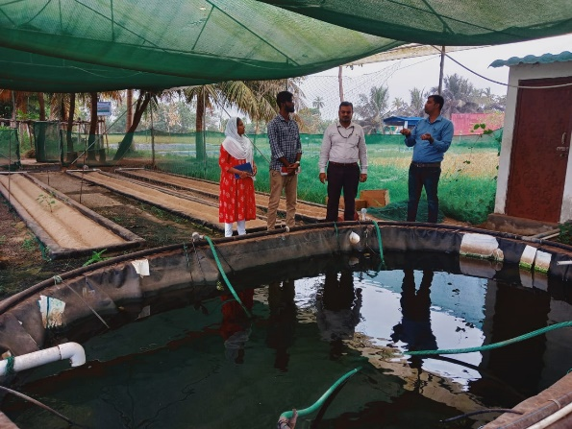 | 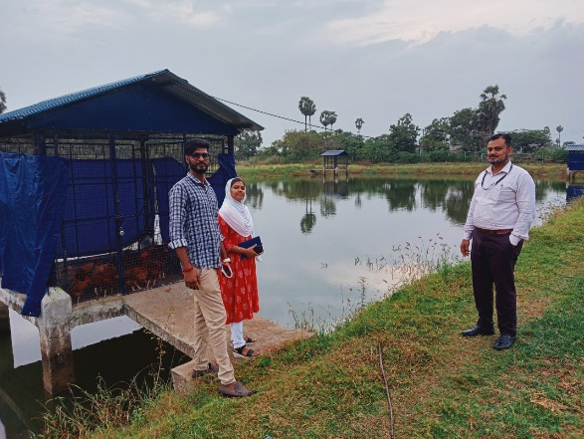
Guest Lecture Delivered
Dr.D.Kesavan, Assistant Professor has delivered Guest Lecture on “Fundamental and Applications of Nanotechnology”, in Special Lecture Series at Jamal Mohammad College, Trichy on 21.01.2023. More than 100 PG and Ph.D., students participated in the event.

Best Poster Presentation Award

Ms.M.Archana, IV B.Tech.(Energy and Environmental Engineering) student under the guidance of Dr.D.Kesavan, Assistant Professor, has received Best Poster Presentation Award for presentation entitled “Design and Development of Atmospheric Water Generator” in the International Conference on Environmental Management and Sustainable Development” organized by Holy Cross College, Trichy, on 24.01.2023.

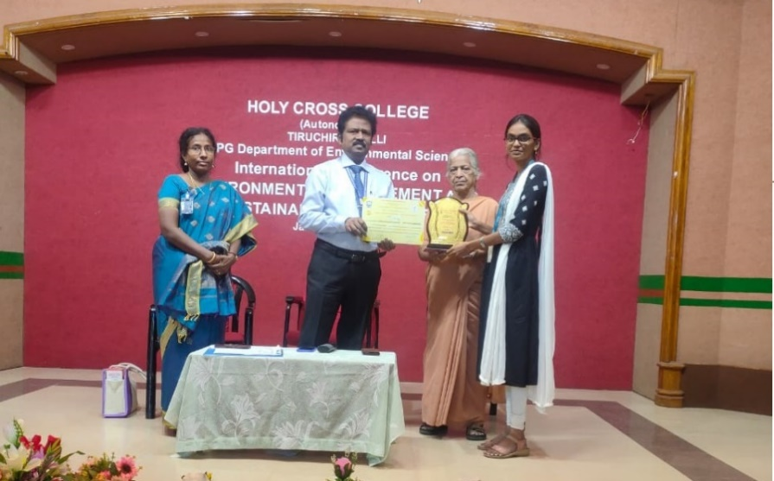

Republic Day celebration at CoFE

CoFE celebrated 74th Republic Day on the theme of “75th Indian Independence Anniversary and Independent India @ 75 - Self-reliance with Integrity” on 26.01.2023. Our National Flag was hoisted by Dr.Mohammad Tanveer, Dean i/c. In his speech, he listed the history of Indian independence and highlighted how Constitution was created and came to effect in India.

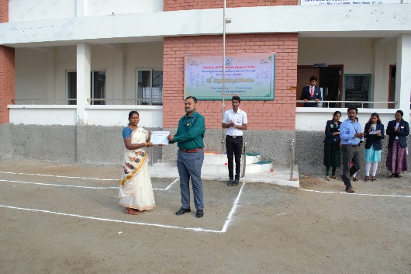 | 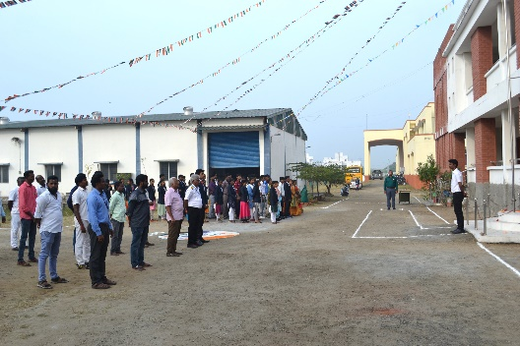

ABOLITION OF UNTOUCHABILITY- 2023

The Untouchability Abolition Day was observed on 30th January every year. Article 17 of the Indian Constitution abolishes the practice of untouchability. The pledge was taken by Dr. Mohammad Tanveer, Dean i/c followed by teaching, non-teaching staffs and students of CoFE.
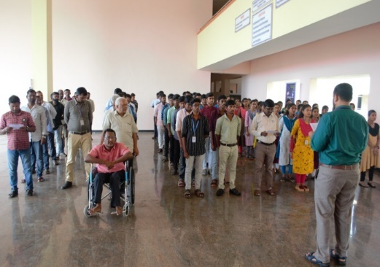 | 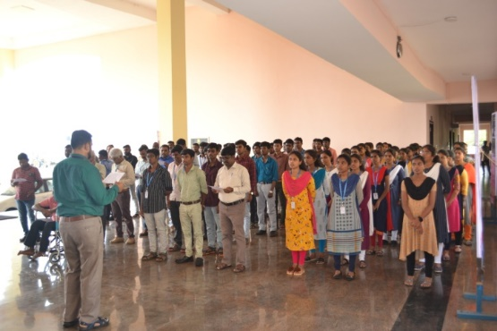

National Voters Day – 2023

National voters Day pledge was observed at CoFE on 25.01.2023. Dr. Mohammad Tanveer, Dean (i/c), preside the event at college premises along with the Teaching, Non-teaching staff, UG and PG students. The event was co-ordinated by Dr.M.Ramar and Er.S.Monikandon, NSS and RRC Co-ordinators.

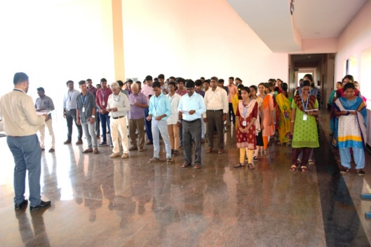 | 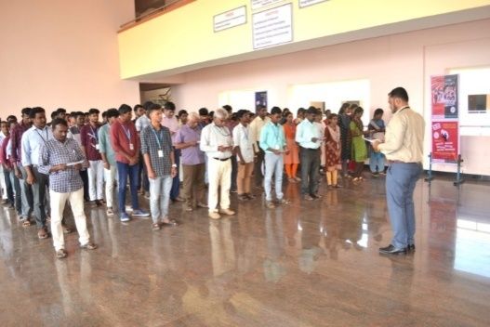

CoFE Students bagged prizes in TN CM Sports meet 2022-23 Nagapattinam
Students of CoFE have participated in Chief Minister Trophy Sport’s meet 2022-23 conducted by Nagapattinam Collectorate from 07.02.2023 to 09.02.2023. Three students secured prizes. Ms.Vanapriya, I B.Tech FE secured II and III prize in Double and Single Sticks of Silambam event, Ms.SahayaRubhasha II B.Tech EEE secured II prize in Shot put event, Ms.Pravarthika II B.Tech FE secured III Prize in High jump event and Mr. Nithish secured Second Prize in High jump event. Students were accompanied by Dr. P. Karthickumar, Assistant Professor and Sports Secretary. Appreciation certificates were given by Dr. N. Felix Registrar TNJFU in the presence of Dr. N. Manimehalai, Dean CoFE at CoFE Seminar Hall on 14.02.2023.

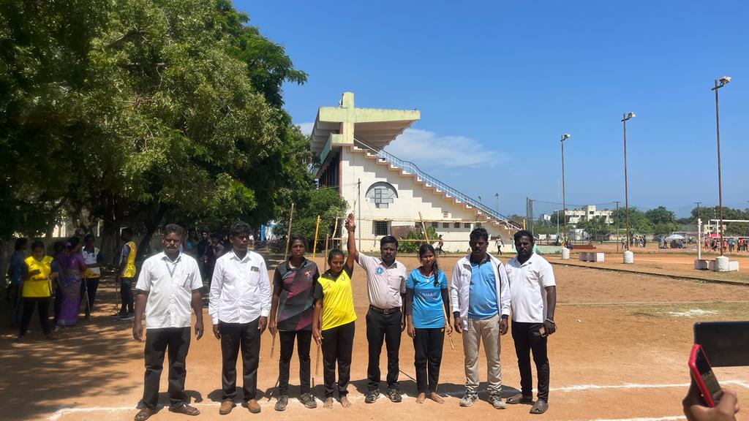 | 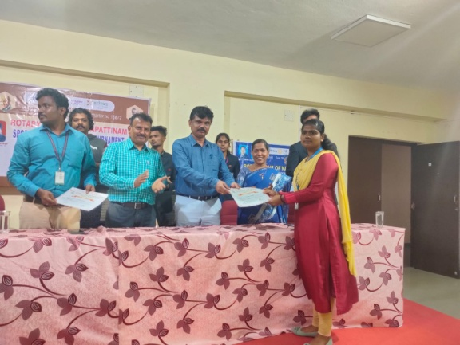

Chess Competition held at CoFE by Rotaract team on 14.02.2023
Chess competition for College of Fisheries Engineering students was organized by Rotaract club of CoFE on 14.02.2023. The competition was inaugurated by Dr. N. Manimehalai Dean i/c, College of Fisheries Engineering, Nagapattinam. Thirty students (Twelve boys and Eighteen Girls) participated in this event. Valedictory session was headed by Dr. N. Felix, Registrar TNJFU and prizes were distributed to the best performers. The event was coordinated by Dr. P. Karthickumar, Assistant Professor and Rotract Club CoFE Coordinator.
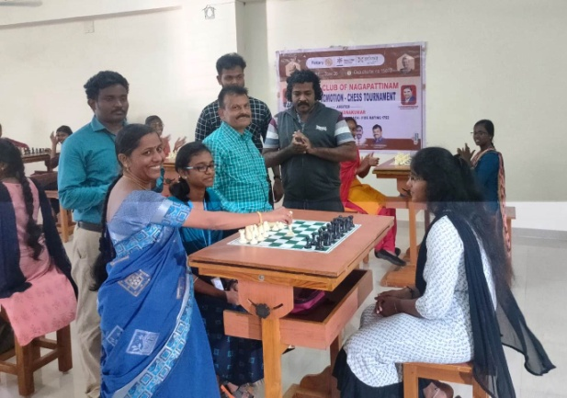 | 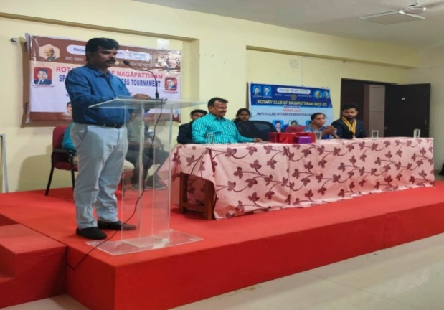

Participation of Students in Workshop
B.Tech. (FE) and (EEE) II year, III Semester students, of College of Fisheries Engineering attended the workshop on “Deep learning and its applications in Aquaculture” at NIT- PY, Karaikal during 13th& 17th of February 2023. The workshop was very much useful for their research work as well as career growth. The students were coordinated by Dr. Mohammad Tanveer, Associate Professor, CoFE, Nagapattinam.
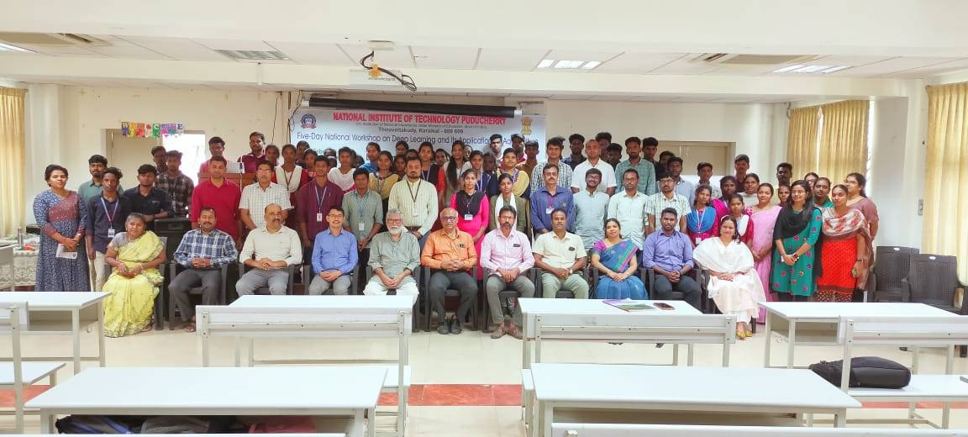

Project obtained under UBA Scheme
- Development of edible package technology for fish soup for economic empowerment of Vadagudi and Manjakollai villagers
PI: Dr.D.Kesavan, Assistant Professor & Head i/c, Department of Basic Sciences, CoFE
Budget: Rs.1.0 lakhs

- Solar infrared hybrid dryer for hygienic production of dry fish
PI: Dr.P.Karthickumar, Assistant Professor, Department of Fish Process Engineering, CoFE Budget: Rs.1.0 lakhs
- Design and fabrication of fish vending trolley for empowerment fish peripatetic vendor women in Akkaraipettai village
PI: Er.S.Monikandon, Assistant Professor & Head i/c, Department of Energy and Environmental Engineering, CoFE.
Budget: Rs.1 lakhs.
Publication
- R. Ragasudha, P. Karthickumar, S. Murali, R. Pradeep, K. Rathnakumar, C. Mercy Amrita, D. Babiyola& N. Manimehalai. Design and performance analysis of a PV-powered solar-infrared hybrid dryer for anchovy fish drying. Biomass Conv. Bioref. (2023). https://doi.org/10.1007/s13399-023-03944-0. (NAAS Rating 10.05).

(iii) TNJFU, Fisheries Business School, Vaniyanchavadi, Chennai
Sl.No. | Any other relevant information
Currently, the final year B.B.A. (FEM) students (2019-2020 batch) are undergone internship programmes in the following institutions.
1. | JMJ Exports Near Fishing Harbou,Kanyakumari 629 702, (3 students )
2. | M/s. IAS Group of Hatcheries, PalmanPeta,Kakinada, (3 students )
3. | Sun Aquaa marine ,Venkannapale village ,T.P.Gudurmandal,  Nellore Districts, Andhra Pradesh. (2 students )
4. | Philiip food India PVt Limited, Plot No. C75/76 SIPCOT Industrial Complex,  Madathoor (po)Tuticorin, TamilNadu. 628 008 (1 students )
5. | Sun Shine Marine ,95/1, Happy bay Annexe, Muguaiyur village,(2 students )
6. | S.K.Marine Technologies Pvt Ltd ,Part 2 off M.K.Radha Avenue.(2 students )  Injambakkam, Chennai 600115

(iv) College of Fish Nutrition and Food Technology, Madhavaram
Sl.No. | Any other relevant information
1. | In the feedback form, we need a separate cumulative mark / score card for each subject

Section C: Outcomes achieved by the end of the quarter

(i) Fisheries College & Research Institute, Thoothukudi
DAQ
- 6 UG courses were handled
- NADP scheme on “Integrated fish farm model complex at Fisheries College & Research Institute, Thoothukudi for capacity building of inland fish culturists to augment fish production” was operated
- 5 training programmes were conducted
DFPHM
- Three nos. of B.F.Sc courses offered
- Six nos. of M.F.Sc courses offered
- National Surveillance programme for Aquatic Animal Diseases –Phase II scheme
- Three MFSc students and 2 PhD student guided
DFQAM
- Teaching one UG and six PG courses.
- Research Proposals prepared for MFSc students
- Samples analysed for various quality parameters and certificates issued

(ii) Dr. M. G. R. Fisheries College & Research Institute, Ponneri
- Various programmes to benefit the students, such as special lecture on preparation of UPSC and TNPSC examination, inspirational talk Series on “Break the Barrier Initiative” to motivate the students to become entrepreneurs were arranged
- Steps for the start of the online skill development course on Culture of PearlSpot Etroplus suratensis isin progress
- Two JTRF Proposals submitted have been selected for funding support by the university ( PIs - Mr.K.Karuppasamy, DFBRS and Dr.S.Saravanan, DAAHM)
- Digital media lab, Acoustic recording studio and ICT lab with inherent facilities was established by the Department of Fisheries extension, economics and statistics
- Outcome Mention about Best paper award
- Best paper award IFBT’23 ‘Packing Innovations in Food and Beverage’

(iii) College of Fisheries Engineering, Nagapattinam
(iv) Dr. M. G. R. Fisheries College & Research Institute, Thalainayeru
1. Pongal Celebration
The Harvest festival, Pongal was celebrated in Dr.M.G.R Fisheries College and Research Institute, Thalainayeru on 12.01.2023. Students and staff participated in the festival with traditional attire. Many fun games were conducted for the staff and students.
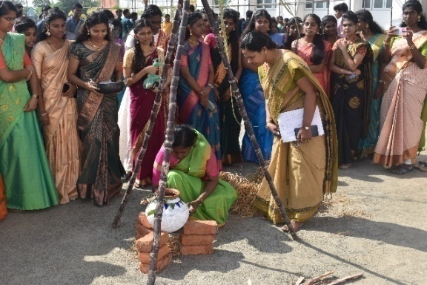 | 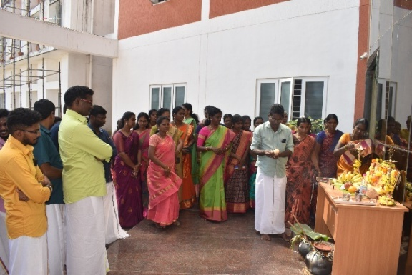
2. Fisheries Business Start-up Cell infused the idea of Aquaponics Technology for school children
A passion of fish culture using aquaponics was taught to the school children with a simple 10 steps process to imbibe the interest of developing a hobby in Fish rearing & maintenance on 13.01.2023. A total of 52 school children from class 5 to 8 along with the school teachers exposed to this training and demonstration through video portraits. A flyer on 'Ten Easy Steps to Start Aquaponics' was also released by Th.Anbazhagan, Head Master.
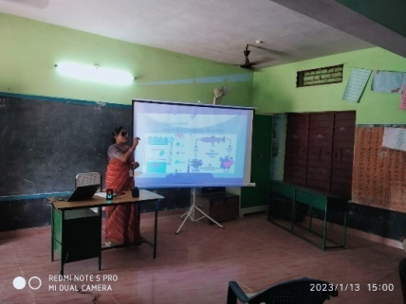 | 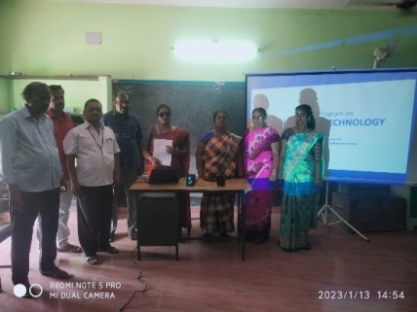

3. Republic Day Celebration, 2023
The 74th Republic Day was celebrated at Dr. M.G.R Fisheries College and Research Institute, Thalainayeru on 26.01.2023. The Dean i/c, Dr. S. Balasundari unfurled the national flag. A total of 60 staff and 180 students attended the programme. In the Republic Day address, Dean i/c spoke on the responsibilities of citizens to contribute to the nation’s wealth. Selvi. D.A. Shree Gowri, (I B.F.Sc.) and Selvi J. Vivilia Jessica (I B.F.Sc.) delivered Republic Day speech. Mr. S. Kesavan, Assistant Professor, DFBRM coordinated the event.
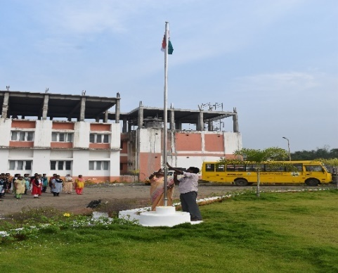 | 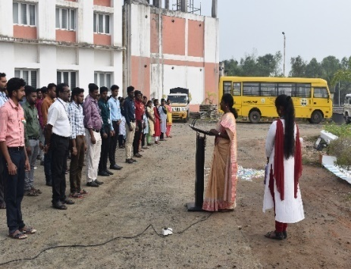
4. Welcome Day to the Fresher’s
Welcome Day to the Freshers was celebrated on 27.01.2023. Dr. S.Balasundari, Dean i/c and President of Students Association delivered the Presidential address and Dr. J. Jaculine Pereira, Assistant Professor and Vice - President of Students Association felicitated the event.
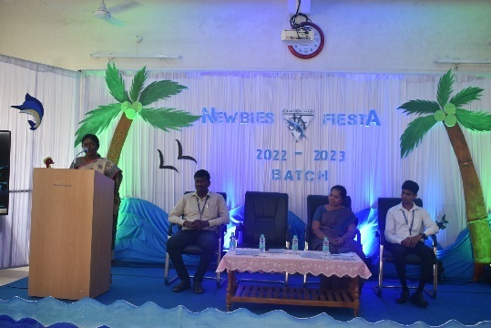 | 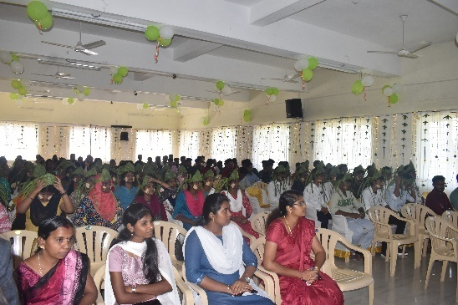
5. Inauguration of Students’ Association, 2023
The Students Association of the institute was inaugurated on 31.01.2023. Dr. J. Jaculine Pereira, Assistant Professor and Head i/c. and Vice-President of Students' Association welcomed the gathering and administered the oath of office bearers of Students’ Association. Mr. M.Muthukumaran, Managing Director, Sivasakthi International School, Thalainayeru served as the Chief Guest. Dr.S. Balasundari, Dean i/c and President of Students Association presided over the function.
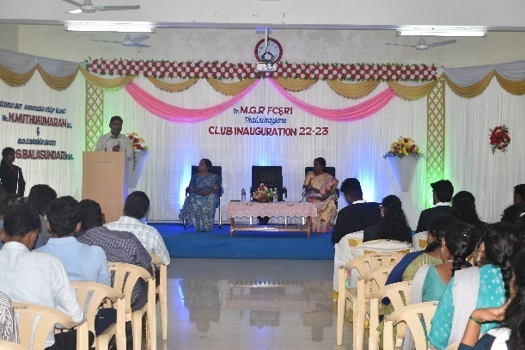 | 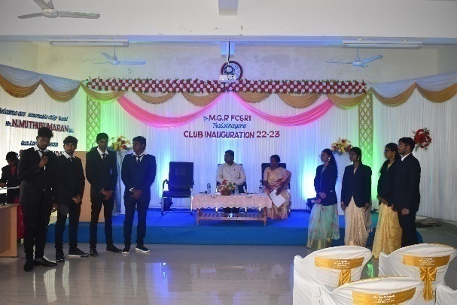
6. Curtin University Students embarked on a Visit to Dr.MGR.FC&RI, Thalainayeru
A group of 10 students from Curtin University Department of Marine Science and Technology embarked on a visit to the Dr. MGR. Fisheries College and Research Institute at Thalainayeru on 04.02.2023 to learn more about the latest advances in fisheries technology and practices in the Indian subcontinent. They engaged in lively discussions with the students and faculty about a range of topics related to fisheries and aquaculture and also visited near by shrimp farm, to observe the farming techniques. They were also treated with a range of performances, including traditional music, dance, drama and traditional games.
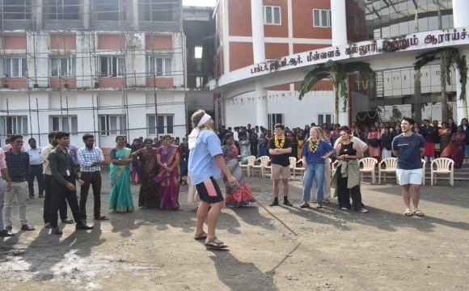 | 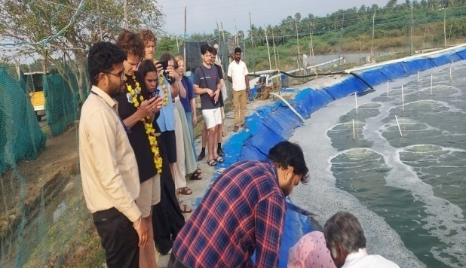
7. Eentrepreneurship ideas for Engineering Students
Fisheries Business Startup cell organised a "Students Entrepreneurship Program" in EGS Pillai College of Engineering, Nagapattinam on 10.02.2023. A talk on Emerging Entrepreneurial Opportunities in Aquaculture was delivered to a total of 200 students from various departments fostering curiosity and innovation in young minds through technologies.
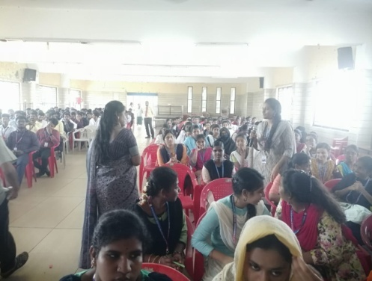 | 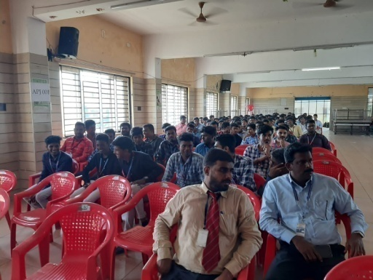

8. All India Study Tour 2023
The 2019-20 batch students underwent All India Study Tour as a part of Student READY programme from 11-02-2023 to 25-02-2023. The students visited various ICAR institutes across the country and gained knowledge about the role and functioning of the research institutions.
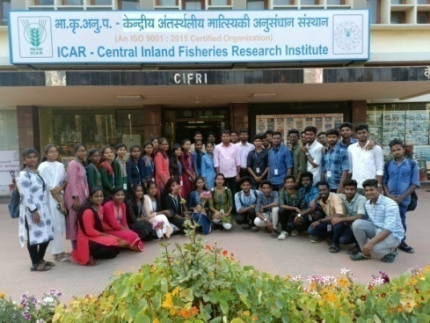

9. Exposure visit under Naan mudhalvan scheme
32 students and 7 teachers from Government High Schools in Nagapattinam district made an exposure visit to Dr. MGR. Fisheries College and Research Institute, Thalainayeru under Naan Mudhalvan scheme on 27.02.2023. The students were exposed to the courses offered in the university and employment opportunities. The students also visited the departments and laboratories, interacted with our students and participated in the events conducted by the final year students.
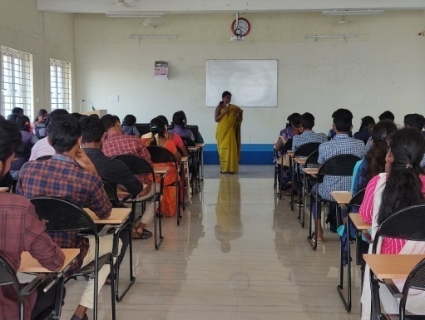 | 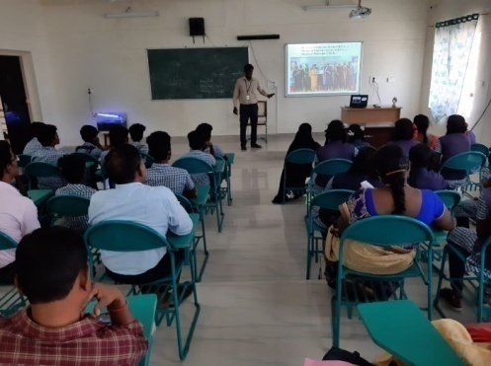
10. National Science Day Celebration, 2023
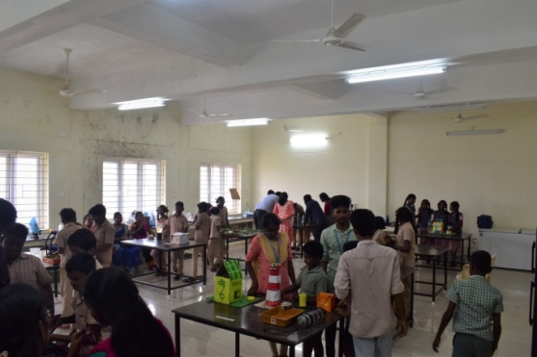 | 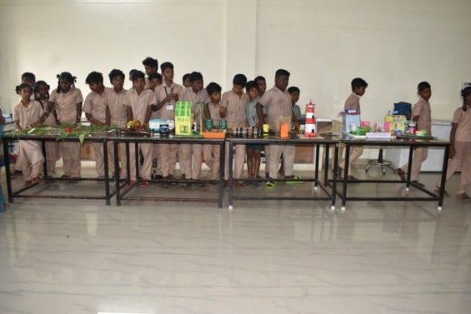
In the event of National Science Day, Science exhibition was organized for the school students on 28th February, 2023. Students from 6 schools from the adopted villages participated n the exhibition. Prizes were distributed to the winners.
11. NSS Camp
Dr. M.G.R Fisheries College and Research Institute, Thalainayeru, has organized NSS camp for five days in the adopted village Vattakudi of Nagapattinam district from 01.03.2023 to 05.03.2023. Mr. S. Kesavan, Assistant Professor, coordinated the NSS camp. Forty-four students of 2019-20 batch participated in the NSS camp and conducted the various activities such as training on fish culture in community and temple ponds with 80 participants (65 female and 15 male), cleaning of village road, school and temple, tree plantation (65 saplings), blood donation (23 students) and yoga and cultural event (40 school students).
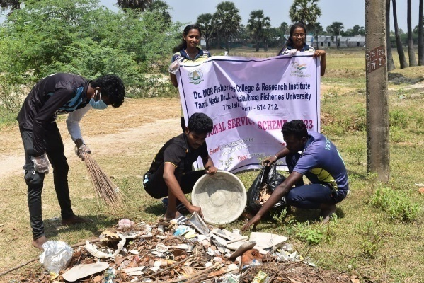 | 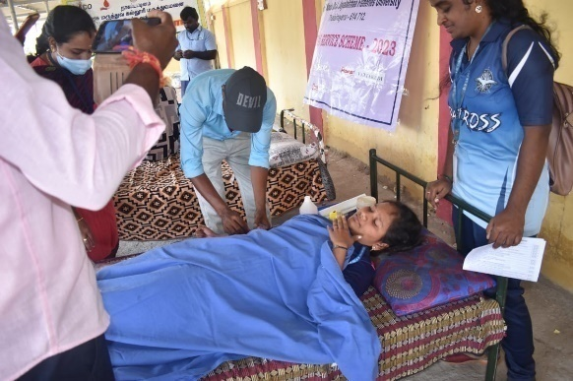

12. Celebration of International Women's Day
Dr. MGR Fisheries College & Research Institute, Thalainayeru celebrated women’s day on 07.03.2023. The event was graced by the presence of Ms. YahiraPaedrahita, Executive Director of the National Chamber for Aquaculture in Ecuador, who served as the chief guest, and Shri. Balasubramanyan, Proprietor of Certitude Farms Pvt. Ltd., who served as the guest of honour. The speakers expatiated on the momentousness of gender parity and women's empowerment in the domain of aquaculture and fisheries.
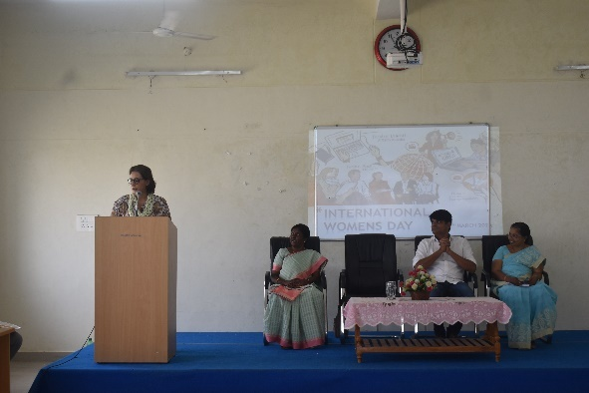 | 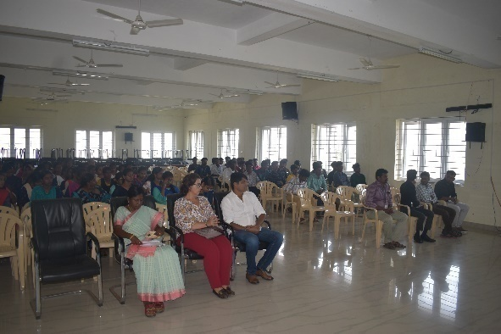

13. World Water Day celebration, 2023
On the occasion of World Water Day, working model exhibition, quiz competition and photography contest were conducted for the students of Dr. M.G.R Fisheries College and Research Institute, Thalainayeru on 24.03.2023. Dr.S.Balasundari, Dean i/c, presided over the function and distributed prizes to the winners of the events.
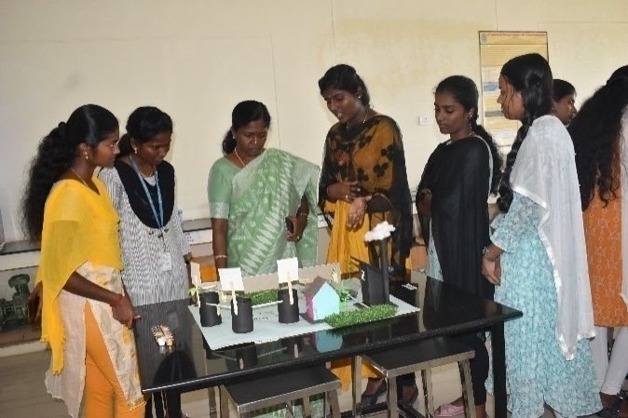 | 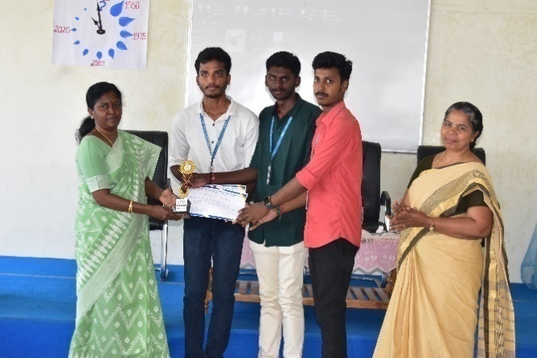
14. Two-days NSS Camp at Kameshwaram
Dr. M.G.R Fisheries College and Research Institute, Thalainayeru, has organized two-day NSS camp with night stay at Kameshwaram Village on 24.03.2023 and 25.03.2023. The socio-economic survey was conducted among 25 fishers of Kameshwaram village using a questionnaire. The coastal cleanup activity was conducted along the coast of Kameshwaram village and removed the marine debris.
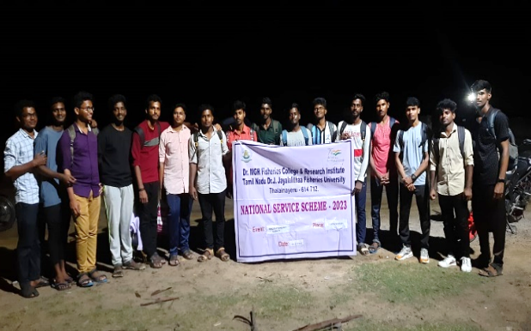 | 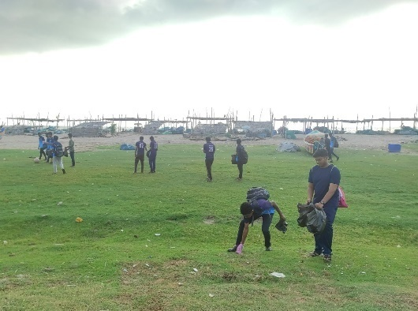

(v) Institute of Fisheries Biotechnology, Vaniyanchavadi, Chennai
- Action plan for 2023 has been prepared
- One alumnus has been included in the IQA cell of TNJFU-IFBT
- Initiated ‘Group Study’ activity through ‘Prospicience Groups’for knowledge improvement
- ‘Academic Proficiency Prize’has been initiated

(vi) Institute of Fisheries Postgraduate Studies, Vaniyanchavadi, Chennai
1.Action plan for 2023 has been prepared
2.Academic calendar is implemented

(vii) TNJFU, Fisheries Business School, Vaniyanchavadi, Chennai
- 8918 numbers of feedback received from the students
- Academic proficiency awards were presented to the deserving candidates
- 5 MBA (FEM) students were placed through placement cell
- 09 webinars were organized
- Two endowment (Rs. 200000/-) were mobilized for presenting awards to students for their academic excellence
- 5 programmes were participated and won prices by FBS students conducted by other university and colleges.

(viii) College of Fish Nutrition and Food Technology, Madhavaram
- To prepare template for counseling class
- To arrange guest lecture for FSSAI, BIS, GATE, TNPSC for 3rd year students
- Preparing to arrange for the Entrepreneurship and Personality development training program for other students
- Every month IQAC meeting will be conducted with the staff to follow up on the required action / suggestions given during IQAC Meeting
- The Action Taken Report should be submitted by the individual faculty

(ix) PPIFT, Madhavaram
(x) Directorate of Incubation and Vocational Training in Aquaculture, Muttukadu, Chennai
- Mentors allotted for each student.
- eBooks facility at DIVA Library.
- Innovation and entrepreneurship club formed for DIVA campus.
- Course file maintenance.
- Students database was maintained.
- Alumni association was formed.
- Placement cell was formed.
- Greening of campus was timely ensured.

(xi) DIVF, Mandapam
- 16 B.Voc. (IFT) UG courses and 1 M.F.Sc. course was taught
- 16 B.Voc. (IFPT) UG courses were taught
- Revised draft of a textbook on “Refrigeration and Equipment Engineering” was submitted to the Jaya Publishing House on 21.03.2023
- Revised draft of a handbook on “Navigation and Seamanship” was submitted to the Elite Publishing House on 03.04.2023
- Research guidance for 1 M.F.Sc. students
- Two research paper was published in the Journal of Coastal Research
- One research paper was submitted to the Journal of Ichthyology
- One research paper was submitted to the Journal of Applied Ichthyology
- Pamphlets were prepared under the NADP scheme
- Established the computer lab at PPIFT, Ramanathapuram
- Fundamental duties and activities were sent to Admo on 04.01.2023
- Revised RE 2022-23 detail was sent to the Finance Officer on 05.01.2023
- NADP scheme Utilization certificate report was sent to the FO on 11.01.2023
- 60th USO meeting ATR sent to the Registrar on 11.01.2023
- One page write up detail of Deep-Sea Training and Research boat was sent to the Registrar on 24.01.2023
- Annual report was sent to the DR on 24.01.2023
- Students and staff particulars were sent to the FO on 25.01.2023

Training programs organized: 01
Sl. No. | Title | Date & Venue | Online / Offline | Funding Agency | No. of participants (Male/Female) | Name of the Faculty
 | Skill Development Training on Value Added Product to the Widows/Destitute Women members enrolled in TNFWB | 28.03.2023 to 29.03.2023 at Royapuram | offline | Tamil Nadu Fishermen Welfare Board | 40 | Dr. Vinothkumar L.

February 2023
- 16 B.Voc. (IFT) UG courses and 1 M.F.Sc. course was taught
- 16 B.Voc. (IFPT) UG courses were taught
- NADP status report was sent to Admo on 14.02.2023
- The DCB statement sent to the FO on 20.02.2023
- 60th USO meeting ATR sent to the Registrar on 20.02.2023
- The TN scholarship particulars were sent to the Registrar on 21.02.2023
- The level 5 & 6 exam proposal was sent to the ASCI on 24.02.2023
- Campus Interview was organized at PPIFT, Madhavaram for B.Voc. (2018-19 & 2019-20 batch) students for the post of Quality Controller in Fishing’ India Private Limited on 27.02.2023
- A revised e-learning module has been prepared for the course of FS_08 Navigation and Seamanship and the same has been uploaded to the NEHAP Portal
- The proposal was prepared and the same was submitted to the Registrar, TNJFU on 28.02.2023 regarding the inclusion of the B.Voc. (IFT) program for the permanent post of Assistant Manager by direct recruitment in the Tamil Nadu Fisheries Development Corporation Limited, Department of Fisheries and Fishermen Welfare, Tamil Nadu.
March 2023
- 16 B.Voc. (IFT) UG courses were taught
- 16 B.Voc. (IFPT) UG courses were taught
- The level 5 & 6 exam particulars were sent to the ASCI Director on 02.03.2023
- The student and fee particularly sent to the FO office on 02.03.2023
- The DCB statement sent to the FO on 02.03.2023
- The LF particulars were sent to the FO on 03.03.2023
- The 1 day and week training request letter sent to the Registrar on 06.03.2023
- The newsletter report sent to the DEE on 09.03.2023
- The placement cell activities report was sent to the Admo on 13.03.2023
- The evaluation of the financial position report sent to Admo on 16.03.2023
- 62nd USO meeting ATR sent to the Registrar on 16.03.2023
- The policy note report was sent to the Registrar on 21.03.2023
- The driver license proposal sent to the Registrar on 27.03.2023
- The 8th report was sent to the DEE on 30.03.2023
- The 8th planning board particulars sent to the PAtoVC on 31.03.2023
- Conducted the mid-term examination under the I semester
Additional responsibilities held:
Mr.M.Kalaiarasan
- Students’ co-ordinator (2020-21, 2021-22 and 2022-23)
- ETC coordinator
- EMS coordinator
- Report compilation coordinator
- Online exam coordinator
- Vehicle officer
- Campus development officer

Section D: Plans of the Institute for the next quarter

(i) Fisheries College & Research Institute, Thoothukudi
DAQ
- 6 UG courses and 3 PG courses will be handled
- DSIR research scheme on “Livelihood improvement of women through skill development in ornamental fish farming with special emphasis on production of attractive and high quality ornamental fishes” will be operated.
- Training programme will be conducted
DFPHM
- Offering courses to UG, PG and PhD
- Continuing the PG and PhD research guidance
- National Surveillance programme for Aquatic Animal Diseases –Phase II scheme till March 2025.
DFPT
- The objectives of the EDII Scheme will be accomplished.
- The Ph.D. Students research work will be continued
- The courses of the Department of Fish Processing Technology will be handled.
- A seafood mela is planned to conduct during 3rd week of May 2023 at Muthunagar
Beach, Thoothukudi under the project of EDII-Marine Products Business Incubation
Forum.
DFQAM
- To offer courses pertaining to fish quality and safety to the B.F.Sc. degree students
- To carry out research works on fish quality assurance
- To guide the PG and Ph.D. degree students in the field of fish quality assurance
- To serve as fish quality monitoring and certification centre
- To impart training to personnel of seafood processing industries, fisherfolk, SHGs on fish quality and safety
- Library:
- Uploading of all the PG and Ph.D. thesis from 2020 to 2022 batch in the Krishikosh Portal.
- https://krishikosh.egranth.ac.in/

(ii) Dr. M. G. R. Fisheries College & Research Institute, Ponneri

Library
- Uploading of all the PG and Ph.D. thesis from 2016-2017 batch to 2020-2021 batch in the college website on the university portal
- Compiling e text books and circulation to the UG, PG and Ph.D students and maintaining records of the ebooks circulated
Department of Aquaculture
- Strengthening on farm skills for the UG students in feeds and feeding management in fish/shrimp culture systems and in farmers field
- Strengthening soft skills in Microsoft Office for UG students- Word, Excel ,PPT and reporting
Department of Aquatic Animal Health Management
- To propose projects to the external funding agency
- Publication of research papers in high- impact factor journal (DAAHM)
Department of Fisheries Biology and Resources Management
- Will be Organize one day training program regarding Taxonomy
Department of Fisheries Extension Economics and Statistics
- Development of video module in core document of area of aquaculture
Department of Aquatic Environment Management
- Water quality management – skill development will be imparted to final year students.
- Awareness Programmes or events will be conducted in commemoration of World Environment day and World Ocean day.

Department of Fish Processing Technology
- Course schedule for skill development course on preprocessing & value addition & Aquatic food products
- To propose a project to the external funding agency
- To propose training project to the external funding agency
- To write Popular article
- To write Technical article

(iii) College of Fisheries Engineering, Nagapattinam
(iv) Dr. M. G. R. Fisheries College & Research Institute, Thalainayeru
The second quarter (April - June, 2023) meeting is planned on 27.04.2023 for the teaching staff and 28.04.2023 for IQAC committee members and the action plan will be submitted along the minutes of the second quarter meeting.

(v) Institute of Fisheries Biotechnology, Vaniyanchavadi, Chennai
- Encouraging the participation of students in personality development programmes
- Organizing parent-teacher meeting
- Organizing ‘Psychological Counselling’ programs for the benefit of the students

(vi) Institute of Fisheries Postgraduate Studies, Vaniyanchavadi, Chennai
1.Encouraging the participation of students in personality development programmes
2.Organizing ‘Psychological Counselling’ programs for the benefit of the students

(vii) TNJFU, Fisheries Business School, Vaniyanchavadi, Chennai
- BBA and MBA students to enroll in MOOC , NPTEL, Swayam and course ERA
- FDP to be organized by faculty members of FBS
- Skill development Initiative to be implemented for BBA and MBA (FEM) students

(viii) College of Fish Nutrition and Food Technology, Madhavaram
- The External IQAC meeting will be conducted on 19.04.2023
- The Internal IQAC meeting will be conducted on 28.04.2023
- Discussed with the External members about internship and placement activities
- Conducted awareness program through IQAC
- Dean will discuss with the faculty to prepare and publish the research paper related to food and fish
- Will discuss with the faculty about Students feedback form

(ix) PPIFT, Madhavaram
(x) Directorate of Incubation and Vocational Training in Aquaculture, Muttukadu, Chennai
- Frequent field visits for the students to Farms, hatcheries, industries and TNJFU centresto be arranged.
- Regular class committee meeting to be conducted and file to be maintained.
- Few magazines for DIVA Library to be subscribed.
- Skill based training programs to be arranged.
- Feedback from the students to be collected periodically.
- Research Publication in the Scopus Indexed Journals
- Consultancy and Research and Development cell to be created.
- Laboratories to be further strengthened.
- Courseoutcomes to be developed.
- Faculty empowerment programs to be encouraged.
- Greening of campus to be ensured.

(xi) DIVF, Mandapam
PPIFT, Ramanathapuram – April 2023
Conduct a One week on Campus Training Programme
Purchase of Navigational communication equipment
Submission of one research paper
BOS agenda preparation
Preparation of Annual Account 2022-23
Conducting the practical exam under the I semester
May 2023
Preparation of Tamil books for the subject of Fishing Gear Technology, Basic Navigation, Basic Marine Engine
Preparation of 9th Annual report 2022-23
June 2023
Conducting the practical examination under the III semester
Online examination under the I semester

